# RISC-V

## Prerequisites

**Setup C program runtime environment**:

* Create a stack (per CPU core) in memory;
* sp register <- stack top address. //Because stack grown from top to bottom

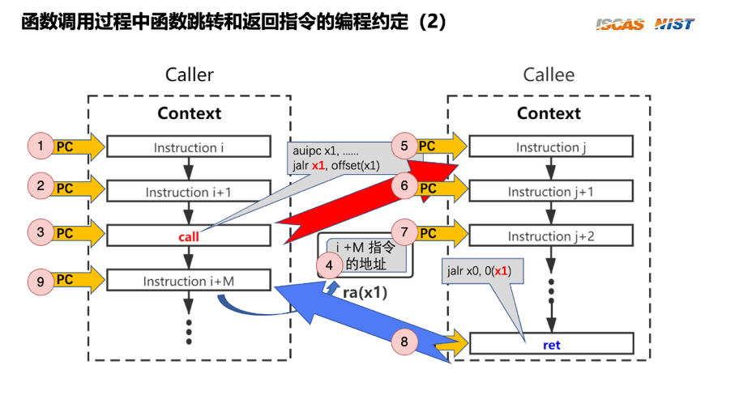

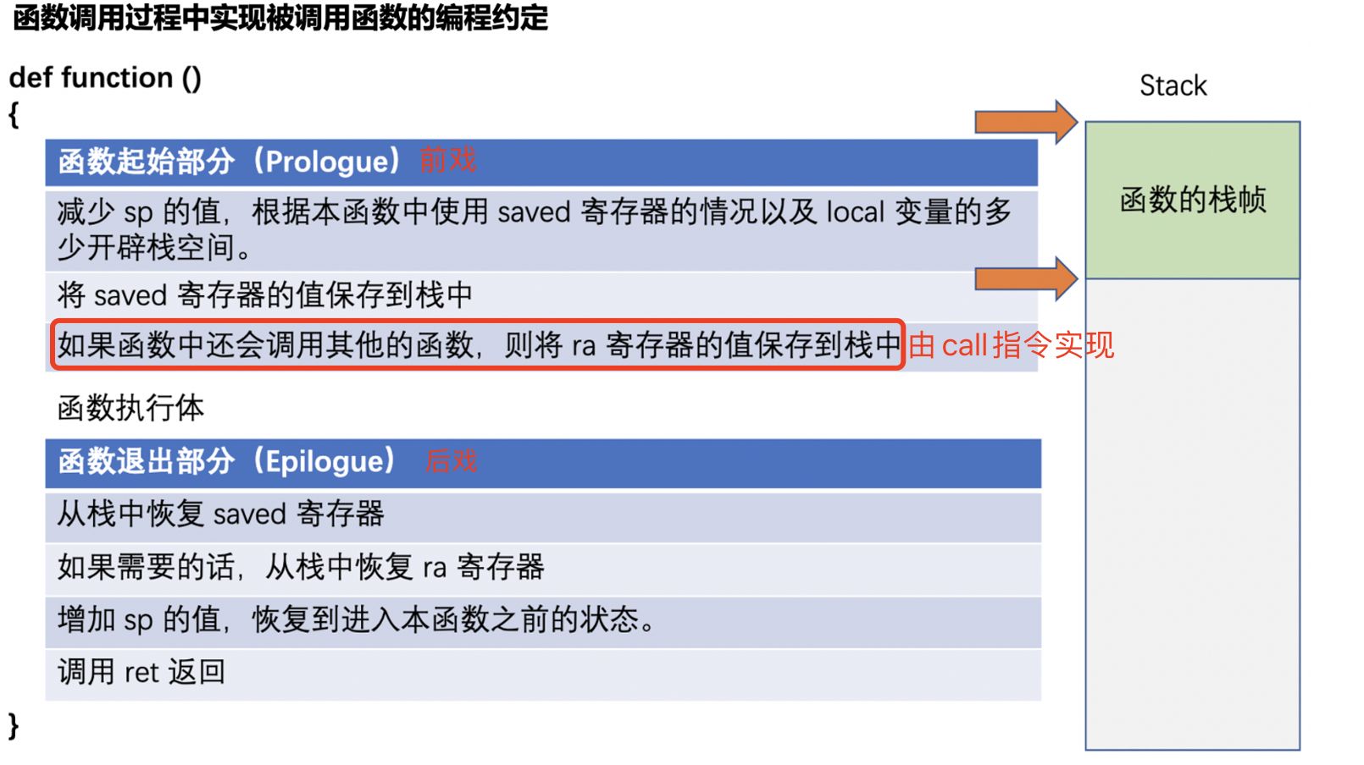

Note: RISC-V没有把pc register暴露给user. 而是user用ra 来保存ret之后继续执行的指令地址. 返回的时候，硬件会把pc设置为ra.

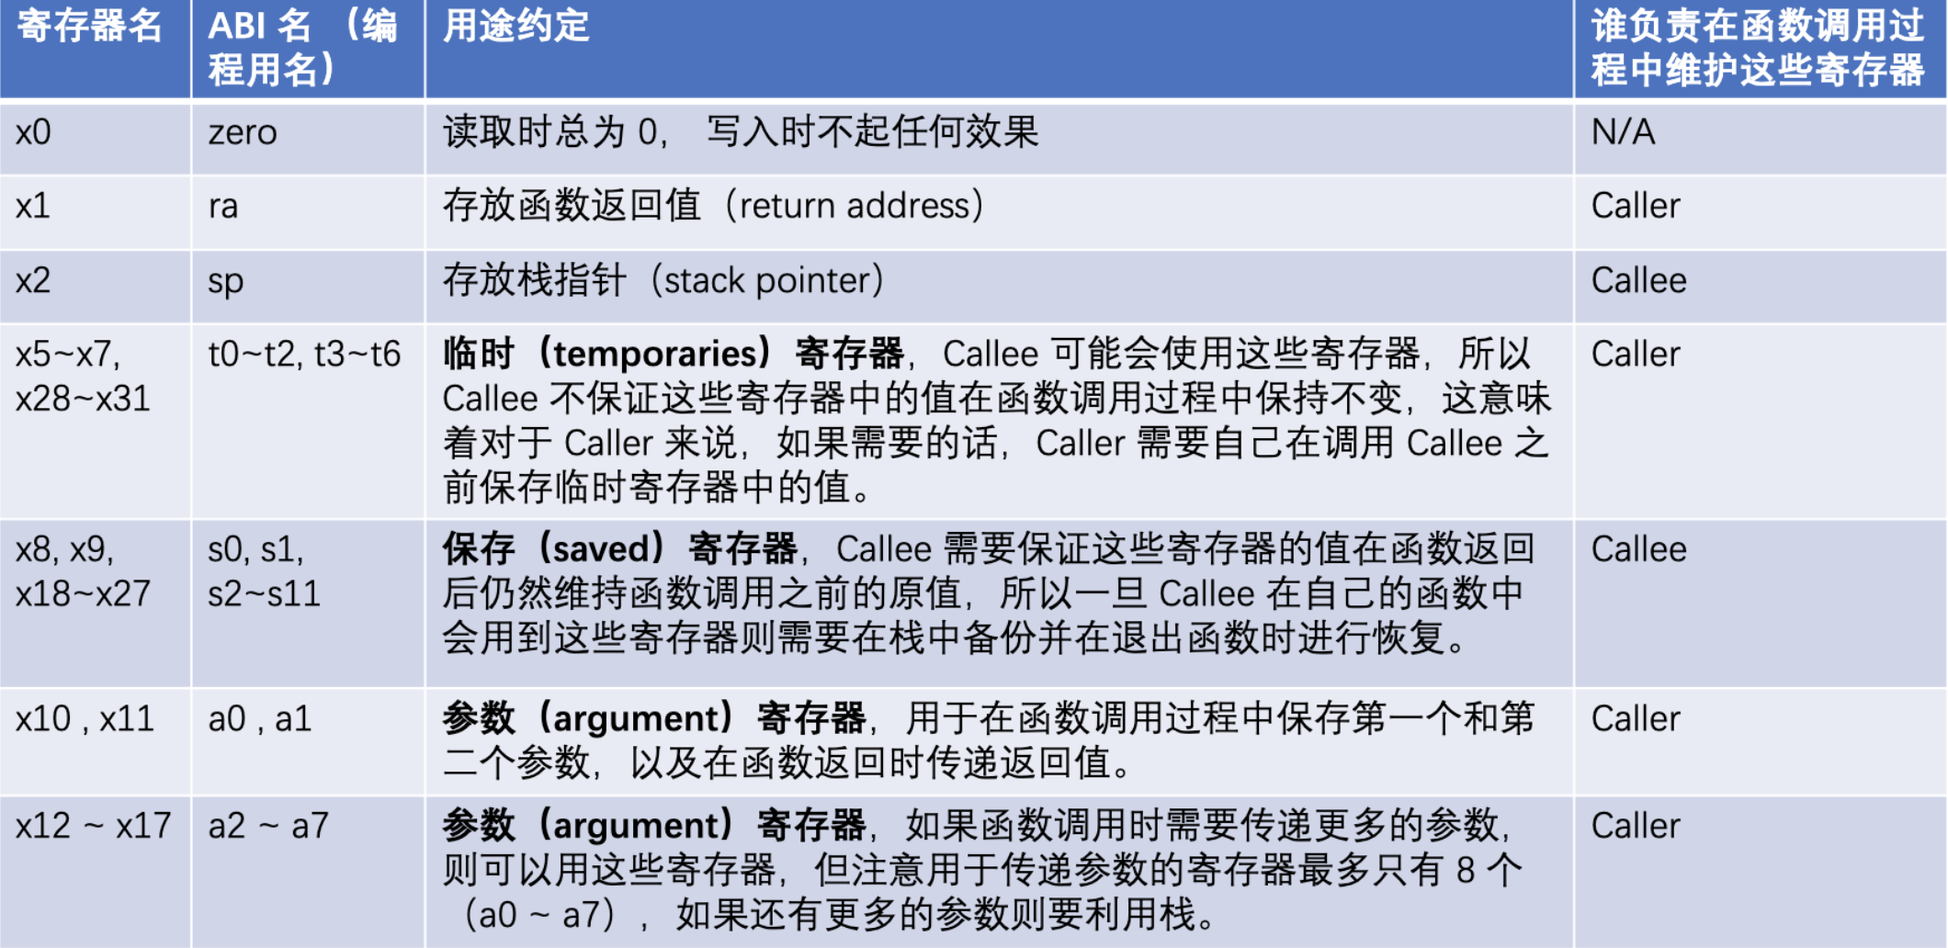

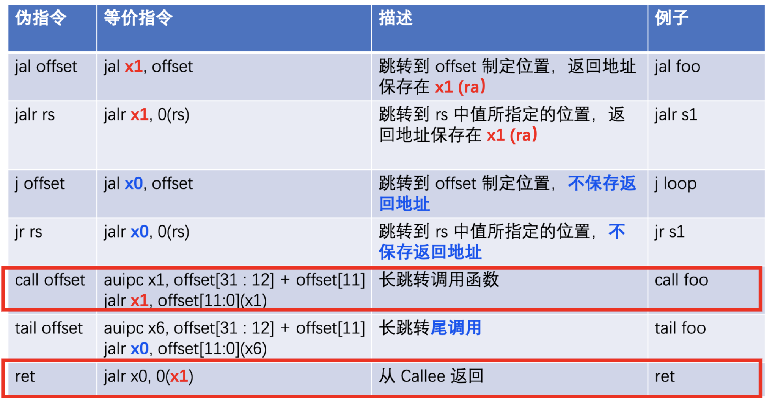

### Registers & Modes

Risc-v Modes

|  |  |
| --- | --- |
| Mode | abbrievation |
| Machine | M |
| Supervisor | S |
| Reserved |  |
| User | U |

Note: 每个mode都有自己一套独立的CSR. Higher level能访问lowe level CSR, 反过来不能.

M-mode Registers

|  |  |  |
| --- | --- | --- |
| Register | Description | Bits |
| Machine Information Registers | | |
| mhartid | the integer ID of hart running the code |  |
| Machine Trap Setup | | |
| mstatus | Controls the hart’s current operating state | MPP // 11( M-mode prior to the trap), 00(U) , 01(S)  MIE // 1(M-mode interrupt enabled), 0(disabled)  PIE // Save MIE bit prior to trap |
| medeleg/ mideleg | Certain **exceptions** and **interrupts** should be processed directly by a lower privilege level(S-mode).  Configure the bits for whatt type of exception/interrupt to be delegated. |  |
| mie | Interrupt-enable register |  |
| mtvec | Trap-handler base address. |  |
| Machine Trap Handling | | |
| mepc | Exception program counter |  |
| mtval | bad address or instruction. |  |
| mip | interrupt pending |  |
| mscratch |  |  |
| mcause |  |  |

S-mode Registers

|  |  |  |
| --- | --- | --- |
| Register | Description |  |
| Supervisor Trap Setup | | |
| sstatus | Status Register | SPP // 1(S-mode prior to the trap), 0(U)  SPIE // Save SIE bit prior to trap  SIE // 1(interrupt enabled), 0(disabled) |
| sie | Interrupt-enable register | SEIE // 1(enable external device interrupt), 0(disable)  STIE // 1(enable timer interrupt), 0(disable)  SSIE // 1(enable software interrupt), 0(disable) |
| stvec | Trap handler base virtual or physical address, depend on satp is set or not | Executed once trapped into S-mode |
| Supervisor Trap Handling | | |
| sscratch | Supervisor Scratch register, for early trap handler in trampoline.S. |  |
| sepc | Exception program counter, holds the  instruction address to which a return from  exception will go. | 当trap into S-mode, sepc is written with the virtual address of the instruction that was interrupted or that encountered the exception. |
| stval | Bad address or instruction. |  |
| sip | Interrupt Pending indicates type of currently pending **interrupts** |  |
| scause |  |  |
| Supervisor Address Protection and Translation | | |
| satp | Holds the physical page number(physical address divided by PAGE_SIZE) of the root page table. | Set 0 to disable virtual address. |

|  |  |  |
| --- | --- | --- |
| instruction | description |  |
| mret | **Lowers** the privilege mode to a mode less privileged than M-mode. |  |
| sret | **Lowers** the hardware privilege level and resumes executing user instructions just after the system call instruction。 |
| ecall | **Raises** the hardware privilege level and changes the program counter to a kernel-defined entry point. | ecall主动触发了一个exception, 所以CPU会raise特权级，然后执行trap handler.  其他的interrupt/exception都是被动的. |
| csrr/  csrw | Read/Write into CSR(control and status registers) |  |

### Traps

|  |  |  |
| --- | --- | --- |
| Traps | Exceptions(Sync) | System call: *ecall instruction* |
| Error: *Illegal instruction…* |
| … |
| Interrupt(Async) |  |

Trap 流程: Hardware Action

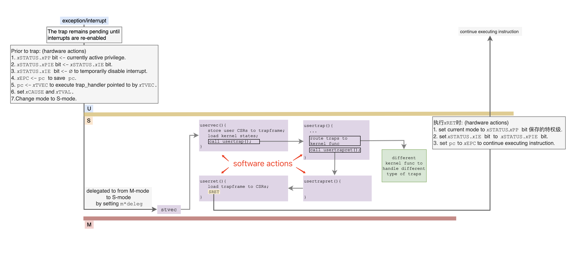

* ONLY TIMER interrupt traps into M-mode and cannot be delegated.

mtvec=timervec; // M-mode trap handler

* All other interrupts are **delegated** to S-mode by writing m*x*deleg.

stvec=uservec(trap_handler in S-mode)

timervec:

# start.c has set up the memory that mscratch points to:

# scratch[0,8,16] : register save area.

# scratch[24] : address of CLINT's MTIMECMP register.

# scratch[32] : desired interval between interrupts.

csrrw a0, mscratch, a0

sd a1, 0(a0)

sd a2, 8(a0)

sd a3, 16(a0)

# schedule the next timer interrupt

# by adding interval to mtimecmp.

ld a1, 24(a0) # CLINT_MTIMECMP(hart)

ld a2, 32(a0) # interval

ld a3, 0(a1)

add a3, a3, a2

sd a3, 0(a1)

**# raise a S-mode software interrupt.**

li a1, 2

csrw sip, a1

ld a3, 16(a0)

ld a2, 8(a0)

ld a1, 0(a0)

csrrw a0, mscratch, a0

mret

Software Action:

struct trapframe {

**#每个proc的trapframe的内核属性都会相同，因为内核只有一个**

/* 0 */ uint64 kernel_satp; // kernel page table

/* 8 */ uint64 kernel_sp; // top of process's kernel stack

/* 16 */ uint64 kernel_trap; // usertrap()

/* 24 */ uint64 epc; // saved user program counter

/* 32 */ uint64 kernel_hartid; // saved kernel tp

**#存储了每个proc的通用寄存器状态，每个proc都不一样**

/* */ uint64 x1-x31; // 31个通用寄存器

};

uservec:

# swap a0 and sscratch:

# a0 points to p->trapframe.

# sscratch now points to user->a0

# p->trapframe <<<=== 31 通用寄存器

# p->trapframe->a0 <<<=== user a0

# sp <<<=== p->trapframe->kernel_sp

# tp <<<=== p->trapframe->kernel_hartid

# satp <<<=== p->trapframe->kernel_satp(kernel page table)

sfence.vma zero, zero

# a0 is no longer valid, since the kernel page table does not specially map p->tf.

# jump to usertrap(), which does not return;

# t0 <<<=== p->trapframe->kernel_trap (usertrap)

jr t0

// handle an interrupt, exception, or system call from user space.

void usertrap(void){

if((r_sstatus() & SSTATUS_SPP) != 0)

panic("usertrap: not from user mode");

// send interrupts and exceptions to kerneltrap(),since we're now in the kernel.

w_stvec((uint64)kernelvec);

// Current epc keep user program counter,

p->trapframe->epc = r_sepc();

uint64 scause = r_scause();

if(scause == 8){

// system call

// sepc points to the ecall instruction, but we want to return to the next instruction.

p->trapframe->epc += 4;

// an interrupt will change sstatus &c registers,

// so don't enable until done with those registers.

intr_on();

syscall();

} else if((scause & 0x8000000000000000L) && (scause & 0xff) == 9){

// this is a supervisor external interrupt, via PLIC.

// irq indicates which device interrupted.

int irq = plic_claim();

if(irq == UART0_IRQ){

uartintr();

} else if(irq == VIRTIO0_IRQ){

virtio_disk_intr();

} else if(irq){

printf("unexpected interrupt irq=%d\n", irq);

}

// the PLIC allows each device to raise at most one

// interrupt at a time; tell the PLIC the device is

// now allowed to interrupt again.

if(irq)

plic_complete(irq);

} else if(scause == 0x8000000000000001L){

// software interrupt from a machine-mode timer interrupt,

// forwarded by timervec in kernelvec.S.

if(cpuid() == 0){

clockintr();

}

// acknowledge the software interrupt by clearing the SSIP bit in sip.

w_sip(r_sip() & ~2);

// give up the CPU if this is a timer interrupt.

yield();

}else {

p->killed = 1;

}

usertrapret();

}

// return to user space

void usertrapret(void){

struct proc *p = myproc();

// we're about to switch the destination of traps from

// kerneltrap() to usertrap(), so turn off interrupts until

// we're back in user space, where usertrap() is correct.

intr_off();

w_stvec(TRAMPOLINE + (uservec - trampoline));

**# 内核状态缓存起来，因为马上要切换到U-mode了**

p->trapframe->kernel_satp = r_satp(); // kernel page table

p->trapframe->kernel_sp = p->kstack + PGSIZE; // process's kernel stack

p->trapframe->kernel_trap = (uint64)usertrap;

p->trapframe->kernel_hartid = r_tp(); // hartid for cpuid()

// set up the registers that trampoline.S's sret will use

// to get to user space.

// set S Previous Privilege mode to User.

unsigned long x = r_sstatus();

x &= ~SSTATUS_SPP; // clear SPP to 0 for user mode

x |= SSTATUS_SPIE; // enable interrupts in user mode

w_sstatus(x);

// set S Exception Program Counter to the saved user pc.

w_sepc(p->trapframe->epc);

// jump to trampoline.S at the top of memory, which

// switches to the user page table, restores user registers,

// and switches to user mode with sret.

uint64 userret_fn = TRAMPOLINE + (userret - trampoline);

((void (*)(uint64,uint64))userret_fn)(TRAPFRAME, MAKE_SATP(p->pagetable););

}

userret:

# switch to the user page table.

# put the saved user a0 in sscratch, so we

# can swap it with our a0 (TRAPFRAME) in the last step.

ld t0, 112(a0)

csrw sscratch, t0

# restore all 通用寄存器 but a0 from TRAPFRAME

# restore user a0, and save TRAPFRAME in sscratch

csrrw a0, sscratch, a0

# return to user mode and user pc.

# usertrapret() set up sstatus and sepc.

**sret**

## Booting

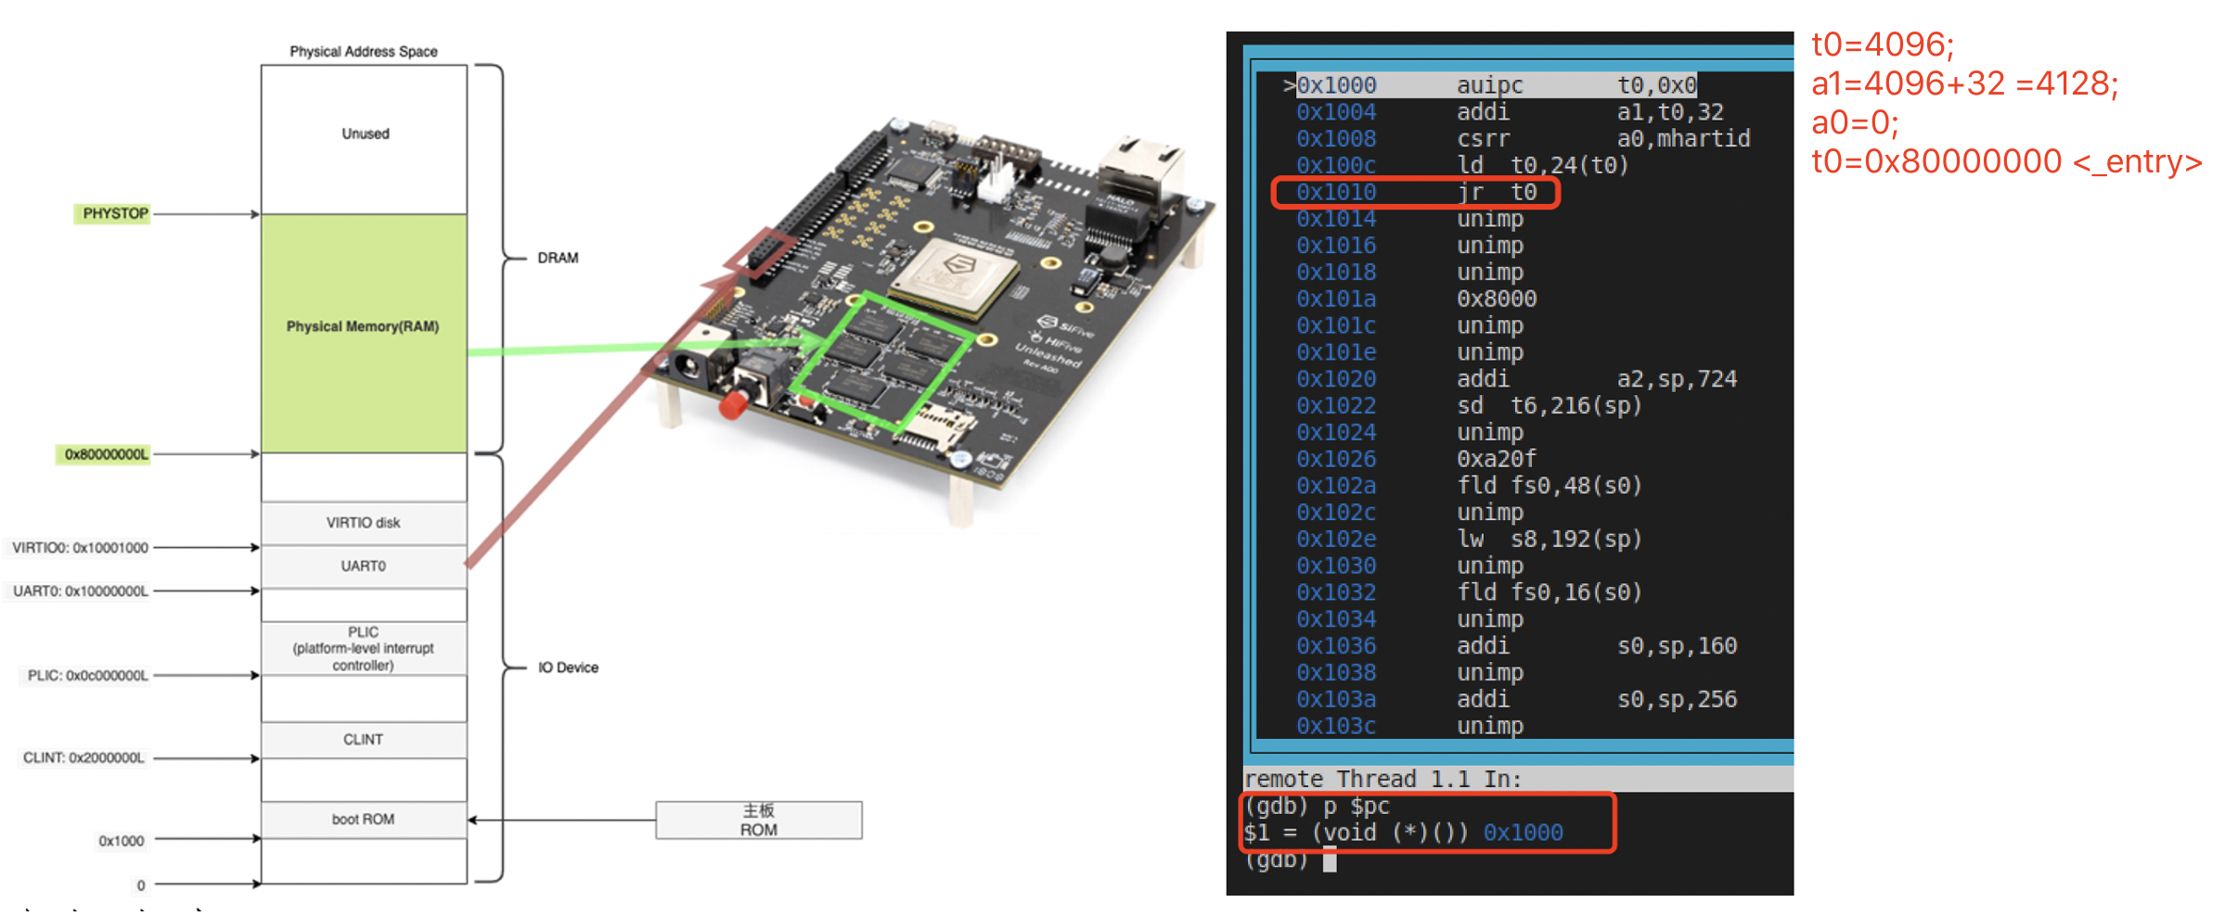

CPU reset => pc=0x1000;

BIOS => Run boot loader to load the OS kernel image into physical memory @ address: 0x80000000<_entry>;(Currently paging is disabled)

# qemu -kernel loads the kernel at 0x80000000

# and causes each CPU to jump there.

# kernel.ld causes the following code to

# be placed at 0x80000000.

.section .text

.global _entry

_entry:

# set up a stack for C program.

# stack0 is declared in start.c, with a 4096-byte stack per CPU.

# sp = stack0 + (hartid * 4096). set stack pointer register.

la sp, stack0

li a0, 1024*4

csrr a1, mhartid

addi a1, a1, 1

mul a0, a0, a1

add sp, sp, a0

call start # jump to start() in start.c

spin:

j spin

start() (M-mode); // set some CSR registers.

* mstatus.MPP=S-mode; // This will allow CPU to go to S-mode when executing mret
* mepc=main; // 当执行mret的时候，run mian() function
* satp=0; // disable paging;
* medeleg=0xffff,mideleg= 0xffff; // delegate all interrupts/exceptions to S-mode.
* sie=SIE_SEIE|SIE_STIE|SIE_SSIE; // enable external, timer, software interrupts
* pmpaddr0=0x3fffffffffffffull, pmpcfg0=0xf ; // physical memory protection
* initialize timer interrupts
  + w_mscratch;
  + mtvec=timervec; // set the M-mode timer trap handler, because only timer interrupt

// cannot be delegated into S-mode directly by hardware, so use // software to forward it to S-mode

* + mstatus=r_mstatus()|MSTATUS_MIE; // enable M-mode interrupts.
  + mie=r_mie()|MIE_MTIE; //enable M-mode timer interrupt.
* tp=mhartid;
* asm volatile("mret");// 1.CPU mode change to MPP=S-mode; 2.执行epc指向的main;`

main(): (S-mode)

* initialize several devices and subsystems;
  + console, printf;
  + satp=kernel_pagetable for each hart;// open paging by setting kernel pagetable to satp
  + initialize proc[NPROC];
  + install kernel trap vector for each hart: stvec=kernelvec;
  + filesystem, inode…
  + call userinit(); // init first user process:
* userinit()
  + p = allocproc(); // creates the first user process.
* ...
* p->context.ra = (uint64)forkret; // Run forkret after context switch

// finished (i.e. executing ret), 也就是

说每当context switch，轮到一个user process运行的时候，它做的第一件事就是返回用户态.

* p->context.sp = p->kstack + PGSIZE;
  + set initcode into 0 of p->pagetable;
  + p->trapframe->epc=0; // 这两个组合起来就是把epc指向initcode,只不过这

// 里用的是虚拟地址。

* + p->trapframe->sp=PGSIZE;
* scheduler():
  + switch from current CPU context(CSR states) to first_proc->context:
    - current CPU context => mycpu()->context;
    - first_proc->context => current CPU context;
    - (function call) RET, 执行ra=forkret,然后执行usertrapret,最后执行userret->sret返回U-mode.
  + 执行initcode -> exec("/init").

## System Call

### Run executable in Shell

用户程序保存在磁盘上，最终通过shell script / GUI operation(*shell和GUI 本质上都是一个进程，它是一个无限循环，不断监听用户输入.*)

如果监听到执行一个程序(比如双击icon 或者在terminal 执行一个command)，那么就会fork()一个子进程，然后在子进程中 invoke system call: int exec(char*, char**);

U-mode：用户程序只能访问通用寄存器和进程的地址空间。假定用户程序总是恶意的，不可靠的。

S-mode：内核程序可以访问全部寄存器和全部地址空间。假定内核代码总是安全的，可靠的。

### System Call

System call本质上是通过代码执行ECALL指令，然后主动陷入S-mode.过程跟中断/异常相同.

**重要：**首先在U mode中执行ECALL时, CPU从U->S, 接着CPU执行stvec register保存的trap handler指针uservec. (defined in trampoline.S).

但有一个问题: 执行ECALL指令之后，CPU**不会自动**switch from user page table into kernel user table(by loading the user page table base addr into satp register)，并且ECALL之前处于U- mode，是无法操作satp register的。

也就是说：执行ECALL陷入S-mode，此时仍然是user page table. 开始执行trap handler (uservec), 在uservec中切换到S页表。为保证切换到S页表之后uservec中的指令可以继续执行，必须保证在U和S中有相同的虚拟地址映射到trampoline.S

## Paging

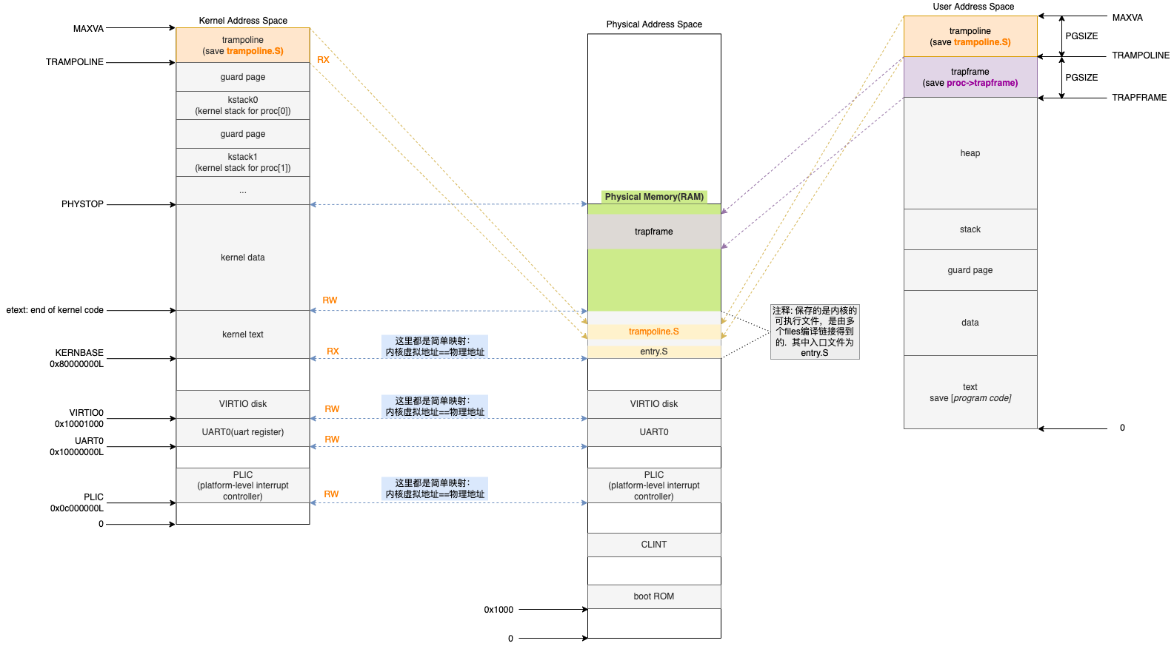

Figure 1. Memory Layout

user address space和pa通过proc page table(每个proc一个)来映射，而kernel addres space(整个kernel只有一个)和pa 通过kernel page table 来映射。

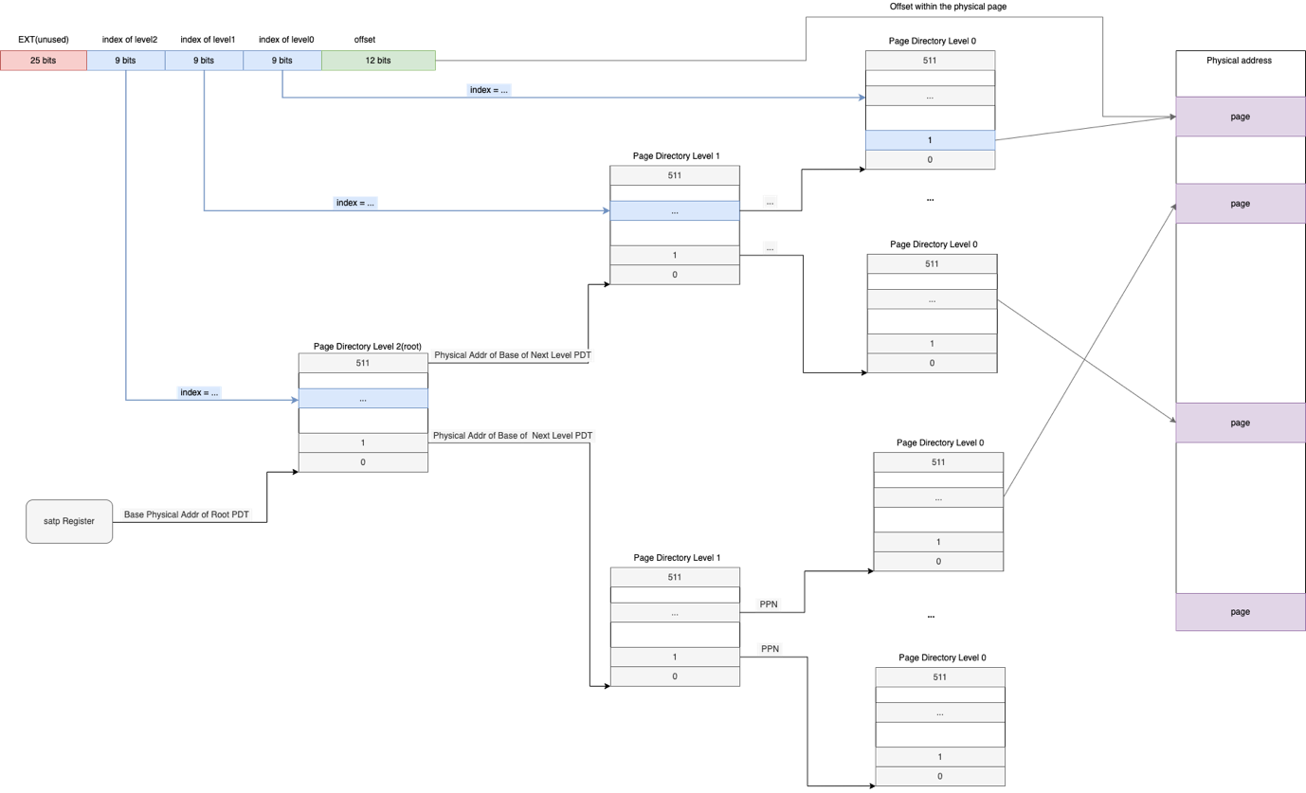

Figure 2. Multiple Level Page Table

satp指向Physical Page Number (Physical address / PAGE_SIZE) of root page table.

虚拟地址空间 ------> (多级)页表 --------> 物理地址空间

process进程结构体中的pagetable_t保存的是root page table的起始物理页框号(PFN)。

每个page table占一个physical page(4Kb), 包含512个entry, 每个entry指向下级页表的起始物理地址，size = sizeof(uint64) = 64 bit = 8byte, 那么512*8byte = 4Kb. 刚好占满一个物理page。

- 创建process的时候，只会创建一个root page table; 其他level的page table是需要的. 时候再创建(walk());

- Mapping TRAMPOLINE(va) => trampoline(pa), TRAPFRAME => p->trapframe(pa).

Note: 此时树形页表中有许多的空洞，也就说许多的pte还未指向任何下级page table. 这就是多级页表的好处，对不连续的虚拟地址可以节省空间。

- 如果进程需要内存时，分配一个虚拟地址(页对齐)和物理页，然后建立映射。可优化使用lazy page allocation, 当需要的时候才分配物理页+建立映射关系，不然只分配给一个虚拟地址。

Note: 为简化内存管理，我们做了一些tradeoff. 浪费一些storage efficiency， 从而简化了内存管理算法。比如需要分配的内存空间小于<PGSIZE, 那么我们也给他分配一个PGSIZE, 可能他用不完，会造成浪费。

pte_t*

walk(pagetable_t pagetable, uint64 va, int alloc)

{

if(va >= MAXVA)

panic("walk");

for(int level = 2; level > 0; level--) {

pte_t *pte = &pagetable[PX(level, va)];

if(*pte & PTE_V) {

pagetable = (pagetable_t)PTE2PA(*pte);

// 此时pagetable指向了下级页表的base phy addr, 原则上这里是不允许使用物理地址的，因为此时

// paging is enabled, 但是由于内核空间跟物理空间是平行映射(物理地址=虚拟地址)，所以不

// 用做转换也可以.

} else {

if(!alloc || (pagetable = (pde_t*)kalloc()) == 0)

return 0;

memset(pagetable, 0, PGSIZE);

*pte = PA2PTE(pagetable) | PTE_V;

}

}

return &pagetable[PX(0, va)];

}

### Speed up syscall

可以让用户进程地址空间的一个page和内核空间的一个page 共同映射到同一个物理page.

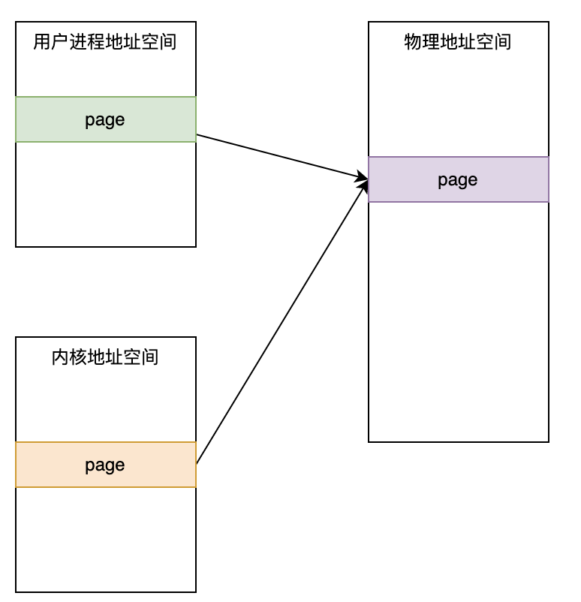

**好处：**用户进程可以直接通过自己的地址空间访问对应的物理页；

如果没有这样的映射的话，要访问**物理page**的话, 需要先从用户态陷入内核态，然后通过内核程序将数据copy out from kernel to user space，最后切换回用户态，由用户程序再通过虚拟地址访问物理页。

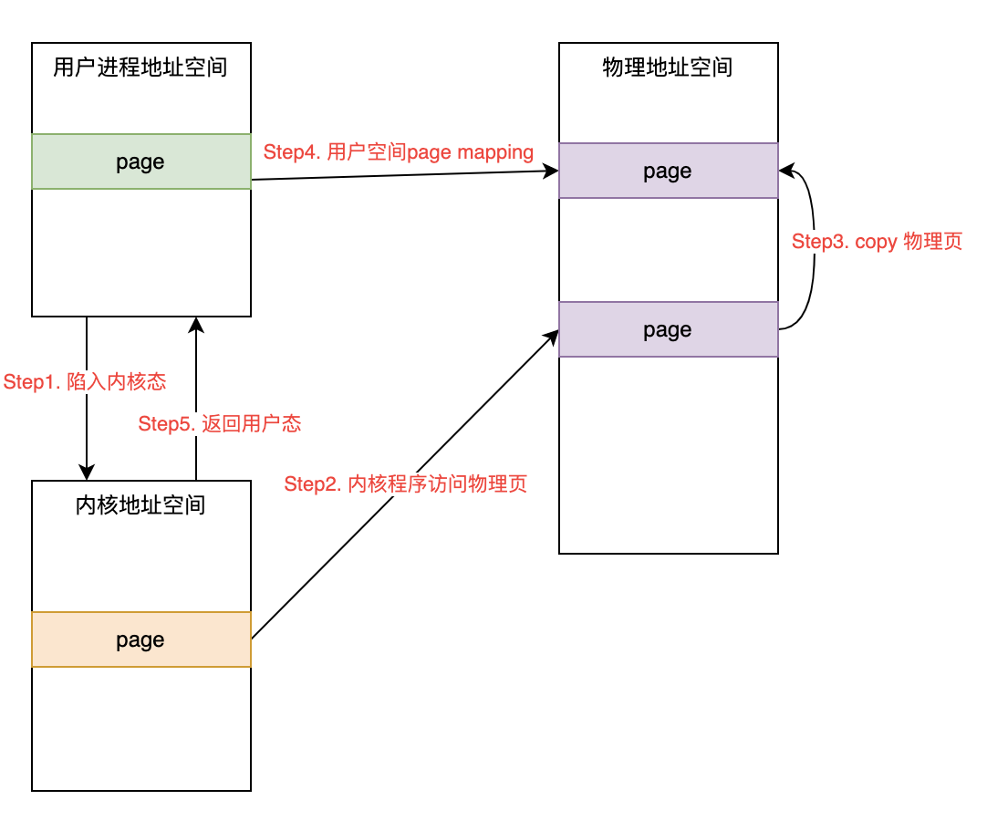

内核创建进程的流程：

fork()->

allocproc()->

proc_pagetable()-> //allocate user space page table for process

# 到了这里就已经知道了进程的pid了和user space page table.

# 那么需要将pid所在的物理内存找到，并建立它与 process 指定虚拟地址的映射.

freefork()->

free the user spance page mapped into pid

### COW fork

当fork一个child process的时候，kernel并不会立刻给child分配physical memory, 而是让parent 和child 的虚拟地址空间指向同一个块physical memory, 并且把该physical memory设置为readonly. (clear PTE_W)

当parent 或child需要向写入的时候，由于对应pte缺少PTE_W, 所以CPU会产生page fault exception, 然后陷入usertrap().

这时候再分配新的物理页并建立page table映射关系.

scause for page fault

|  |  |  |
| --- | --- | --- |
| type | cause | scuase code |
| load page faults | when a load instruction cannot translate its virtual address | 13 |
| store page faults | a store instruction cannot translate its virtual address | 15 |
| instruction page faults | the address in the program counter doesn’t translate | 12 |

* The scause register indicates the type of the page fault;
* The stval register contains the bad address that couldn’t be translated.

## Thread

switch from shell (proc 1) to cat(proc 2):

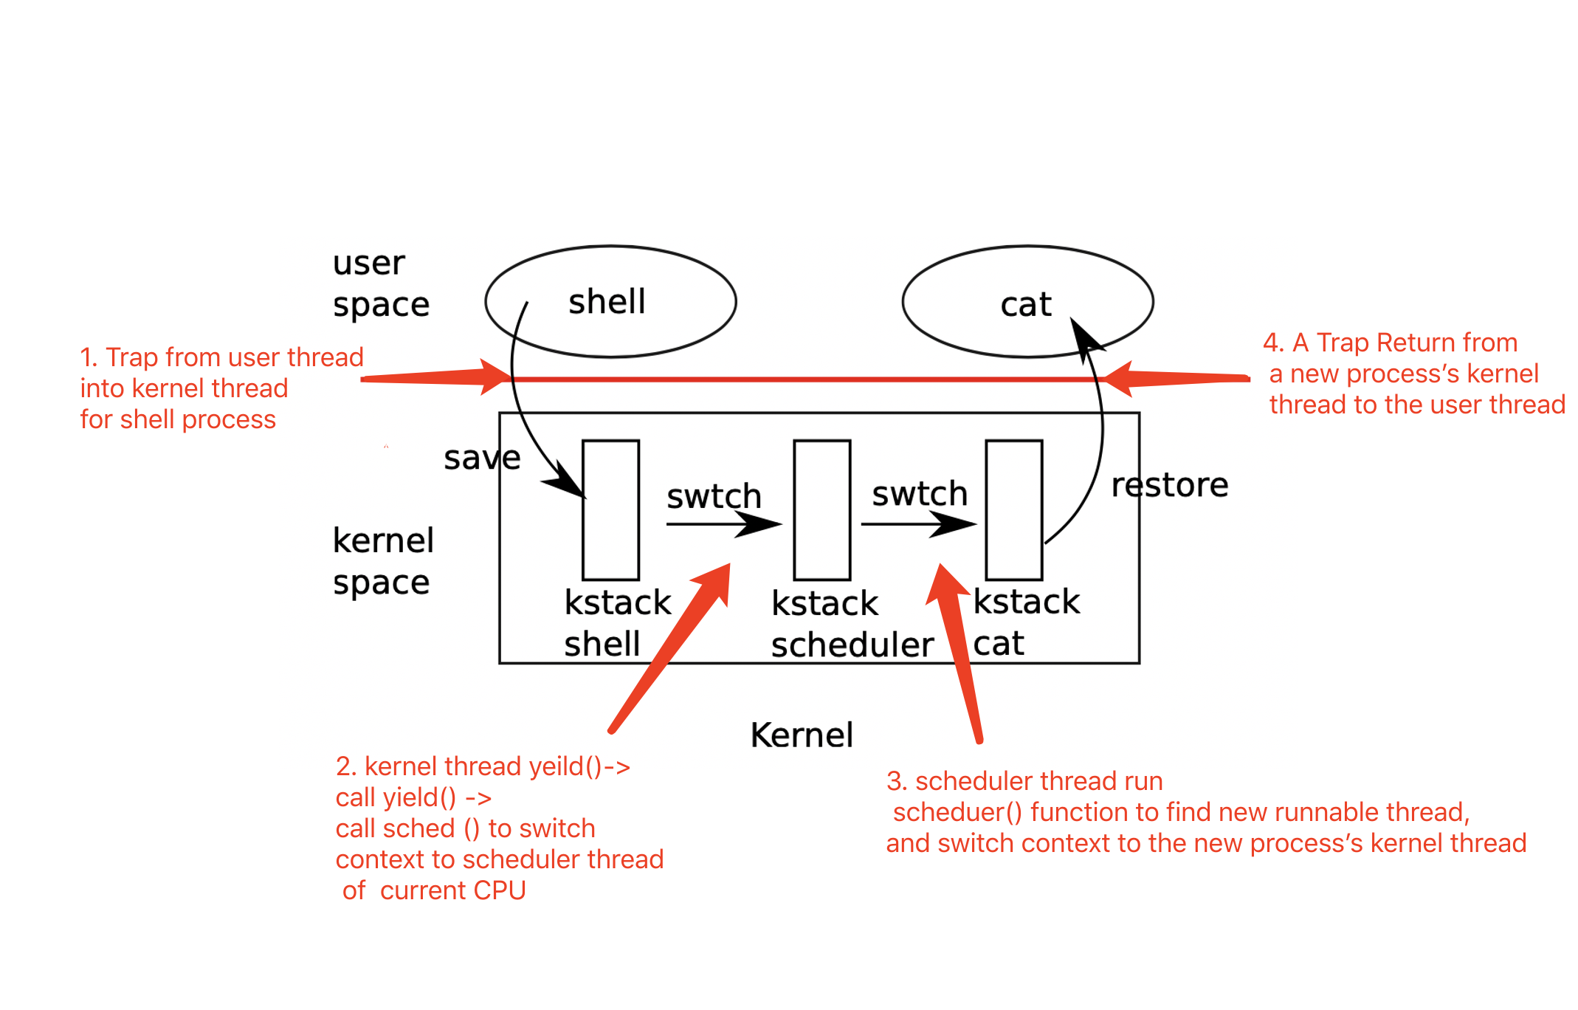

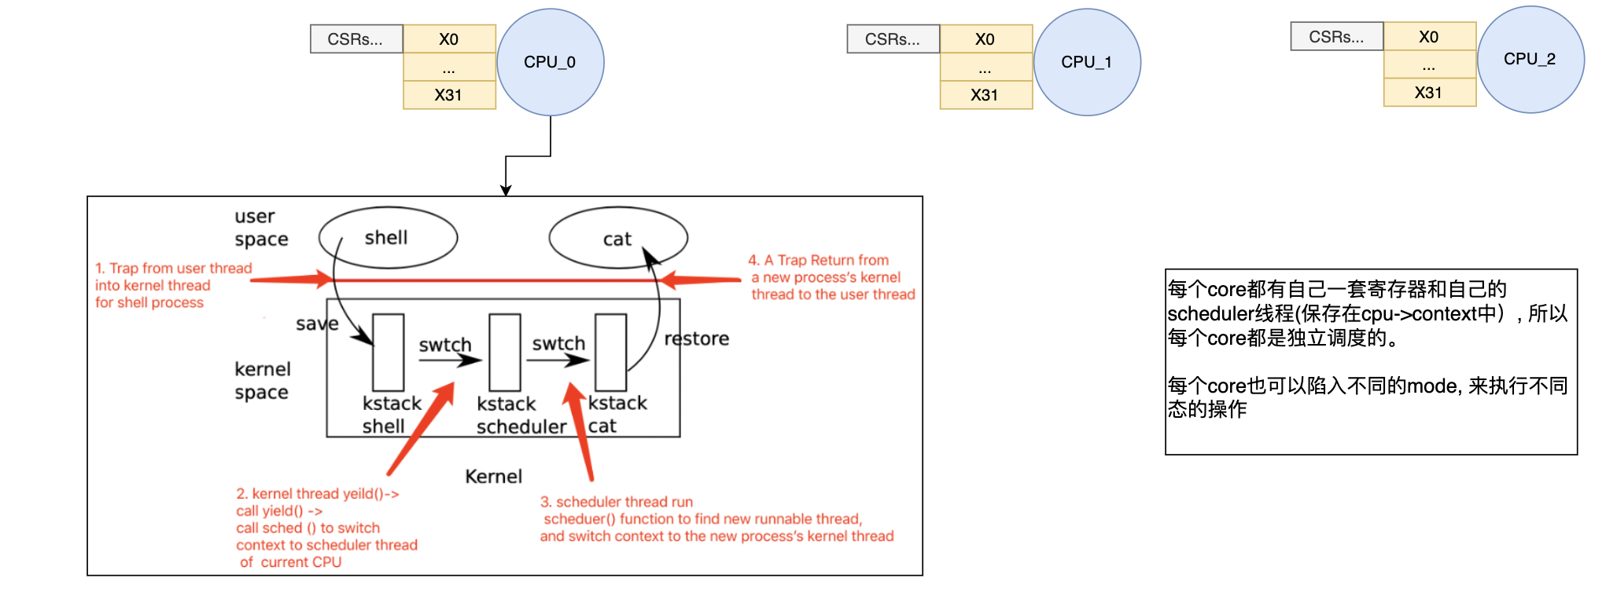

Kernel CSR states被保存在每个进程instance的trapframe中

struct trapframe {

/* 0 */ uint64 kernel_satp; // satp: kernel page table

/* 8 */ uint64 kernel_sp; // sp: top of process's kernel stack

/* 16 */ uint64 kernel_trap; // stvec: usertrap()

/* 24 */ uint64 epc; // sepc: saved user program counter

/* 32 */ uint64 kernel_hartid; // tp: saved kernel tp

/*40~280*/ uint64 x1~x31; // user proc 31个通用寄存器

};

// Saved registers for kernel context switches.

struct context {

uint64 ra;

uint64 sp;

// callee-saved

uint64 s0;

uint64 s1;

uint64 s2;

uint64 s3;

uint64 s4;

uint64 s5;

uint64 s6;

uint64 s7;

uint64 s8;

uint64 s9;

uint64 s10;

uint64 s11;

};

struct **proc** {

struct spinlock lock;

enum procstate state; // Process state

void *chan; // If non-zero, sleeping on chan

int killed; // If non-zero, have been killed

int xstate; // Exit status to be returned to parent's wait

int pid; // Process ID

struct proc *parent; // Parent process

// 这里kstack和context两个属性封装在一起相当于一个内核线程. 等于说每个用户进程都有一个内核线程。

// 线程和进程都是逻辑概念，只不过对多个属性的一个封装而已

uint64 kstack; // Virtual address of kernel stack, 每个进程在内核空间都有一个栈

struct context context; // swtch() here to run process. 表示进程的内核态线程的context.

// 这里相当于是user thread对应的context, 每次从用户线程切换到内核线程时，CPU状态被保存在这里。

struct trapframe *trapframe;

uint64 sz; // Size of process memory (bytes)

pagetable_t pagetable; // User page table

struct file *ofile[NOFILE]; // Open files

struct inode *cwd; // Current directory

char name[16]; // Process name (debugging)

};

// Per-CPU hart state.

struct cpu {

struct proc *proc; // The process running on this cpu, or null.

struct context context; // swtch() here to enter scheduler(),保存的是scheduler的context

int noff; // Depth of push_off() nesting.

int intena; // Were interrupts enabled before push_off()?

};

// Thread

struct thread {

char stack[STACK_SIZE]; /* the thread's stack */

int state; /* FREE, RUNNING, RUNNABLE */

struct context context;

};

**进程的本质就是：一个状态机(包括堆栈和寄存器状态), 它每执行一条指令就相当于从一组状态transite到另一组状态。**

一个process同时只能在一个CPU hart上运行，为了提高一个process内部的并行度，就有了thread。一个process中包含多个threads，多个threads共享了process的text/data/heap段。

thread也是一个逻辑概念，它只不过是**运行指令所需的一组CPU寄存器状态和stack**组成的数据结构。因为一个CPU core在不同的线程之间切换，本质上是一组寄存器状态的切换(包含了pc, sp, …寄存器, 对于sp所指向的stack也需要一并切换), 所以保存这些寄存器的状态就可以得到一个线程确定的状态。每次switch from的时候，把这些状态给store into (内存中的)context结构体； switch into的时候，再load (内存中的)context into a set of registers.

## Concurrency

### Multi-threads Issue

Multi-threads share some process resources(data/heap segament), which are called critical section.

### Spin Lock

// Mutual exclusion lock.

struct spinlock {

uint locked; // Is the lock held?

// For debugging:

char *name; // Name of lock.

struct cpu *cpu; // The cpu holding the lock.

};

asm volatile(“amoswap r, a”); // amoswap atomically swap/exchage value between register r and memory a. It performs this sequence atomically, using special hardware to prevent any other CPU from using the memory address between the read and the write.

// Acquire the lock.

// Loops (spins) until the lock is acquired.

void acquire(struct spinlock *lk){

push_off(); // disable interrupts to avoid deadlock.

if(holding(lk))

panic("acquire");

// On RISC-V, sync_lock_test_and_set turns into an atomic swap:

// a5 = 1

// s1 = &lk->locked

// amoswap.w.aq a5, a5, (s1)

while(__sync_lock_test_and_set(&lk->locked, 1) != 0)

;

// Tell the C compiler and the processor to not move loads or stores

// past this point, to ensure that the critical section's memory

// references happen strictly after the lock is acquired.

// On RISC-V, this emits a fence instruction.

__sync_synchronize();

// Record info about lock acquisition for holding() and debugging.

lk->cpu = mycpu();

}

// Release the lock.

void

release(struct spinlock *lk)

{

if(!holding(lk))

panic("release");

lk->cpu = 0;

// Tell the C compiler and the CPU to not move loads or stores

// past this point, to ensure that all the stores in the critical

// section are visible to other CPUs before the lock is released,

// and that loads in the critical section occur strictly before

// the lock is released.

// On RISC-V, this emits a fence instruction.

__sync_synchronize();

// Release the lock, equivalent to lk->locked = 0.

// This code doesn't use a C assignment, since the C standard

// implies that an assignment might be implemented with

// multiple store instructions.

// On RISC-V, sync_lock_release turns into an atomic swap:

// s1 = &lk->locked

// amoswap.w zero, zero, (s1)

__sync_lock_release(&lk->locked);

pop_off();

}

### Sleep locks

// Long-term locks for processes

struct sleeplock {

uint locked; // Is the lock held?

struct spinlock lk; // spinlock protecting this **locked** field

// For debugging:

char *name; // Name of lock.

int pid; // Process holding lock

};

void

acquiresleep(struct sleeplock *lk)

{

acquire(&lk->lk);

while (lk->locked) {

sleep(lk, &lk->lk); //yeild CPU and be switched out.

}

lk->locked = 1;

lk->pid = myproc()->pid;

release(&lk->lk);

}

void

releasesleep(struct sleeplock *lk)

{

acquire(&lk->lk);

lk->locked = 0;

lk->pid = 0;

wakeup(lk);

release(&lk->lk);

}

int

holdingsleep(struct sleeplock *lk)

{

int r;

acquire(&lk->lk);

r = lk->locked && (lk->pid == myproc()->pid);

release(&lk->lk);

return r;

}

## IO Device

## Interrupts & Device Driver

scause register

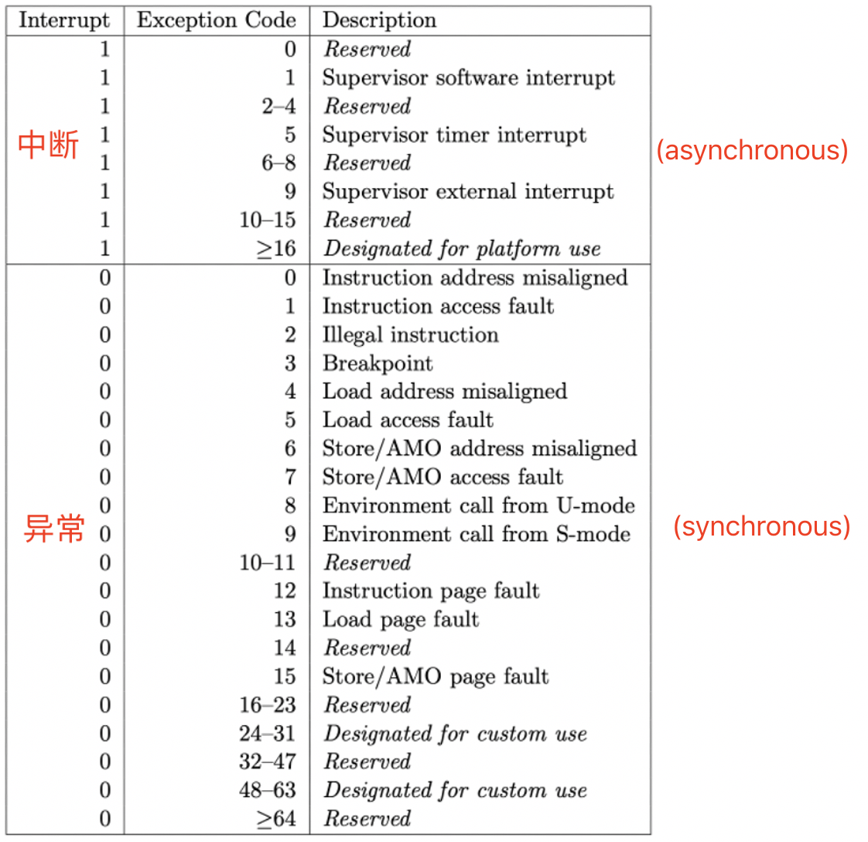

### Memory mapped IO (MMIO)

There are some physical addresses that RISC-V hardware connects to the UART device, so that loads and stores interact with the device hardware rather than RAM.

编程是通过memory mapped I/O完成的。操作系统需要知道这些设备位于物理地址空间的具体位置，然后再通过普通的load/store指令对这些地址进行编程。load/store指令实际上的工作就是读写设备的控制寄存器。例如，对网卡执行store指令时，CPU会修改网卡的某个控制寄存器，进而导致网卡发送一个packet。所以这里的load/store指令不会读写内存，而是会操作设备。

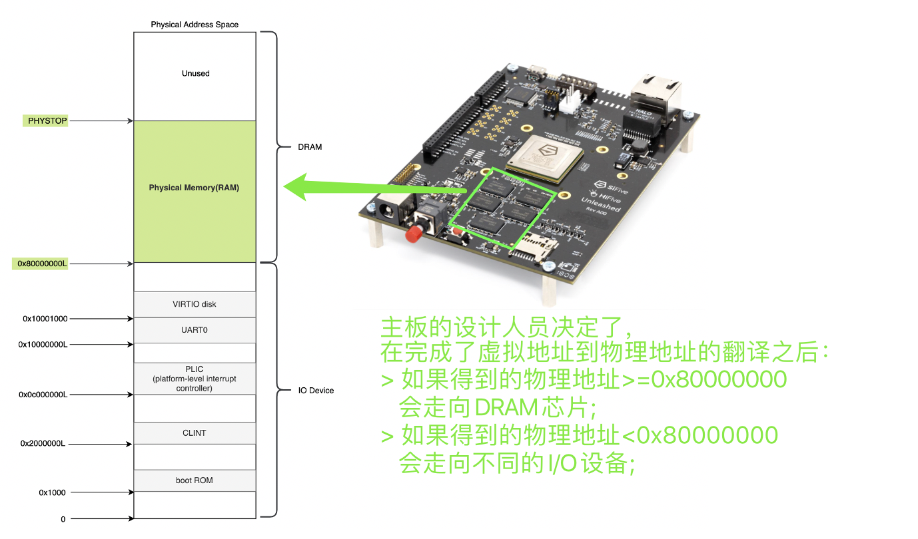

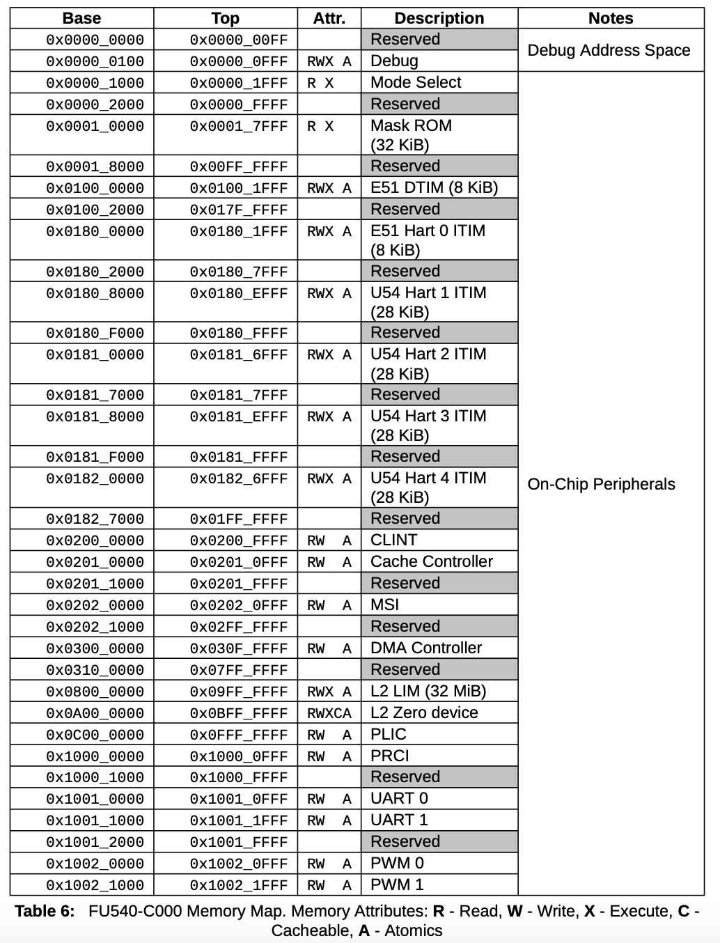 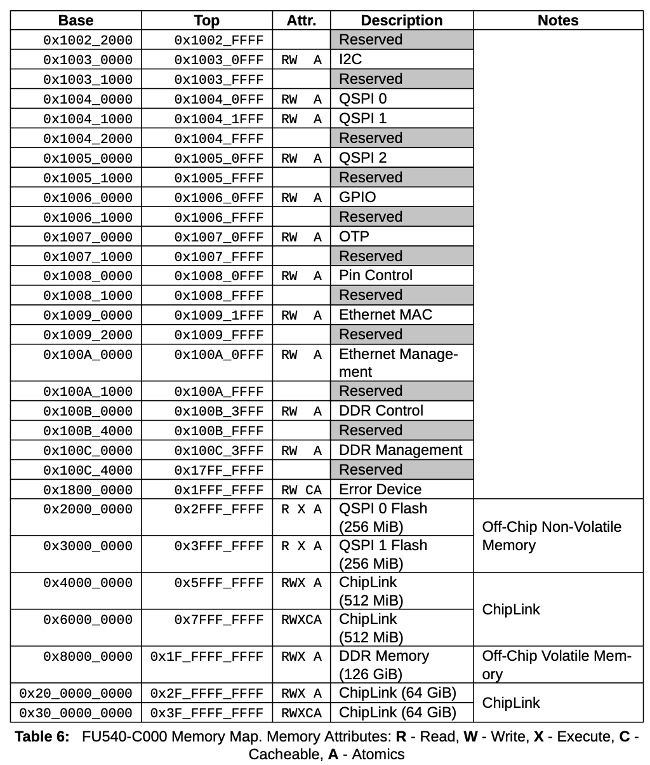

所有的设备都连接到CPU，通过PLIC(Platform Level Interrupt Control)来处理设备中断。PLIC会管理来自于外设的中断。

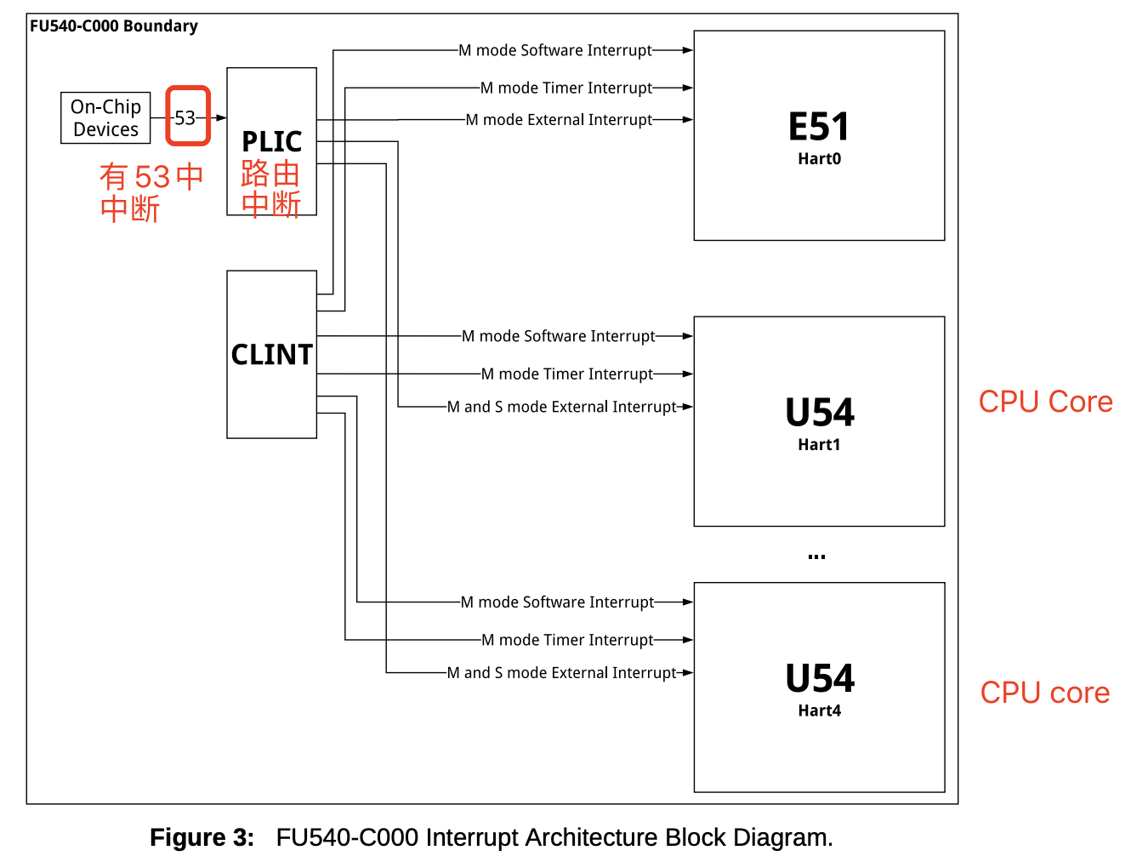

启动Device和PLIC流程：

* Devices initialization: Device (controller registers) initialization通过调用driver的方法.
* PLIC initialization:
  + Enable PLIC需要响应的中断号, 比如UART0_IRQ和VIRTIO0_IRQ
  + PLIC配置可以把哪些中断号路由到哪些CPU code.
  + 每个CPU core本身要enable S-mode interrupt:

w_sstatus(r_sstatus() | SSTATUS_SIE).

外部中断处理的具体流程：

* Device 产生一个中断，然后通知PLIC;
* PLIC会通知当前有一个待处理的中断;
* 其中一个CPU核会Claim接收中断，这样PLIC就不会把中断发给其他的CPU处理;
* CPU核处理完中断之后，CPU会通知PLIC;
* PLIC将不再保存中断的信息.

### UART

UART设备用来与Keyboard和Console(显示设备)进行交互。UART 和Keyboard连接，也和 Console连接。

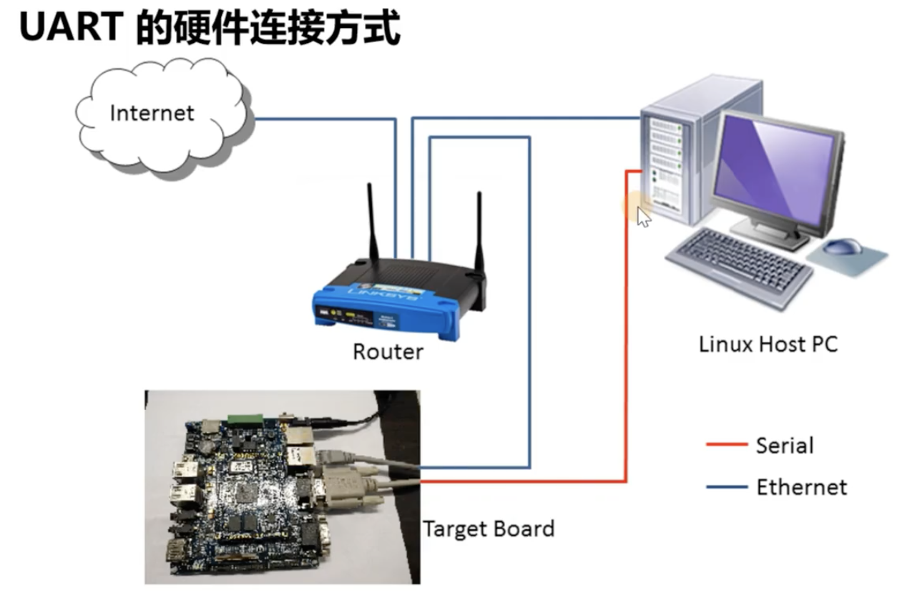

#### User process => Console

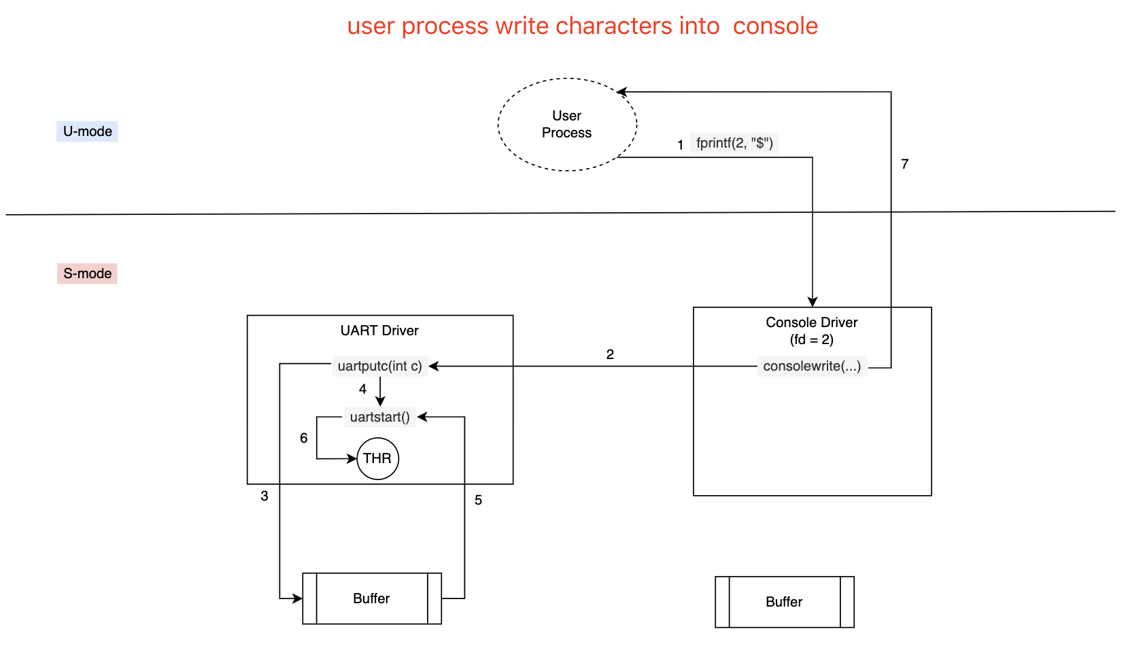

A general pattern to note is the decoupling of **process activity** from **device activity** via **buffering** and **interrupts**. Processes can send output (step.1~6) without having to wait for the device.

This decoupling can increase performance by allowing processes to execute concurrently with device I/O, and is particularly important when the device is slow (as with the UART) or needs immediate attention (as with echoing typed characters). This idea is sometimes called *I/O concurrency*.

#### Keyboard => Console => User Process

用户从keyboard输入一个字符，会触发一个外部中断，中断号为UART0_IRQ. 于是调用中断处理函数：uartint()

// handle a uart interrupt, raised because input has

// arrived, or the uart is ready for more output, or

// both. called from trap.c.

void uartintr(void){

// 首先尝试逐个从RHR寄存器中读取字符，然后把字符传入consoleintr(), 他负责对传入字符进行二次处理：比

// 如分行等

while(1){

int c = uartgetc();

if(c == -1)

break;

consoleintr(c);

}

// 读取处理完之后再处理传输

acquire(&uart_tx_lock);

// 每调用一次uartstart，会把buf中的字符全部逐个写入THR寄存器中

uartstart();

release(&uart_tx_lock);

}

### Network Device

U-mode:

write(socket_fd, buf, size)->

S-mode:

network_driver: write(packet);

//这里通过读写寄存器来实现数据传输; user proc会call sleep()等待数据传输完成, sleep 会让出CPU资源从而被挂起。等传输成功后，driver会发送中断给CPU. CPU收到中断后调用driver的interrupt handler， 它会double check是否完成传输, 如果完成了再唤醒user proc. 从user 空间来看，它调用write()之后被阻塞(看起来被freeze了)，直到传输完成被唤醒.

另一种方式是非阻塞方式：user proc并不会sleep()等待driver 完成数据传输，而是直接返回。

比如epoll的方式：是在user proc和driver之间加入一个中间环节epoll, 它在内核中替user proc和driver打交道，keep monitoring the status update of interested (open) fds. 这样就解放了user proc, 使它不用sleep(), 还可以继续执行其他指令。

## File System

### Concepts

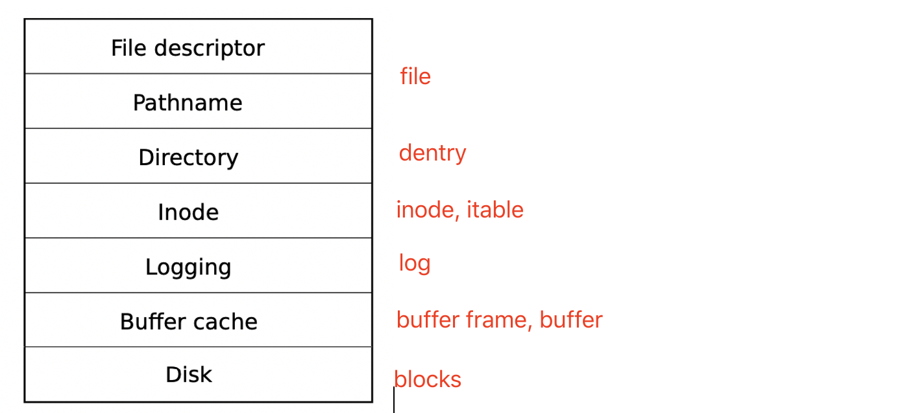

#### Blocks

blocks: 将磁盘看做一个block数组，它的布局如下：

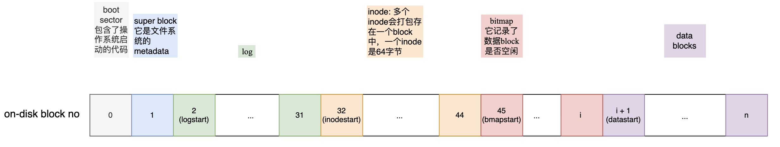

Liang: 注意这里的block no是device driver能识别的block no.

一个block=1024 byte = 1024 * 8 bit = 8192 bit. 也就是说一个bitmap block能管理8192个blocks. 所以假定由N个data blocks, 则需要N / 8192个blocks for bitmap.

#### Buffer Cache

(1) synchronize access to disk blocks to ensure that only one copy of a block is in memory and that only one kernel thread at a time uses that copy;

(2) cache popular blocks so that they don’t need to be re-read from the slow disk.

// in-memory buffer frame, one for one block

struct buf{

    uint data[BSIZE]; // byte array of size BSIZE = 1024  
    lock* lock;

    int ref; // reference count

    int blockno; // on-disk block number recognized by device driver

    buf *prev;

    buf *next;

}

struct {

struct spinlock lock;

struct buf buf[NBUF];

struct buf head; //dummy head, buffer frames are oragnaized as cyclic doubly linkedlist.

} bcache;

buf* bread(int dev, int blockno){

buf* b;

// get target buf of `blockno` from buffer cache, allocate one if not exist;

b = bget(dev, blockno);

if (b) return b;

else: virtio_disk_rw(b, 0); //read block from disk, api from disk driver

}

// write buffer into disk block

uint bwrite(buf* b){

virtio_disk_rw(b, 1);

}

#### Inode

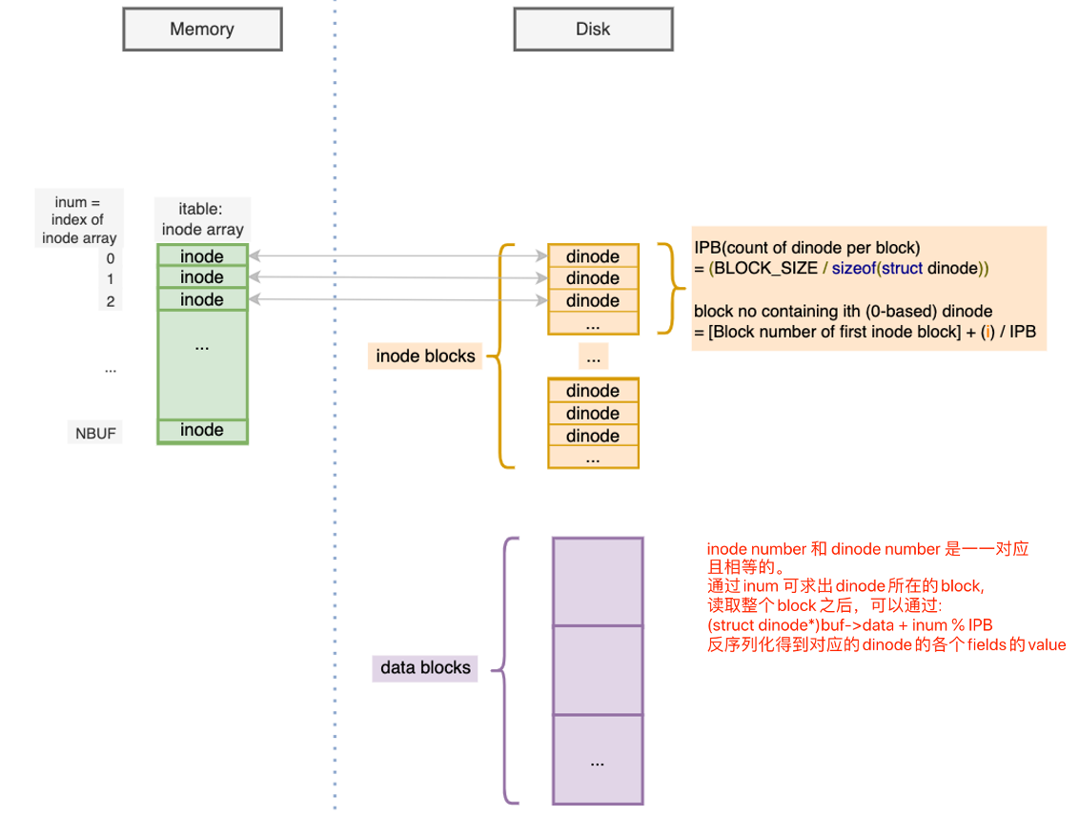

//in-memory inode struct

struct inode {

uint dev; // Device number

uint inum; // Inode number, id of the node

int ref; // Reference count

struct sleeplock lock; // protects everything below here

int valid; // inode has been read from disk?

short type; // 1: Directory; 2: File; 3: Device

short major; // Major device number (T_DEVICE only)

short minor; // Minor device number (T_DEVICE only)

short nlink; // number of links to inode in FS

uint size; // size of inode (in bytes)

// NDIRECT direct blocks and one indirect block.

// mapping from contiguous logical blockno, which is index of array, into physical blockno

// on disk

uint addrs[NDIRECT+1];

};

struct {

struct spinlock lock;

struct inode inode[NINODE]; // (logical) inum is the index of inode array

} itable; // in-memory inode cache

// On-disk inode structure(只保存了一部分inode fields)

struct dinode {

short type;

short major;

short minor;

short nlink;

uint size;

uint addrs[NDIRECT+1];

};

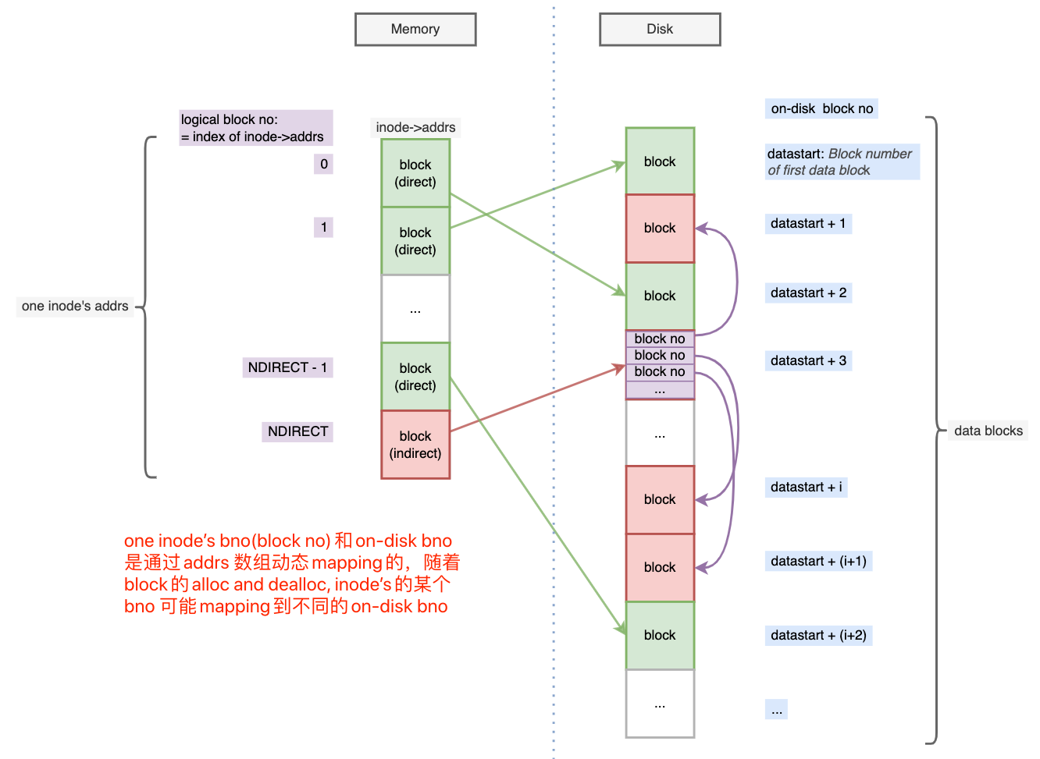

Liang: 文件的存储空间在逻辑上是一个连续的字节数组 => 逻辑上连续的blocks(inode->addrs) => 磁盘上不连续的blocks. (这里的思想跟页表类似).

对磁盘来说block上保存的都是byte array, 它不知道byte array的含义，由上层来负责deserialize bytes into struct.

计算：一个inode占用的count of data blocks:

NDIRECT + BLOCK_SIZE / sizeof(block no) = 12 + 1024 / 4 = 268.

// map (contiguous) logical blockno into on-disk blockno(create one if not yet allocated)

uint bmap(int dev, int blockno){

uint pblockno; //on-disk block no to return

if (blockno < NDIRECT){

if ((pblockno = ip->addrs[blockno]) == 0){

// logical bno not yet mapped into an on-disk block

pblockno = ip->addrs[blockno] = balloc(); //allocate a disk block using block bitmap

}

return pblockno;

}

// direct blocks used up, so try indirect blocks

blockno -= NDIRECT; //indirect blockno start from 0

if (blockno >= NINDIRECT){ // NINDIRECT = BSIZE / sizeof(uint)

panic("bmap: out of range ");

}

if (ip->addrs[NDIRECT] == 0){ // indirect block not yet allocated

ip->addrs[NDIRECT] = balloc();

}

buf* b = bread(dev, ip->addrs[NDIRECT]); // read indirect root block into memory

if ((pblockno = b->data[blockno]) == 0){

pblockno = b->data[blockno] = balloc();

}

return pblockno;

}

// Read data from inode->addrs. Caller must hold ip->lock.

// Return number of bytes read.

// If user_dst==1, then dst is a user virtual address; otherwise, dst is a kernel address.

// read `n` bytes start from `off`.

int readi(struct inode *ip, int user_dst, uint64 dst, uint off, uint n)

{

// read all blocks referenced by inode in the range [off, off + n) bytes

uint tot; // total number of bytes actually read

uint m; // number of bytes read in each loop

for (tot=0; tot < n; tot += m, off += m, dst+= m){

uint pblockno = bmap(ip->dev, off / BSIZE);

buf* bp = bread(ip->dev, pblockno);

m = MIN(n - tot, BSIZE - off%BSIZE);

if (copy_out(user_dst, dst, bp->data + (off % BSIZE), m) == -1){

brelse(bp);

tot = -1;

break;

}

brelse(bp);

}

return tot;

}

// allocate inode on device `dev`. Does not lock the inode and does not read it from disk.

static struct inode* ialloc(uint dev, short type)

{

int inum;

struct buf *bp;

struct dinode *dip;

// sequentially check every inode by reading inode blocks

for(inum = 1; inum < sb.ninodes; inum++){

uint bno = IBLOCK(inum, sb); // bno is the block no contains dinode of `inum`

buf* bp = bread(dev, bno); // get-or-load the block of `bno`

  dip = (struct dinode*)bp->data + inum % IPB; //deserialize the target `dinode`

if (dip->type == 0){ //dinode is free ?

memset(dip, 0, sizeof(*dip));

dip->type = type;

log_write(bp); // mark it allocated on the disk

brelse(bp);

return iget(dev, inum); //get-or-create an in-memory inode struct from itable.

}

}

panic("");

}

// Write `n` bytes data start from `src` into inode data blocks offset by `off` bytes.

// Caller must hold ip->lock.

// If user_src==1, then src is a user virtual address; otherwise, src is a kernel address.

// Returns the number of bytes successfully written.

// If the return value < n, there was an error of some kind.

int writei(struct inode *ip, int user_src, uint64 src, uint off, uint n)

{

if (off + n > MAXFILE * BSIZE){

return -1; // data is too big to write into inode data blocks

}

uint tot, m;

buf *bp;

for (tot = 0; tot <= n; tot += m, off += m, src += m){

uint bno = off/BSIZE; // logical block no

uint pbno = bmap(ip->dev, bno); // on-disk block number;

bp = bread(ip->dev, pbno);

m = MIN(BSIZE - off % BSIZE, n – tot);

if (either_copy_in(b->data + off % BSIZE, user_src, src, m)==-1){

break;

}

log_write(bp);

}

}

#### Directory

node of tree strucuture name space

struct dirent {

ushort inum;

char name[DIRSIZ];

};

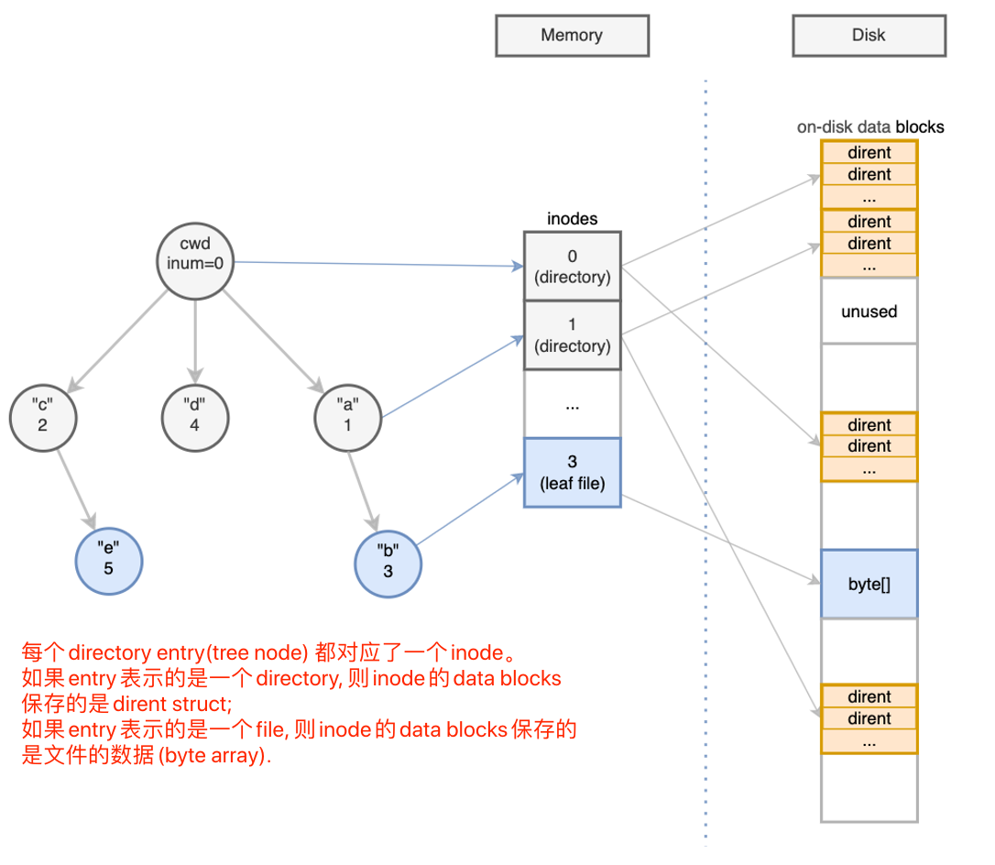

// Look up and return the inode for a path(e.g. "a/b/c").

// If parent != 0, return the inode for the parent and copy the final

// path element into name, which must have room for DIRSIZ bytes.

// Must be called inside a transaction since it calls iput().

static struct inode* namex(char *path, int nameiparent, char *name)

{

struct inode *ip, *next;

if(*path == '/')

//FS root folder, then return FS root inode

ip = iget(ROOTDEV, ROOTINO);

else

ip = idup(myproc()->cwd); //increment myproc->cwd ref count

// BFS: 从myproc()->cwd开始，它保存了进程的root level的directory inode

// 每次loop都从(directory) inode中逐个搜索name,

// 如果找到了dirent, 如果dirent->name与name匹配，则read inode of inum into memory.

while((path = skipelem(path, name)) != 0){

ilock(ip);

if(ip->type != T_DIR){

iunlockput(ip);

return 0;

}

if(nameiparent && *path == '\0'){

// stop one level early.

iunlock(ip);

return ip;

}

if((next = dirlookup(ip, name, 0)) == 0){

iunlockput(ip);

return 0;

}

iunlockput(ip);

ip = next;

}

if(nameiparent){

iput(ip);

return 0;

}

return ip;

}

// Look for a directory entry in a directory.

// If found, set *poff to byte offset of entry.

struct inode* dirlookup(struct inode *dp, char *name, uint *poff)

{

uint off, inum;

struct dirent de;

if(dp->type != T_DIR)

panic("dirlookup not DIR");

// 从dirctory inode中不断读取dirent，然后匹配dirent->name and name

for(off = 0; off < dp->size; off += sizeof(de)){

if(readi(dp, 0, (uint64)&de, off, sizeof(de)) != sizeof(de))

panic("dirlookup read");

if(de.inum == 0)

continue;

if(namecmp(name, de.name) == 0){

// entry matches path element

if(poff)

*poff = off;

inum = de.inum;

return iget(dp->dev, inum); //name match, get the in-memory inode of `inum` from itable.

}

}

return 0; // not found the inode associated with `name`

}

#### File

// opened file struct, in-memory data strcuture.

struct file {

enum { FD_NONE, FD_PIPE, FD_INODE, FD_DEVICE } type;

int ref; // reference count

char readable; // specified when file is opened with flag.

char writable;

struct pipe *pipe; // FD_PIPE

struct inode *ip; // FD_INODE and FD_DEVICE

uint off; // FD_INODE: offset

short major; // FD_DEVICE

};

struct {

struct spinlock lock;

struct file file[NFILE];

} ftable; //in-memory files cache

// opens the file specified by pathname.

// The flags bit-mask argument specifies the permissions to be placed on the file.

int open(char *pathname, int flags){

inode *ip = namex(pathname); // find inode corresponding to leaf file

if (!ip && flg & O_CREATE){

ip = create(pathname, T_FILE, 0, 0);

}

file *fp = filealloc();

allocate a file descriptor(index) for `fp` in myproc()->ofiles array.

set fp attritbutes value;

}

int fileread(file* fp, uint64 addr, int n){

if (fp->type = FD_PIPE){

piperead(...);

}else if(fp->type = FD_DEVICE){

driver[fp->major].read(...); //call driver implementation

}else if(fp->type = FD_INODE){

uint nr = readi(ip, 1, addr, fp->off, n);

if(nr)

f->off += nr;

}

}

int filewrite(file* fp, uint64 addr, int n){

if (fp->type == FD_INODE){

writei(ip, 1, addr, fp->off, n);

}else

...

}

#### Log

Write into path(e.g. "a/b/c"): 分为多个步骤

* open file path with O_CREATE: create directory entry if not exist;
* allocate data blocks for file inode;
* write bytes into data blocks;

在这中间 crash, 会导致文件系统重启之后处于不一致的中间状态。比如：

* directory entry存在，但是没有关联inode;

如果想保证fs consistency(注意: 无法避免数据丢失)，就需要保证这些步骤的原子性(all or nothing)。通过日志来实现.

Note: linux ext3 use word "journal", same concept as log.

struct logheader {

int n; //count of blocks to be write into disk, reset to set after each commit operation

int block[LOGSIZE]; //block #s

};

//in-memory struct

struct log {

struct spinlock lock;

int start; //start log block no

int size; // number of total log blocks

int outstanding; // how many FS sys calls are executing.

int committing; // in commit(), please wait.

int dev;

struct logheader lh;

};

struct log log;

//对于任何fs写操作(比如ialloc, balloc, write 等都需要添加transaction 操作);

filewrite:

// sleep if committing or log is full, otherwise log.outstanding += 1;

begin_op();

write(b->data[]); //注意：写操作仅仅是对buf cache中的数据进行的写操作

// add modified blocks number and count into log header(in-memory)

log_write(bp); //use to replace bwrite();

brelse(bp);

// commit the buffer

end_op();

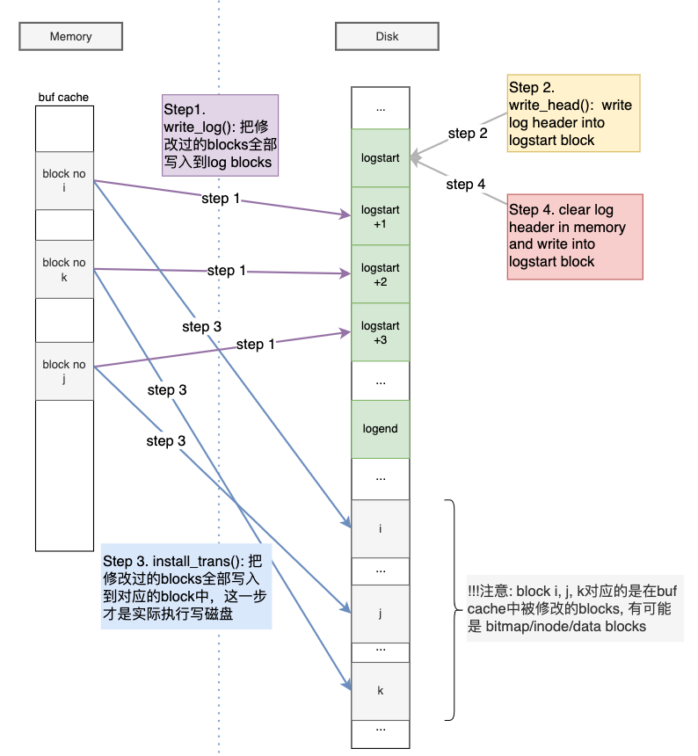

Figure 3 commit steps

分析：

如果在end_op()之前crash，没有影响，因为都是基于内存的操作;

如果在end_op()的过程中crash:

* step1. write log blocks 过程中crash，此时on-disk log header仍然是空的，recovery过程中不会将已经写入的log blocks 写入对用的disk blocks; (nothing)
* step2. write log header 如果成功之后crash(commit point)， 那么recovery会恢复写入的数据(All)；

问题：如果log header部分写入, 比如lh.n = 3, lh.blocks[0] = i, lh.blocks[1]=j, 而k并未写入，那recovery只会恢复i和 j, 这样数据就不一致了.

怎么解决呢?

idea1: 假设写入一个int是原子性的，那么可以先写入block no array, 然后再写入block个数n。当recover的时候，if(n == 0), then do nothing, otherwise install TX.

当recovery完成之后，先将n清零，如果此时crash, 那么下次恢复的时候do nothing.

Liang: 这里出现了一个log的核心思想，要实现FS Level的原子性(多个blocks写入)，必须利用硬件提供的一个更小粒度的原子性(比如一个int, 一个sector等), 才能实现。硬件的原子性就像是一个开关，它只有两种状态：ON和OFF，没有中间状态. 这样当需要write blocks的时候就记录log(sequential write into log blocks on disk), 等到本次写入结束时，拨一下开关到ON状态(commit point), 就可以返回给caller, 写入成功, 之后再把log write into data blocks. 如果在开关拨到ON之前crash, 那么recovery的时候do nothing. 如果on之后crash，就redo log. Recovery完成之后就先拨动开关到OFF, 然后再clear log blocks.

* step3. 将modified log blocks 写入到disk blocks 过程中crash, 那么重来知道成功
* step4. 清理log header：先清除flag bit.
  + 还未清理就失败了，那么recovery会重做一遍；
  + 如果清理过程中失败了，则由于

static void commit()

{

if (log.lh.n > 0) {

write_log(); // Write modified blocks from cache to log

write_head(); // Write header to disk -- the real commit

install_trans(0); // Now install writes to home locations

log.lh.n = 0;

write_head(); // Erase the transaction from the log

}

}

// Write in-memory log header to disk.

// This is the true point at which the

// current transaction commits.

static void write_head(void)

{

struct buf *buf = bread(log.dev, log.start);

struct logheader *hb = (struct logheader *) (buf->data);

int i;

hb->n = log.lh.n;

for (i = 0; i < log.lh.n; i++) {

hb->block[i] = log.lh.block[i];

}

bwrite(buf);

brelse(buf);

}

// Copy committed blocks from log to their home location

static void

install_trans(int recovering)

{

int tail;

for (tail = 0; tail < log.lh.n; tail++) {

struct buf *lbuf = bread(log.dev, log.start+tail+1); // read log block

struct buf *dbuf = bread(log.dev, log.lh.block[tail]); // read dst

memmove(dbuf->data, lbuf->data, BSIZE); // copy block to dst

bwrite(dbuf); // write dst to disk

if(recovering == 0)

bunpin(dbuf);

brelse(lbuf);

brelse(dbuf);

}

}

static void

recover_from_log(void)

{

read_head(); //read header from logstart block: update log.lh.n and log.lh.blocks

install_trans(1); //if committed, copy from log blocks to overwrite cooresponding disk blocks.

log.lh.n = 0;

write_head(); // clear the log

}

# Linux

Liang写在前面

计算机精髓是分层解耦，上层依赖下层，而下层不依赖上层。但是在设计下层的时候又不能不考虑上层的需求，所以他们之间需要紧密地配合，硬件和OS设计者需要紧密合作就说明了这一点。

作为一个从业者，我们需要确定自己的定位，因为精力有限，不可能层层深入。所以，如果你是一个底层开发者，毫无疑问你需要了解硬件的原理。

作为一个上层开发者，你的职责是解决问题，把现实世界的问题转换成为能用计算机系统表示的问题。这就需要你有：解决现实问题的能力+对工具的掌握和理解。两者紧密结合，缺一不可。对工具的功能的理解决定了你如何转换，知道哪些是工具擅长的，哪些是工具无法解决的。那么对工具的熟悉过程应该是先读文档，看看这个工具的目标是解决哪些问题，然后解决某些特定的问题的套路。

比如SQL就是database的接口，DB可以解决的问题：

* 数据的存储和查询(trade-off: 牺牲了少部分的存储效率换取更快的查询效率)
* 保证了数据ACID(transaction)

那在我们学习OS的时候也应该遵循这个过程。首先理解OS解决了什么问题，然后看看OS的接口都实现了什么。

然后学习OS的另一个目标是，看看OS设计者如何把一个需求设计表示成一系列的数据结构和算法，其中的trade-off是什么。

## 前置知识

冯·诺依曼体系将计算机系统分为：CPU, Memory and IO Devices. 所以对于OS开发人员来说：

1. 熟悉CPU Registers and (assembly) instructions; (Platform specific)
2. 熟悉IO Device的Registers and (assembly) instructions.

note: 这对device driver开发人员更重要

Liang: 基于硬件的编程本质就是对各种registers的操作.

## Memory Management(x86)

Linux在x86平台下"变相"屏蔽了segmentation,为了兼容性有些不支持segmentation的CPU架构(比如ARM)。

### Physical Memory

这个跟主板的设计者有关。Layout(e820 physical memory map)由主板的BIOS在启动时传给OS Kernel. 然后OS Kernel会在physical memory map的基础上进行物理内存管理。

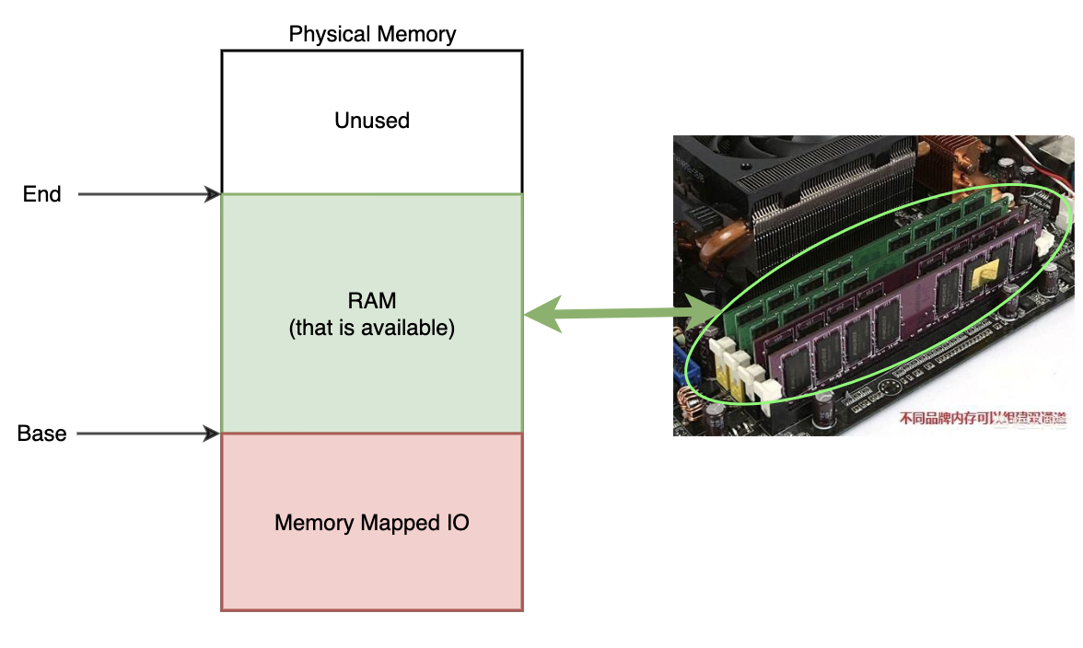

采用伙伴系统管理物理页框(TBD):

MMU把物理内存划分成an list of fixed-size page frames. 然后按照一定的规则组织：

[1]: Linked list, node is 1 free page frame.

[2]: Linked list, node is 2 continuous free page frames.

[4]: Linked list, node is 4 continuous free page frames.

…

### Process Address Space

#### Layout

struct mm_struct {

struct vm_area_struct * mmap; // VMA regions in the address space

int map_count; // VMA count

struct rw_semaphore mmap_sem;

pgd_t * pgd; // root page table: Page Global Directory

spinlock_t page_table_lock;

struct list_head mmlist; // All mm_structs are linked together via this field;

unsigned long start_code, end_code, start_data, end_data; //code(text) and data section

unsigned long start_brk, brk, start_stack; //Heap and stack section

// command line arguments, environment variables

unsigned long arg_start, arg_end, env_start, env_end;

unsigned long rss, total_vm, locked_vm;

unsigned long def_flags;

unsigned long cpu_vm_mask;

unsigned long swap_address;

unsigned dumpable:;

/* Architecture-specific MM context */

mm_context_t context;

};

#### VMA

VMA表示一段连续的virtual memory area。它表示一个具有特定功能的area(比如代码区，数据区等)。为什么要按功能区分？因为不同功能的代码块可能有不同权限，或者其他不同的 属性，所以需要分区。

// Note: vma和segmentation中的segment是完全不同的概念.

struct vm_area_struct {

unsigned long vm_start; /* Our start address within vm_mm. */

unsigned long vm_end; /* The first byte after our end address within vm_mm. */

struct vm_area_struct *vm_next, *vm_prev; // linked list of VM areas per task

  struct mm_struct *vm_mm; //当前vma所属的address space

//Methods for this struct(OOP `class` by C language)

  const struct vm_operations_struct *vm_ops;

struct file *vm_file; /* File being mapped to (can be NULL). */

unsigned long vm_pgoff; /* Offset (within vm_file) in PAGE_SIZE units */

}

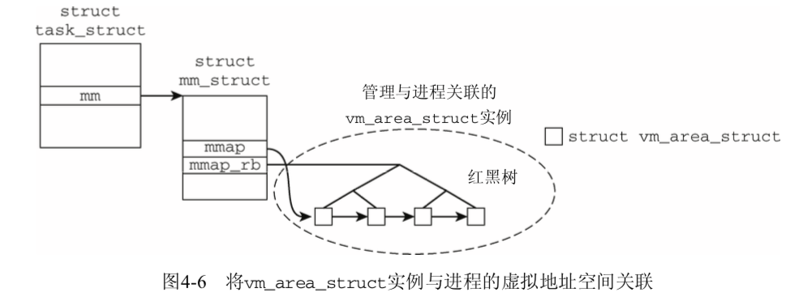

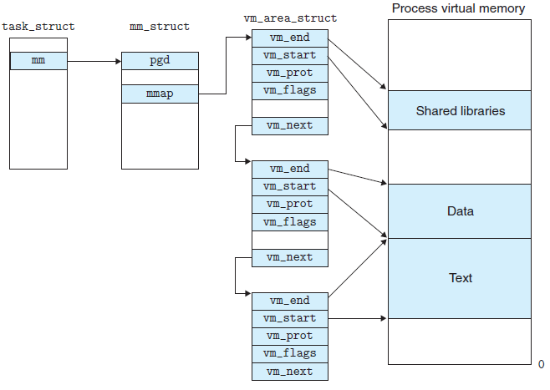

#### VA to PA

前提：设置寄存器中特定bit to enable paging.

MMU帮我们完成：

1. load base physical address of root page table into 寄存器;
2. 通过下面的方法来逐级walk页表, 最终找到PFN, 再通过offset找到最终的物理地址.

内核源代码假定(void *)和unsigned long位数相同

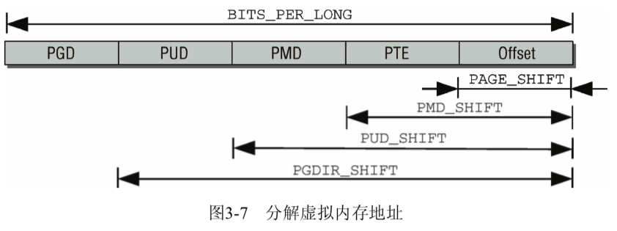

va(Page Number) ==>> pa(PFN): 通过四级页表进行转换。

#define PGDIR_SHIFT 39 //一级页表索引偏移

#define PTRS_PER_PGD 512 //一级页表中entry数目

#define PUD_SHIFT 30

#define PTRS_PER_PUD 512 // 二级页表中entry数目

#define PMD_SHIFT 21

#define PTRS_PER_PMD 512 //三级页表中entry数目

#define PAGE_SHIFT 12

#define PAGE_SIZE (1UL << PAGE_SHIFT) = 4byte

#define PUD_SIZE (1UL << PUD_SHIFT)

#define PMD_SIZE (1UL << PMD_SHIFT)

#define PGDIR_SIZE (1UL << PGDIR_SHIFT)

#define PAGE_MASK (~(PAGE_SIZE-1))

#define PUD_MASK (~(PUD_SIZE-1))

#define PMD_MASK (~(PMD_SIZE-1))

#define PGDIR_MASK (~(PGDIR_SIZE-1))

#### mmap

## Process

### task_struct

/* 资源分配的最小单位，通用进程结构体.

* 那么既然是资源的最小调度单位，它肯定包含了进程所需的全部资源, 计算机的资源无非就是cpu time, memory,

* file system, network, io devices, register.

*/

struct task_struct{

thread_info thread_info; //processor specific data

volatile long state;

struct mm_struct *mm;// 进程运行时所使用的内存描述符，一个进程一个，表示进程的虚拟地址空间

struct mm_struct *active_mm;

fs_struct* fs; // 进程使用的文件系统

//进程打开的文件描述符(整数)，本质上就是files->fdt->fd[fd]数组的index

files_struct* files;

thread_struct thread; // cpu specific state of this task，如寄存器的值

void* stack; // 内核栈地址

//全部的进程按照tree进行组织

task_struct* parent;

list_head* childrenHead;

list_head* siblingHead;

/* PID/PID hash table linkage. */

struct pid* thread_pid;

struct hlist_node pid_links[PIDTYPE_MAX];

struct list_head thread_group;

struct list_head thread_node;

unsigned int cpu; // 该进程所运行的cpu no.

// 跟进程调度有关的结构体

const struct sched_class *sched_class;  
 struct sched_entity se;  
 struct sched_rt_entity rt;

// 这个配置项是放在.config 配置文件中的，表示是否按照cgroup来调度。cgroup后面会看到是用来控制资源分配

#ifdef CONFIG_CGROUP_SCHED

struct task_group *sched_task_group;

#endif

struct sched_dl_entity dl;

char comm[TASK_COMM_LEN]; //可执行文件名称

}

### create process

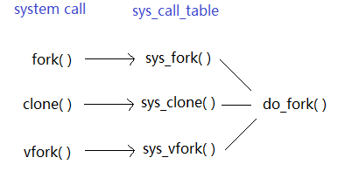

* fork:重量级调用，因为它建立了父进程的一个完整副本，然后作为子进程执行。为减少与 该调用相关的工作量，Linux使用了copy-on-write。
* vfork: 避免使用
* clone: 产生线程，可以对父子进程之间的共享、复制进行精确控制

copy-on-write： fork之后父子进程的地址空间指向同样的物理内存页, 只要一个进程试图向复制的内存页写入，处理器会向内核报告访问错误(此类错误被称作缺页异常)

最终都是调用的do_fork()函数，三者的区别是父子进程隔离的程度。

#define CLONE_NEWUTS 0x04000000 /* 创建新的utsname组 */

#define CLONE_NEWIPC 0x08000000 /* 创建新的IPC命名空间 */

#define CLONE_NEWUSER 0x10000000 /* 创建新的用户命名空间 */

#define CLONE_NEWPID 0x20000000 /* 创建新的PID命名空间 */

#define CLONE_NEWNET 0x40000000 /* 创建新的网络命名空间 */

### thread synchronization

线程同步是指多个线程之间读写相同的数据时(临界区)，需要按照某种顺序来执行，因为不同的执行顺序会导致不同的结果。

异步是指多个线程之间执行顺序是随机的，适合于不存在临界区的多个线程。

例如下面的cases: 有两个线程thread_1, thread_2对同一个内存（变量A）进行读写，那么可以看到不同的顺序会导致A的最终结果不同。

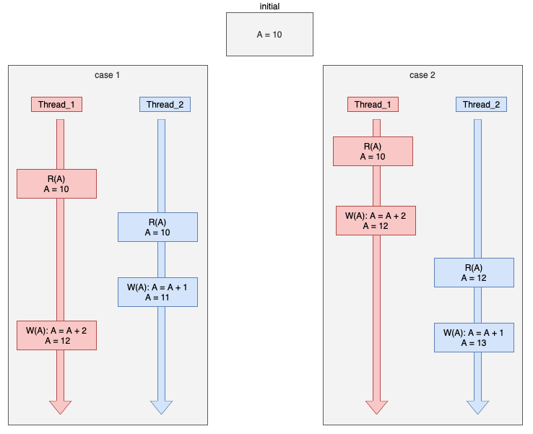

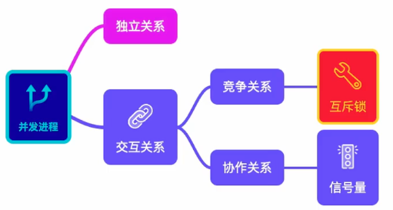

## namespace

DESCRIPTION

A namespace wraps a global system resource in an abstraction that

makes it appear to the processes within the namespace that they

have their own isolated instance of the global resource. Changes

to the global resource are visible to other processes that are

members of the namespace, but are invisible to other processes.

One use of namespaces is to implement containers.

This page provides pointers to information on the various

namespace types, describes the associated /proc files, and

summarizes the APIs for working with namespaces.

The namespaces API

As well as various /proc files described below, the namespaces

API includes the following system calls:

clone(2)

The clone(2) system call creates a new process. If the

flags argument of the call specifies one or more of the

CLONE_NEW* flags listed below, then new namespaces are

created for each flag, and the child process is made a

member of those namespaces. (This system call also

implements a number of features unrelated to namespaces.)

setns(2)

The setns(2) system call allows the calling process to

join an existing namespace. The namespace to join is

specified via a file descriptor that refers to one of the

/proc/[pid]/ns files described below.

unshare(2)

The unshare(2) system call moves the calling process to a

new namespace. If the flags argument of the call

specifies one or more of the CLONE_NEW* flags listed

below, then new namespaces are created for each flag, and

the calling process is made a member of those namespaces.

(This system call also implements a number of features

unrelated to namespaces.)

ioctl(2)

Various ioctl(2) operations can be used to discover

information about namespaces. These operations are

described in ioctl_ns(2).

Creation of new namespaces using clone(2) and unshare(2) in most cases requires the CAP_SYS_ADMIN capability, since, in the new namespace, the creator will have the power to change global resources that are visible to other processes that are subsequently created in, or join the namespace. User namespaces are the exception: since Linux 3.8, no privilege is required to create a user namespace.

Liang: 其实Linux操作系统也可以看做一个multi-tenant系统，能支持多个tenant在同一个系统中运行，那么namespace就提供了一种机制使得tenant之间资源进行隔离，从而不会相互影响。

### 数据结构

Liang: 既然namspace实现了资源的隔离，而进程是资源调度的最小单位，那么必然进程里面包含了它能够使用的资源的集合，那么就是nsproxy，当进程请求资源的时候，只能从这个资源集合中分配???

编译器必须确定是否启用命名空间(见.config文件)， 如果没有启用，所有的属性都是放在默认ns中，相当于全局变量。

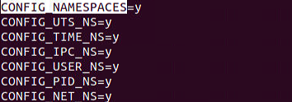

struct task_struct

{

…

// namespaces: 因为使用了指针，多个进程可以共享一组子命名空间。这样，修改给定的 namespace，对

// 所有属于该命名空间的进程都是可见的

struct nsproxy *nsproxy;

…

}

#### nsproxy

// 包含了各个namespace pointers，指向了所有的单个进程的namespace: fs (mount), uts, network, sysvipc, et. 共享一个namespace的所有今年成年共享一个nsproxy，如果namespace被clone或者unshared，那么nsproxy 也会被copy.

struct nsproxy {

atomic_t count; // 引用计数

struct uts_namespace *uts_ns; // unix time share, 隔离Hostname

struct ipc_namespace *ipc_ns; // 隔离进程间通信

struct mnt_namespace *mnt_ns; // 隔离文件系统

struct pid_namespace *pid_ns_for_children; // 隔离进程id

struct net *net_ns; // 隔离网络

struct time_namespace *time_ns;

struct time_namespace *time_ns_for_children;

struct cgroup_namespace *cgroup_ns;

};

Liang: 为什么namespace没有memory namepsace？ 因为namespace目的只为了隔离资源，但是memory引入了地址空间的概念，已经实现了进程级别的 内存隔离，不需要再使用namespace进行隔离了。

#### uts_namespace

// 运行内核的名称、版本、底层体系结构类型等信息。

struct uts_namespace {

struct kref kref; // ref count

struct new_utsname name; // a list of char array(string)

struct user_namespace *user_ns; // 保存的用于限制每个用户资源使用的信息

struct ucounts *ucounts;

struct ns_common ns;

} __randomize_layout;

struct new_utsname {

char sysname[__NEW_UTS_LEN + 1]; //系统的名称

char nodename[__NEW_UTS_LEN + 1]; //内核发布版本

char release[__NEW_UTS_LEN + 1];

char version[__NEW_UTS_LEN + 1];

char machine[__NEW_UTS_LEN + 1]; //机器名称

char domainname[__NEW_UTS_LEN + 1];

};

#### ipc_namespace

struct ipc_namespace {

refcount_t count;

struct ipc_ids ids[3];

int sem_ctls[4];

int used_sems;

unsigned int msg_ctlmax;

unsigned int msg_ctlmnb;

unsigned int msg_ctlmni;

atomic_t msg_bytes;

atomic_t msg_hdrs;

size_t shm_ctlmax;

size_t shm_ctlall;

unsigned long shm_tot;

int shm_ctlmni;

int shm_rmid_forced;

struct notifier_block ipcns_nb;

/* The kern_mount of the mqueuefs sb. We take a ref on it */

struct vfsmount *mq_mnt;

unsigned int mq_queues_count; /* # queues in this ns, protected by mq_lock */

unsigned int mq_queues_max; /* initialized to DFLT_QUEUESMAX */

unsigned int mq_msg_max; /* initialized to DFLT_MSGMAX */

unsigned int mq_msgsize_max; /* initialized to DFLT_MSGSIZEMAX */

unsigned int mq_msg_default;

unsigned int mq_msgsize_default;

struct user_namespace *user_ns; /* user_ns which owns the ipc ns */

struct ucounts *ucounts;

struct llist_node mnt_llist;

struct ns_common ns;

};

#### pid_namespace(尚未搞懂)

// 树形结构。在建立一个新的命名空间时，该命名空间中的所有PID对父命名空间都是可见的，但子命名空间无法看到父命名空间的PID。

struct pid_namespace {

struct kref kref;

struct idr idr;

struct rcu_head rcu;

unsigned int pid_allocated;

struct kmem_cache *pid_cachep;

struct task_struct *child_reaper;

unsigned int level; //当前节点在树中的深度

struct pid_namespace *parent;

struct user_namespace *user_ns;

struct ucounts *ucounts;

struct ns_common ns;

} __randomize_layout;

凡可以看到该进程的命名空间，都会为其分配一个PID。 这必须反映在数据结构中。我们必须区分**局部ID(**属于某个特定的命名空间，不具备全局有效性) 和全局ID(内核本身和初始命名空间中的唯一ID号，在系统启动期间开始的init进程即属于初始命名空间。对每个ID类型，都有一个给定的全局ID，保证在整个系统中是唯一的)。

struct task_struct {

...

pid_t pid; //全局PID

pid_t tgid; // 全局TGID

...

}

需求：

新ID的分配;

通过ID及其类型查找进程的task_struct的功能;

将ID的内核表示形式(pid 结构体)和用户空间可见的数值(pid 整形)进行转换的功能，（类似于fd和file相互转化的过程）

struct pid{

ns; //首先需要知道pid在什么namespace吧，脱离了ns的pid，就没有意义了

index; //这个pid

refcount_t count; //引用计数，表明它被进程共享的

unsigned int level;

spinlock_t lock;

struct hlist_head tasks[PIDTYPE_MAX]; /* lists of tasks that use this pid */

struct hlist_head inodes; ???

wait_queue_head_t wait_pidfd; // wait queue for pidfd notifications

struct rcu_head rcu;

struct upid numbers[1]; // indexed by level of pid_namespace

};

struct upid {

int nr; //

struct pid_namespace *ns; //

};

#### mnt_namespace

struct mnt_namespace {

atomic_t count; // ref count

struct ns_common ns;

struct mount *root;

struct list_head list;

struct user_namespace *user_ns;

struct ucounts *ucounts;

u64 seq; // Sequence number to prevent loops */

wait_queue_head_t poll;

u64 event;

unsigned int mounts; // number of mounts in the namespace */

unsigned int pending_mounts;

};

新的命名空间可以用下面两种方法创建。

(1) 在用fork或clone系统调用创建新进程时，有特定的选项可以控制是与父进程共享命名空间还是建立新的命名空间。

(2) unshare系统调用将进程的某些部分从父进程分离，其中也包括命名空间。更多信息请参见手 册页unshare(2)。

命名空间的实现需要两个部分:每个子系统的命名空间结构，将此前所有的全局组件包装到命名 空间中;将给定进程关联到所属各个命名空间的机制。

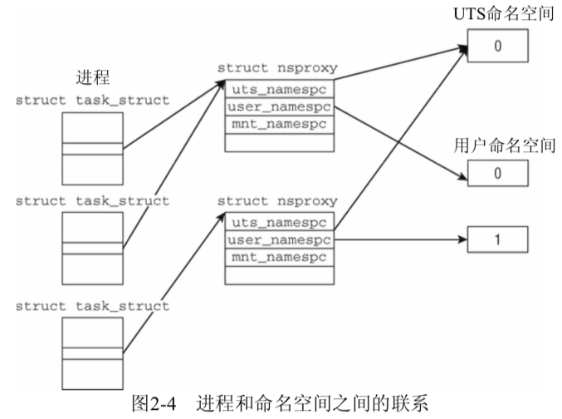

#### net

网络包括哪些资源？

device, 网络协议栈，…

## Cgroup

<https://man7.org/linux/man-pages/man7/cgroups.7.html>

DESCRIPTION

Cgroup是一个内核功能。它把进程组织成树形的group, 通过group对不同类型资源的使用进行限制和监控。内核cgroup 接口通过pseudo-filesystem cgroupfs来提供(Linux一切皆文件)。

Terminology

A cgroup is a collection of processes that are bound to a set of limits or parameters defined via the cgroup filesystem.

A subsystem is a kernel component that modifies the behavior of the processes in a cgroup. Various subsystems have been implemented, making it possible to do things such as limiting the amount of CPU time and memory available to a cgroup, accounting for the CPU time used by a cgroup, and freezing and resuming execution of the processes in a cgroup. Subsystems are sometimes also known as resource controllers (or simply, controllers).

The cgroups for a controller are arranged in a hierarchy. This hierarchy is defined by creating, removing, and renaming subdirectories within the cgroup filesystem. At each level of the hierarchy, attributes (e.g., limits) can be defined. The limits, control, and accounting provided by cgroups generally have effect throughout the subhierarchy underneath the cgroup where the attributes are defined. Thus, for example, the limits placed on a cgroup at a higher level in the hierarchy cannot be exceeded by descendant cgroups.

struct cgroup {

// self css with NULL ->ss, points back to this cgroup

struct cgroup_subsys_state self;

unsigned long flags; // "unsigned long" so bitops work

int level; // The depth this cgroup is at

int max_depth;

int nr_descendants;

int nr_dying_descendants;

int max_descendants;

int nr_populated_csets;

int nr_populated_domain_children;

int nr_populated_threaded_children;

int nr_threaded_children; /* # of live threaded child cgroups */

struct kernfs_node *kn; /* cgroup kernfs entry */

struct cgroup_file procs_file; /* handle for "cgroup.procs" */

struct cgroup_file events_file; /* handle for "cgroup.events" */

u16 subtree_control;

u16 subtree_ss_mask;

u16 old_subtree_control;

u16 old_subtree_ss_mask;

/* Private pointers for each registered subsystem */

struct cgroup_subsys_state __rcu *subsys[CGROUP_SUBSYS_COUNT];

struct cgroup_root *root;

struct list_head cset_links;

/*

* On the default hierarchy, a css_set for a cgroup with some

* susbsys disabled will point to css's which are associated with

* the closest ancestor which has the subsys enabled. The

* following lists all css_sets which point to this cgroup's css

* for the given subsystem.

*/

struct list_head e_csets[CGROUP_SUBSYS_COUNT];

struct cgroup *dom_cgrp;

struct cgroup *old_dom_cgrp; /* used while enabling threaded */

// per-cpu recursive resource statistics

struct cgroup_rstat_cpu __percpu *rstat_cpu;

struct list_head rstat_css_list;

struct cgroup_base_stat last_bstat;

struct cgroup_base_stat bstat;

struct prev_cputime prev_cputime;

/*

* list of pidlists, up to two for each namespace (one for procs, one

* for tasks); created on demand.

*/

struct list_head pidlists;

struct mutex pidlist_mutex;

/* used to wait for offlining of csses */

wait_queue_head_t offline_waitq;

/* used to schedule release agent */

struct work_struct release_agent_work;

/* used to track pressure stalls */

struct psi_group psi;

/* used to store eBPF programs */

struct cgroup_bpf bpf;

/* If there is block congestion on this cgroup. */

atomic_t congestion_count;

/* Used to store internal freezer state */

struct cgroup_freezer_state freezer;

/* ids of the ancestors at each level including self */

u64 ancestor_ids[];

};

/* The cgroup filesystem superblock creation/mount context.*/

struct cgroup_fs_context {

struct kernfs_fs_context kfc;  
 struct cgroup_root *root;  
 struct cgroup_namespace *ns;  
 unsigned int flags; /* CGRP_ROOT_* flags */  
  
 /* cgroup1 bits */

bool cpuset_clone_children;  
 bool none; /* User explicitly requested empty subsystem */

bool all_ss; /* Seen 'all' option */

u16 subsys_mask; /* Selected subsystems */

char *name; /* Hierarchy name */

char *release_agent; /* Path for release notifications */  
};

## IO Device

### Driver and Device

#### Device设计

typedef struct s_DEVID

{

uint_t dev_mtype; //设备类型号

uint_t dev_stype; //设备子类型号

uint_t dev_nr; //设备序号

}devid_t;

NOTE: Device type 大致分为character device and block device. 区别是字符设备以字符为单位IO 数据，而block device是以block为单位IO数据。

typedef struct s_DEVICE

{

list_h_t dev_list; //设备链表

list_h_t dev_indrvlst; //设备在驱动程序数据结构中对应的挂载链表

list_h_t dev_intbllst; //设备在设备表数据结构中对应的挂载链表

spinlock_t dev_lock; //设备自旋锁

uint_t dev_count; //设备计数

sem_t dev_sem; //设备信号量

uint_t dev_stus; //设备状态

uint_t dev_flgs; //设备标志

devid_t dev_id; //设备ID

uint_t dev_intlnenr; //设备中断服务例程的个数

list_h_t dev_intserlst; //设备中断服务例程的链表

list_h_t dev_rqlist; //对设备的请求服务链表

uint_t dev_rqlnr; //对设备的请求服务个数

sem_t dev_waitints; //用于等待设备的信号量

struct s_DRIVER* dev_drv; //设备对应的驱动程序数据结构的指针

void* dev_attrb; //设备属性指针

void* dev_privdata; //设备私有数据指针

void* dev_userdata; //将来扩展所用

void* dev_extdata; //将来扩展所用

char_t* dev_name; //设备名

}device_t;

#### Driver设计

typedef struct s_DRIVER

{

spinlock_t drv_lock; //保护驱动程序数据结构的自旋锁

list_h_t drv_list; //挂载驱动程序数据结构的链表

uint_t drv_stuts; //驱动程序的相关状态

uint_t drv_flg; //驱动程序的相关标志

uint_t drv_id; //驱动程序ID

uint_t drv_count; //驱动程序的计数器

sem_t drv_sem; //驱动程序的信号量

void* drv_safedsc; //驱动程序的安全体

void* drv_attrb; //LMOSEM内核要求的驱动程序属性体

void* drv_privdata; //驱动程序私有数据的指针

drivcallfun_t drv_dipfun[IOIF_CODE_MAX]; //驱动程序功能派发函数指针数组

//挂载驱动程序所管理的所有设备的链表，因为一个driver可以驱动多个device

list_h_t drv_alldevlist;

drventyexit_t drv_entry; //驱动程序的入口函数指针

drventyexit_t drv_exit; //驱动程序的退出函数指针

void* drv_userdata; //用于将来扩展

void* drv_extdata; //用于将来扩展

char_t* drv_name; //驱动程序的名字

}driver_t;

//驱动程序入口和退出函数

drvstus_t device_entry(driver_t* drvp, uint_t val, void* p);

drvstus_t device_exit(driver_t* drvp, uint_t val,void* p);

//设备中断处理函数

drvstus_t device_handle(uint_t ift_nr, void* devp, void* sframe);

//打开、关闭设备函数

drvstus_t device_open(device_t* devp, void* iopack);

drvstus_t device_close(device_t* devp, void* iopack);

//读、写设备数据函数

drvstus_t device_read(device_t* devp, void* iopack);

drvstus_t device_write(device_t* devp, void* iopack);

//调整读写设备数据位置函数

drvstus_t device_lseek(device_t* devp, void* iopack);

//控制设备函数

drvstus_t device_ioctrl(device_t* devp,void* iopack);

//开启、停止设备函数

drvstus_t device_dev_start(device_t* devp,void* iopack);

drvstus_t device_dev_stop(device_t* devp,void* iopack);

//设置设备电源函数

drvstus_t device_set_powerstus(device_t* devp,void* iopack);

//枚举设备函数

drvstus_t device_enum_dev(device_t* devp,void* iopack);

//刷新设备缓存函数

drvstus_t device_flush(device_t* devp,void* iopack);

//设备关机函数

drvstus_t device_shutdown(device_t* devp,void* iopack);

#define IOIF_CODE_OPEN 0 //对应于open操作

#define IOIF_CODE_CLOSE 1 //对应于close操作

#define IOIF_CODE_READ 2 //对应于read操作

#define IOIF_CODE_WRITE 3 //对应于write操作

#define IOIF_CODE_LSEEK 4 //对应于lseek操作

#define IOIF_CODE_IOCTRL 5 //对应于ioctrl操作

#define IOIF_CODE_DEV_START 6 //对应于start操作

#define IOIF_CODE_DEV_STOP 7 //对应于stop操作

#define IOIF_CODE_SET_POWERSTUS 8 //对应于powerstus操作

#define IOIF_CODE_ENUM_DEV 9 //对应于enum操作

#define IOIF_CODE_FLUSH 10 //对应于flush操作

#define IOIF_CODE_SHUTDOWN 11 //对应于shutdown操作

#define IOIF_CODE_MAX 12 //最大功能码

// 驱动程序分派函数指针类型

typedef drvstus_t (*drivcallfun_t)(device_t*,void*);

//驱动程序入口、退出函数指针类型

typedef drvstus_t (*drventyexit_t)(struct s_DRIVER*,uint_t,void*);

#### Device & Driver 的组织

#define DEVICE_MAX 34

typedef struct s_DEVTLST

{

uint_t dtl_type; //设备类型

uint_t dtl_nr; //该类型中设备个数

list_h_t dtl_list; //挂载设备device_t结构的链表

}devtlst_t;

typedef struct s_DEVTABLE

{

list_h_t devt_list; //设备表自身的链表

spinlock_t devt_lock; //设备表自旋锁

list_h_t devt_devlist; //全局设备链表

list_h_t devt_drvlist; //全局驱动程序链表，驱动程序不需要分类，一个链表就行

uint_t devt_devnr; //全局设备个数

uint_t devt_drvnr; //全局驱动程序个数

devtlst_t devt_devclsl[DEVICE_MAX]; //分类存放设备数据结构的devtlst_t结构数组

}devtable_t;

Cosmos 内核在首次启动驱动程序时，就会调用这个驱动程序的入口点函数，在这个函数中驱动程序会分配一个设备数据结构，并用相关的信息将其实例化，比如填写正确的设备类型、设备 ID 号、设备名称等。

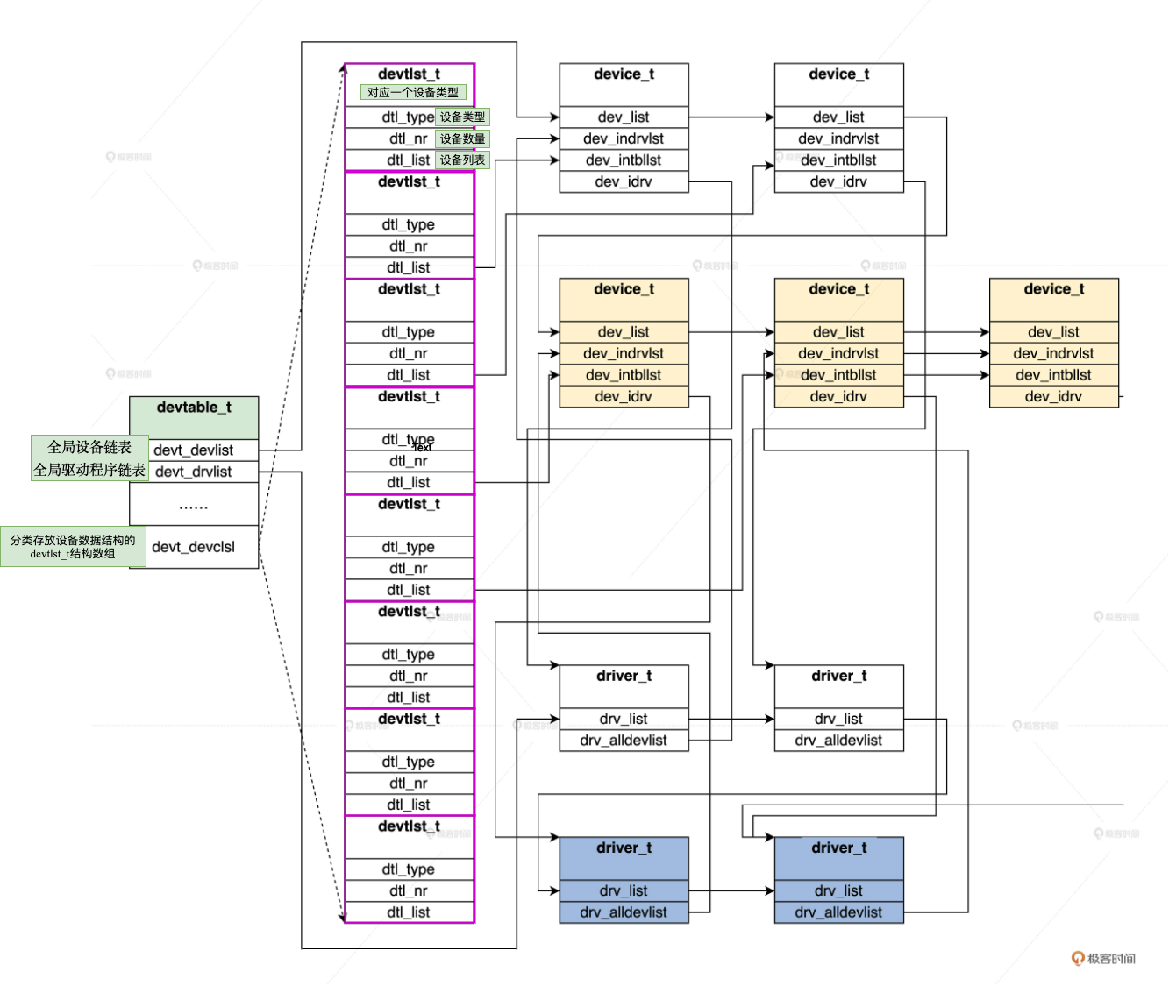

### Linux 驱动框架

#### Load driver

#include<linux/init.h>

#include<linux/module.h>

#include<linux/kernel.h>

#include<linux/fs.h>

#include <linux/string.h>

#include <linux/uaccess.h>

#include <linux/types.h>

#include <linux/cdev.h>

#include <linux/device.h>

MODULE_LICENSE("GPL");

#define NEWCHRLED_NAME "newchrled"

#define NEWCHRLED_COUNT 1

// 自定义device struct

typedef struct newchrled_dev {

struct cdev cdev; /**char device*/

dev_t devid; /** device types*/

struct class *class; /** */

struct device *device; // 这个是linux built-in device 结构体，自定义结构体相当于继承了它

int major; /** major device number */

int minor; /** minor device number */

}newchrled_dev;

struct newchrled_dev newchrled;

static char readbuf[100];

static char writebuf[100];

static char krldate[] = {"kernel data liang!"};

static int newchrled_open(struct inode *inode, struct file *filp)

{

printk("char device base open\r\n");

// set private data as device instance, such that device instance is accessible

// from read/write function

filp->private_date = &newchrled;

return 0;

}

static int newchrled_release(struct inode *inode, struct file *filp)

{

printk("char device base release\r\n");

return 0;

}

static ssize_t newchrled_read(struct file *filp, __user char *buf, size_t count, loff_t *ppos)

{

int ret = 0;

// printk("char device base read\r\n");

memcpy(readbuf, krldate, sizeof(krldate));

//copy the readbuf(kernel space data) to user space

ret = copy_to_user(buf, readbuf, count);

if (ret <= 0){

}else{

//failed

return -1;

}

return 0;

}

static ssize_t newchrled_write(struct file *filp, const char *buf, size_t count, loff_t *ppos)

{

int ret = 0;

// printk("char device base write\r\n");

ret = copy_from_user(writebuf, buf, count);

if (ret == 0){

printk("received data from user: %s\r\n", writebuf);

}else{

//failed

return -1;

}

return 0;

}

static const struct file_operations newchrled_fops={

.owner = THIS_MODULE,

.open = newchrled_open,

.release = newchrled_release,

.read = newchrled_read,

.write = newchrled_write

};

static int __init newchrled_init(void)

{

int ret = 0;

printk(KERN_EMERG"newchrled module init \r\n");

//1. register a device number

if (newchrled.major){

//register device number if major is given

newchrled.devid = MKDEV(newchrled.major, 0);

ret = register_chrdev_region(newchrled.devid, NEWCHRLED_COUNT, NEWCHRLED_NAME);

}else{

// apply for a device number

ret = alloc_chrdev_region(&newchrled.devid, 0, NEWCHRLED_COUNT, NEWCHRLED_NAME);

newchrled.major = MAJOR(newchrled.devid);

newchrled.minor = MINOR(newchrled.devid);

}

if (ret < 0){

printk("newharled chrdev region error\r\n");

return -1;

}

printk("newchrled device major = %d, minor = %d\r\n", newchrled.major, newchrled.minor);

// 2. register char device

newchrled.cdev.owner= THIS_MODULE;

cdev_init(&newchrled.cdev, &newchrled_fops);

ret = cdev_add(&newchrled.cdev, newchrled.devid, NEWCHRLED_COUNT);

// 3. Create device node under /dev/

newchrled.class = class_create(THIS_MODULE, NEWCHRLED_NAME);

if (IS_ERR(newchrled.class)){

return PTR_ERR(newchrled.class);

}

// 4. Create char device instance under /proc/

newchrled.device = device_create(newchrled.class, NULL, newchrled.devid, NULL, NEWCHRLED_NAME);

if (IS_ERR(newchrled.device)){

return PTR_ERR(newchrled.device);

}

return 0;

}

static void __exit newchrled_exit(void)

{

printk(KERN_EMERG"newchrled module exit\r\n");

// 1. delete char device

cdev_del(&newchrled.cdev);

// 2. unregister device number

unregister_chrdev_region(newchrled.devid, NEWCHRLED_COUNT);

// 3. destroy device

device_destroy(newchrled.class, newchrled.devid);

// 4. delete class which the device belongs to

class_destroy(newchrled.class);

}

// fn will be executed when load / unload module

module_init(newchrled_init);

module_exit(newchrled_exit);

#### Application call driver

#include <sys/types.h>

#include <sys/stat.h>

#include <fcntl.h>

#include <stdio.h>

#include <unistd.h>

#include <stdlib.h>

#include <string.h>

/** This is the application that read/write from the device

* "./chrdevbaseAPP /dev/chrdevchild 1" represents Read from device

* "./chrdevbaseAPP /dev/chrdevchild 2" represents Write into device

* */

int main(int argc, char *argv[]){

if (argc != 3){

printf("Not enough input parameters, supposed to be 3");

return -1;

}

//This will force stdout to be line-buffered.

setvbuf(stdout, NULL, _IONBF, 0);

int ret = 0;

int fd = 0;

char *file_name = argv[1];

char buf[100];

char write_buf[100];

static char usr_data[] = {"user data"};

// open device “/dev/chrdevchild”

fd = open(file_name, O_RDWR);

if (fd < 0){

printf("Cannot open file '%s' \r\n", file_name);

return -1;

}else{

printf("Open file '%s' success \r\n", file_name);

}

if (atoi(argv[2]) == 1){

ret = read(fd, buf, 50);

if (ret < 0){

printf("failed to read file '%s'\r\n", file_name);

return -1;

}else{

printf("Read from file '%s' success, data %s\r\n", file_name, buf);

}

}

if (atoi(argv[2]) == 2){

memcpy(write_buf, usr_data, sizeof(usr_data));

ret = write(fd, write_buf, 50);

if (ret < 0){

printf("Failed to write file %s\r\n", file_name);

return -1;

}else{

printf("Write file '%s' success\r\n", file_name);

}

}

ret = close(fd);

if (ret < 0){

printf("Failed to close file '%s'\r\n", file_name);

return -1;

}else{

printf("Close file '%s' success\r\n", file_name);

}

return 0;

}

## Virtual File System

### Concept

VFS是Linux内核里提供文件系统接口给用户态应用程序的一个虚拟文件系统层。同时VFS还提供了抽象化的操作接口以方便实现内核的底层文件系统.

* 基于磁盘(disk-based)的文件系统：如 ext4、ext3 等；
* 网络文件系统：允许方便访问网络上其他计算机的文件系统。
* 特殊文件系统：不管理磁盘空间。/proc就是一个特殊的文件系统。

#### superblock

superblock保存了整个file system (implementation) 的metadata.它存储在磁盘特定的扇区上。不是基于磁盘的文件系统(基于内存的虚拟文件系统，如sysfs)会临时生成sb，并保存在内存中。

struct super_block {

struct list_head s_list; //超级块链表

dev_t s_dev; //设备标识

unsigned char s_blocksize_bits;//以位为单位的块大小

unsigned long s_blocksize;//以字节为单位的块大小

loff_t s_maxbytes; //一个文件最大多少字节

struct file_system_type *s_type; //文件系统类型

const struct super_operations *s_op;//超级块函数集合

const struct dquot_operations *dq_op;//磁盘限额函数集合

unsigned long s_flags;//挂载标志

unsigned long s_magic;//文件系统魔数

struct dentry *s_root;//挂载目录

struct rw_semaphore s_umount;//卸载信号量

int s_count;//引用计数

atomic_t s_active;//活动计数

struct block_device *s_bdev;//块设备

void *s_fs_info;//文件系统信息

time64_t s_time_min;//最小时间限制

time64_t s_time_max;//最大时间限制

char s_id[32]; //标识名称

uuid_t s_uuid; //文件系统的UUID

struct list_lru s_dentry_lru;//LRU方式挂载的目录

struct list_lru s_inode_lru;//LRU方式挂载的索引结点

struct mutex s_sync_lock;//同步锁

struct list_head s_inodes; //所有的索引节点

spinlock_t s_inode_wblist_lock;//回写索引节点的锁

struct list_head s_inodes_wb; //挂载所有要回写的索引节点

} __randomize_layout;

//所有函数指针所指向的函数(API)，都应该要由一个具体文件系统实现。这是典型的面向对象设计，抽象层规定了所有文件系统都有的功能，然后具体api交给具体FS来实现。

struct super_operations {

//分配一个新的索引结点结构

struct inode *(*alloc_inode)(struct super_block *sb);

//销毁给定的索引节点

void (*destroy_inode)(struct inode *);

//释放给定的索引节点

void (*free_inode)(struct inode *);

//VFS在索引节点为脏(改变)时，会调用此函数

void (*dirty_inode) (struct inode *, int flags);

//该函数用于将给定的索引节点写入磁盘

int (*write_inode) (struct inode *, struct writeback_control *wbc);

//在最后一个指向索引节点的引用被释放后，VFS会调用该函数

int (*drop_inode) (struct inode *);

void (*evict_inode) (struct inode *);

//减少超级块计数调用

void (*put_super) (struct super_block *);

//同步文件系统调用

int (*sync_fs)(struct super_block *sb, int wait);

//释放超级块调用

int (*freeze_super) (struct super_block *);

//释放文件系统调用

int (*freeze_fs) (struct super_block *);

int (*thaw_super) (struct super_block *);

int (*unfreeze_fs) (struct super_block *);

//VFS通过调用该函数，获取文件系统状态

int (*statfs) (struct dentry *, struct kstatfs *);

//当指定新的安装选项重新安装文件系统时，VFS会调用此函数

int (*remount_fs) (struct super_block *, int *, char *);

//VFS调用该函数中断安装操作。该函数被网络文件系统使用，如NFS

void (*umount_begin) (struct super_block *);

};

#### inode

一个inode(index node) represents a file, directory in file system，它也可以是设备或管道这样的特殊文件(linux 一切皆文件，所以inode不仅仅表示文件系统的文件，也可以指一些特殊文件)。因此inode结构体中有一些和特殊文件相关的项(比如i_pipe项就指向一个代表命名管道的 数据结构。如果索引节点并非代表一个命名管道，那么该项就被简单地设置为NULL)。和特殊文件相关的项还有i_devices、i_bdev和i_cdev等。

硬盘格式化的时候，OS自动将硬盘分成两个区域。一个是数据区，存放文件数据；另一个是inode区（inode table），存放inode所包含的信息。

struct inode {

umode_t i_mode; //文件访问权限

unsigned short i_opflags; //打开文件时的标志

kuid_t i_uid; //文件所属的用户id

kgid_t i_gid; //文件所属的用户组id

unsigned int i_flags; //标志

const struct inode_operations *i_op;//inode函数集

struct super_block *i_sb; //指向所属超级块

struct address_space *i_mapping;//文件数据在内存中的页缓存

unsigned long i_ino; //inode号

dev_t i_rdev; //实际设备标志符

loff_t i_size; //文件大小，以字节为单位

struct timespec64 i_atime; //文件访问时间

struct timespec64 i_mtime; //文件修改时间

struct timespec64 i_ctime; //最后修改时间

spinlock_t i_lock; //保护inode的自旋锁

unsigned short i_bytes; //使用的字节数

u8 i_blkbits; //以bit为单位的块大小；

u8 i_write_hint;

blkcnt_t i_blocks;

struct list_head i_io_list;

struct list_head i_lru; //在缓存LRU中的链表节点

struct list_head i_sb_list; //在超级块中中的链表节点

struct list_head i_wb_list;

atomic64_t i_version; //版本号

atomic64_t i_sequence;

atomic_t i_count; //计数

atomic_t i_dio_count; //直接io进程计数

atomic_t i_writecount; //写进程计数

union {

const struct file_operations *i_fop;//文件函数集合

void (*free_inode)(struct inode *);

};

struct file_lock_context *i_flctx;

struct address_space i_data;

void *i_private; //私有数据指针

} __randomize_layout;

// inode interface

struct inode_operations {

//VFS通过系统create()和open()接口来调用该函数，从而为dentry对象创建一个新的索引节点

int (*create) (struct inode *, struct dentry *,int);

//该函数在特定目录中寻找索引节点，该索引节点要对应于dentry中给出的文件名

struct dentry * (*lookup) (struct inode *, struct dentry *);

//被系统link()接口调用，用来创建硬连接。硬链接名称由dentry参数指定

int (*link) (struct dentry *, struct inode *, struct dentry *);

//被系统unlink()接口调用，删除由目录项dentry链接的索引节点对象

int (*unlink) (struct inode *, struct dentry *);

//被系统symlik()接口调用，创建符号连接，该符号连接名称由symname指定，连接对象是dir目录中的dentry目录项

int (*symlink) (struct inode *, struct dentry *, const char *);

//被mkdir()接口调用，创建一个新目录。

int (*mkdir) (struct inode *, struct dentry *, int);

//被rmdir()接口调用，删除dentry目录项代表的文件

int (*rmdir) (struct inode *, struct dentry *);

//被mknod()接口调用，创建特殊文件(设备文件、命名管道或套接字)。

int (*mknod) (struct inode *, struct dentry *, int, dev_t);

//VFS调用该函数来移动文件。文件源路径在old_dir目录中，源文件由old_dentry目录项所指定，目标路径在new_dir目录中，目标文件由new_dentry指定

int (*rename) (struct inode *, struct dentry *, struct inode *, struct dentry *);

//被系统readlink()接口调用，拷贝数据到特定的缓冲buffer中。拷贝的数据来自dentry指定的符号链接

int (*readlink) (struct dentry *, char *, int);

//被VFS调用，从一个符号连接查找他指向的索引节点

int (*follow_link) (struct dentry *, struct nameidata *);

//在follow_link()调用之后，该函数由vfs调用进行清除工作

int (*put_link) (struct dentry *, struct nameidata *);

//被VFS调用，修改文件的大小，在调用之前，索引节点的i_size项必须被设置成预期的大小

void (*truncate) (struct inode *);

//该函数用来检查给定的inode所代表的文件是否允许特定的访问模式，如果允许特定的访问模式，返回0，否则返回负值的错误码

int (*permission) (struct inode *, int);

//被notify_change接口调用，在修改索引节点之后，通知发生了改变事件

int (*setattr) (struct dentry *, struct iattr *);

//在通知索引节点需要从磁盘中更新时，VFS会调用该函数

int (*getattr) (struct vfsmount *, struct dentry *, struct kstat *);

//被VFS调用，向dentry指定的文件设置扩展属性

int (*setxattr) (struct dentry *, const char *, const void *, size_t, int);

//被VFS调用，拷贝给定文件的扩展属性name对应的数值

ssize_t (*getxattr) (struct dentry *, const char *, void *, size_t);

//该函数将特定文件所有属性列表拷贝到一个缓冲列表中

ssize_t (*listxattr) (struct dentry *, char *, size_t);

//该函数从给定文件中删除指定的属性

int (*removexattr) (struct dentry *, const char *);

};

#### dentry

那么如何根据文件名(路径)找到文件的inode(从而找到文件的block位置)?

1. 保存一个list of <文件名，inode_pointer>

可以用按文件名排序的List， 也可用HashMap<> 实现

优点：实现简单

缺点：全局无法文件重名

1. 二级目录：

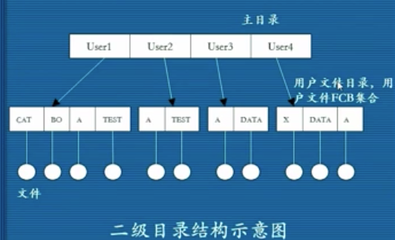

1. Tree（多级目录）

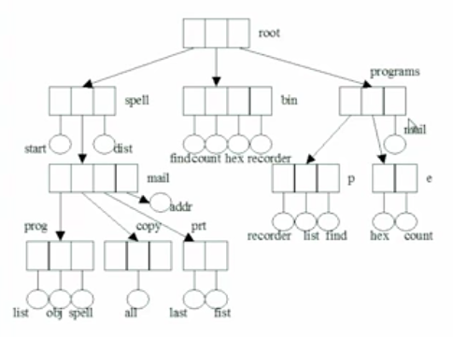

Linux中如何表示上述entry node? **Dentry:**

给定一个文件路径/home/etc/document/abc.txt, 要能定位到文件的inode.

问题： 逻辑空间映射到物理空间。

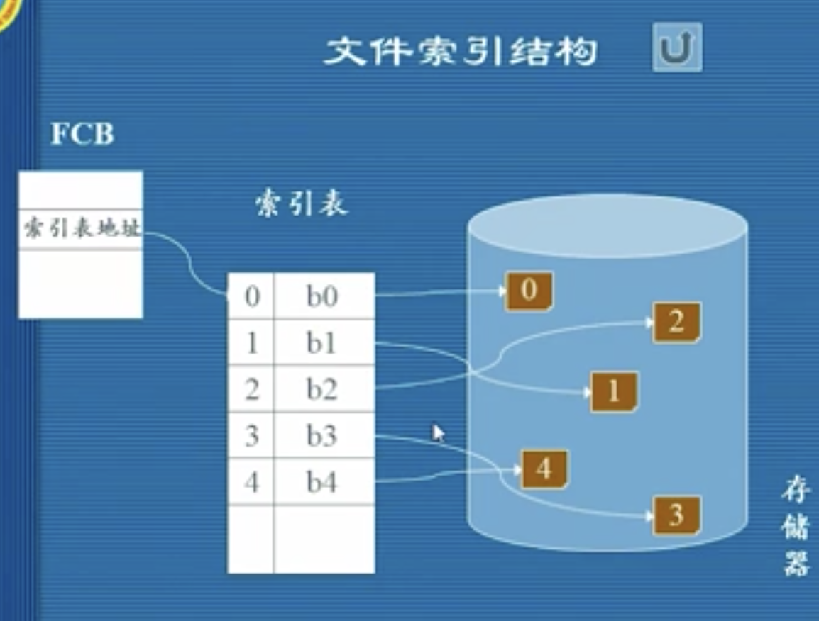

inode 和 dentry的理解

inode其实是文件控制块(FCB)，包含了一个文件的metadata（文件基本信息，block地址）。在文件系统中根据文件名检索文件的inode, 如果我们把inode组织称一个tree，通过文件名来检索tree节点的话，效率很低，因为inode过于臃肿，无法全部加载到内存之中，所以我们可以把inode的文件名信息剥离出来，并创建一个dentry struct, 然后把它组织成一个树形结构，专门用来按文件名检索，这样会提高效率。所以可以把dentry理解为inode的一个索引。这样现根据文件名找到dentry, 然后再找到inode。

inode是指物理意义上的文件，而dentry是逻辑上的文件，inode和dentry是一对多的关系。dentry是一个被组织成一个树形和hash table的结构，并被加载在内存之中，形成我们可视的文件目录结构。我们通过文件名（e.g. “src/folder/myfile.txt”） 在树形结构中查找到对应的dentry, 然后找到它对应的inode， 从而能够找到全部的block位置。

这种设计思想也是一种虚拟化：一套文件目录结构映射到物理文件系统，这么做的好处是，当用户创建一个空文件的时候，不用真的给他分配inode，只有当用户开始写数据的时候才需要创建inode.

源码：

struct dentry {

unsigned int d_flags; //目录标志

seqcount_spinlock_t d_seq; //锁

struct hlist_bl_node d_hash;//目录的哈希链表

struct dentry *d_parent; //指向父目录

struct qstr d_name; //目录名称

struct inode *d_inode; //指向目录文件的索引节点

unsigned char d_iname[DNAME_INLINE_LEN]; //短目录名

struct lockref d_lockref; //目录锁与计数

const struct dentry_operations *d_op;//目录的函数集

struct super_block *d_sb; //指向超级块

unsigned long d_time; //时间

void *d_fsdata; //指向具体文件系统的数据

union {

struct list_head d_lru; //LRU链表

wait_queue_head_t *d_wait;

};

struct list_head d_child; //挂入父目录的链表节点

struct list_head d_subdirs; //挂载所有子目录的链表

} __randomize_layout;

// dentry_operations 结构中的函数，也需要具体文件系统实现，用户通过VFS操作目录时，VFS 就会调用这些函数

struct dentry_operations {

//该函数判断目录对象是否有效

int (*d_revalidate)(struct dentry *, unsigned int);

int (*d_weak_revalidate)(struct dentry *, unsigned int);

//该函数为目录项生成散列值，当目录项要加入散列表中时，VFS调用该函数

int (*d_hash)(const struct dentry *, struct qstr *);

//VFS调用该函数来比较name1和name2两个文件名。多数文件系统使用VFS的默认操作，仅做字符串比较。对于有些文件系统，比如FAT，简单的字符串比较不能满足其需要，因为 FAT文件系统不区分大小写

int (*d_compare)(const struct dentry *,

unsigned int, const char *, const struct qstr *);

//当目录项对象的计数值等于0时，VFS调用该函数

int (*d_delete)(const struct dentry *);

//当分配目录时调用

int (*d_init)(struct dentry *);

//当目录项对象要被释放时，VFS调用该函数，默认情况下，它什么也不做

void (*d_release)(struct dentry *);

void (*d_prune)(struct dentry *);

//当一个目录项对象丢失了相关索引节点时，VFS调用该函数。默认情况下VFS会调用iput()函数释放索引节点

void (*d_iput)(struct dentry *, struct inode *);

//当需要生成一个dentry的路径名时被调用

char *(*d_dname)(struct dentry *, char *, int);

//当要遍历一个自动挂载时被调用（可选），这应该创建一个新的VFS挂载记录并将该记录返回给调用者

struct vfsmount *(*d_automount)(struct path *);

//文件系统管理从dentry的过渡（可选）时，被调用

int (*d_manage)(const struct path *, bool);

//叠加/联合类型的文件系统实现此方法

struct dentry *(*d_real)(struct dentry *, const struct inode *);

} ____cacheline_aligned;

#### file

file表示进程已打开的文件在内存中的表示。进程直接处理的是file对象，而不是superblock、inode或dentry。file对象包含我们非常熟悉的信息（如访问模式、当前偏移等）， 同样道理，文件操作和我们非常熟悉的系统调用read（）和write（）等也很类似。

file对象（不是物理文件）由相应的open（） 系统调用创建，由close（）系统调用销毁，所有这些file相关的调用实际上都是file operations中定义的方法。因为多个进程可以同时打开和操作同一个文件，所以同一个文件也可能存在多个对应的文件对象。文件对象仅仅在进程观点上代表已打开文件，它反过来指向dentry对象（反过来指向索引节点），其实只有目录项对象才表示已打开的实际文件。虽然同一文 件对应的文件对象不是唯一的，但对应的索引节点和目录项则是唯一的。

源码：

struct file {

union {

struct llist_node fu_llist;

struct rcu_head fu_rcuhead;

} f_u;

struct path f_path; //文件路径

struct inode *f_inode; //文件对应的inode

const struct file_operations *f_op;//文件函数集合

spinlock_t f_lock; //自旋锁

enum rw_hint f_write_hint;

atomic_long_t f_count;//文件对象计数据。

unsigned int f_flags;//文件标志

fmode_t f_mode;//文件权限

struct mutex f_pos_lock;//文件读写位置锁

loff_t f_pos;//进程读写文件的当前位置

u64 f_version;//文件版本

void *private_data;//私有数据

} __randomize_layout

// 由具体文件系统实现

struct file_operations {

struct module *owner;//所在的模块

loff_t (*llseek) (struct file *, loff_t, int);//调整读写偏移

ssize_t (*read) (struct file *, char __user *, size_t, loff_t *);//读

ssize_t (*write) (struct file *, const char __user *, size_t, loff_t *);//写

int (*mmap) (struct file *, struct vm_area_struct *);//映射

int (*open) (struct inode *, struct file *);//打开

int (*flush) (struct file *, fl_owner_t id);//刷新

int (*release) (struct inode *, struct file *);//关闭

} __randomize_layout;

// Open file table structure

struct files_struct {

atomic_t count; // ref count

bool resize_in_progress;

wait_queue_head_t resize_wait;

struct fdtable __rcu *fdt;

struct fdtable fdtab;

spinlock_t file_lock ____cacheline_aligned_in_smp;

unsigned int next_fd;

unsigned long close_on_exec_init[1];

unsigned long open_fds_init[1];

unsigned long full_fds_bits_init[1];

struct file __rcu *fd_array[NR_OPEN_DEFAULT];

};

struct fs_struct {  
 int users;  
 spinlock_t lock;  
 seqcount_spinlock_t seq;  
 int umask;  
 int in_exec;  
 struct path root, pwd; //进程的根目录路径，当前工作目录路径  
}

// path包含了当前的文件系统的挂载和在当前文件系统中的目录（相对路径）, 从二者可以退出绝对路径。

struct path {

struct vfsmount *mnt;

struct dentry *dentry;

} __randomize_layout;

// 包含已挂载文件系统的信息??

struct vfsmount {

struct dentry *mnt_root; /* root of the mounted tree */

struct super_block *mnt_sb; /* pointer to superblock */

int mnt_flags;

} __randomize_layout;

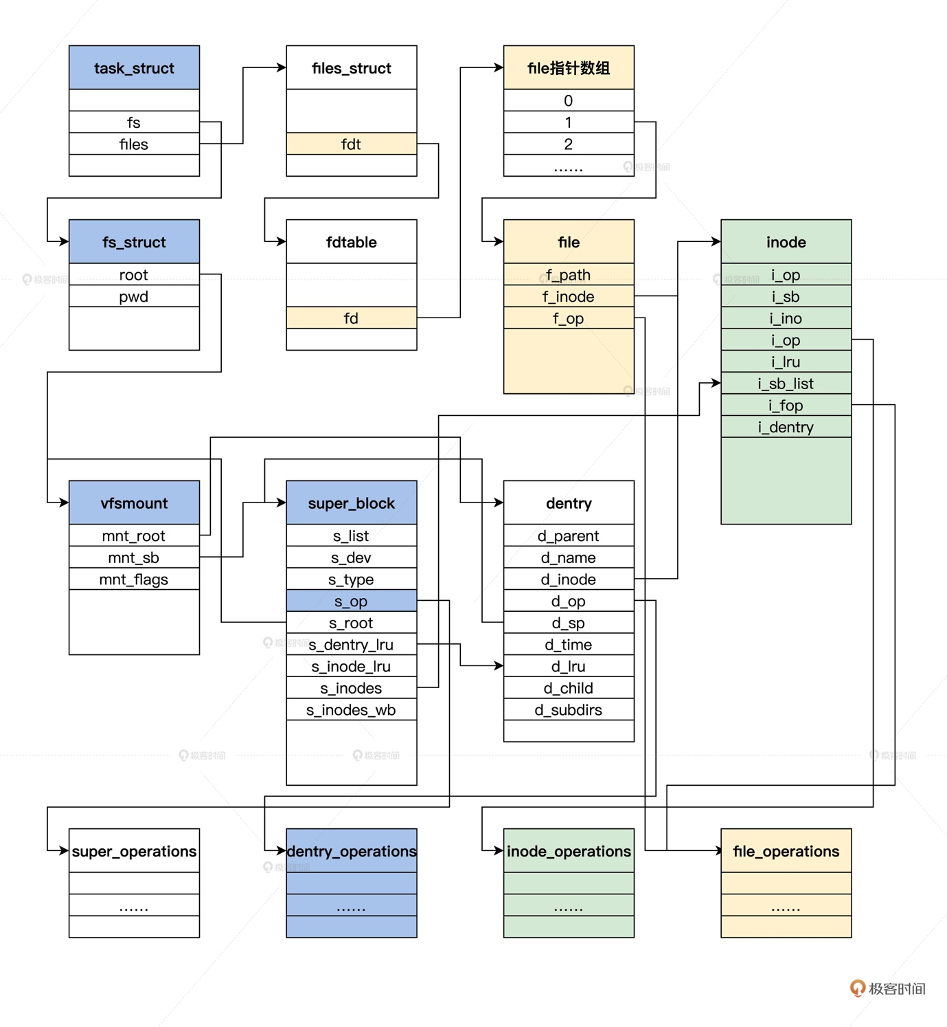

#### mount

mount允许vfs把多个不同的文件系统实现组织成一个树形结构，暴露给用户。它对用户屏蔽了不同的fs实现的差异。只要拿到这棵树，就可以访问上面的任意节点。

mount结构体是用来表示挂载一个文件系统需要用到的数据，一个文件系统可以挂载到多个挂载点，也就是一个文件系统可以有多个mount对象。

struct mount {

struct hlist_node mnt_hash;

struct mount *mnt_parent; // mount按照树形结构进行组织

struct list_head mnt_child; // and going through their mnt_child */

struct list_head mnt_mounts; // list of children, anchored here */

struct dentry *mnt_mountpoint; // 本文件系统的

struct mountpoint *mnt_mp; // 本文件系统的挂载点

struct vfsmount mnt;

union {

struct rcu_head mnt_rcu;

struct llist_node mnt_llist;

};

int mnt_count;

int mnt_writers;

struct list_head mnt_instance; /*mount instance on sb->s_mounts */

const char *mnt_devname; /*Name of device e.g. /dev/dsk/hda1 */

struct mnt_namespace *mnt_ns; /*containing namespace:这个挂载所在的namespace

struct list_head mnt_list;

struct list_head mnt_expire; /* link in fs-specific expiry list */

struct list_head mnt_share; /* circular list of shared mounts */

// master-slave结构吗？

struct list_head mnt_slave_list; /* list of slave mounts*/

struct list_head mnt_slave; /* slave list entry */

struct mount *mnt_master; /* slave is on master->mnt_slave_list */

union {

struct hlist_node mnt_mp_list;/* list mounts with the same mountpoint */

struct hlist_node mnt_umount;

};

struct list_head mnt_umounting; /* list entry for umount propagation */

int mnt_id; /* mount identifier */

int mnt_group_id; /* peer group identifier */

int mnt_expiry_mark; /* true if marked for expiry */

struct hlist_head mnt_pins;

struct hlist_head mnt_stuck_children;

} __randomize_layout;

// 挂载点表示

struct mountpoint {

struct hlist_node m_hash;

struct dentry *m_dentry; // 挂载点的目录项

struct hlist_head m_list; //挂载点组织成年Hash List

int m_count;

};

// 生成一个新的mount

struct vfsmount * do_kern_mount(const char *fstype, int flags, const char *name, void *data)

{

}

// mnt：new, p:existing mount, mp: mountpoint

// 所以我理解是说把mnt挂载到p上，挂载点是mp吗？

static int graft_tree(struct mount *mnt, struct mount *p, struct mountpoint *mp)

{

if (mnt->mnt.mnt_sb->s_flags & SB_NOUSER)

return -EINVAL;

// 新mount的根目录，必须是挂载点所在的目录

if (d_is_dir(mp->m_dentry) != d_is_dir(mnt->mnt.mnt_root))

return -ENOTDIR;

return attach_recursive_mnt(mnt, p, mp, false);

}

### 依据路径查找文件

findDentryByPath(path); // DFS

### 进程读文件的过程

Step1: Open

当process打开一个文件的时候，先根据文件路径找到对应的inode, 然后将它加载到内存中。FS就会创建文件的一个打开实例：File 结构体，然后在进程的open file table中分配一个索引，这个索引称为文件描述符（fd），最后把文件描述符和 file 结构体的映射添加到进程的打开文件表中。然后建立物理块与与进程的地址空间的一一映射。

那么每次就从root dentry开始往下按照name查找，直到找到对应的dentry, 然后返回iNode，就可以读取文件块了。Dentry同时是以Tree， List 和hashtable 多种形式存储的，用于加速查找（空间换时间）。

File**:**与一个进程相关的，当进程调用open(), 就会返回一个File 对象在内核中，但是暴露给用户空间的是一个file descriptor, 它在一个进程内是唯一的。是用户态文件对象的标识符。

struct task_struct {

// ...

struct fs_struct *fs; /* Filesystem information: */

struct files_struct *files; /* Open file information: */

}

Step2: Read

首次读取(at offset 0 unless lseek() has been called) will thus read in the first block of the file, consulting the inode to find the location of such a block; it may also update the inode with a new last- accessed time. The read will further update the in-memory open file table for this file descriptor, updating the file offset such that the next read will read the second file block, etc.

File对应的是打开的一个文件，文件是逻辑存储空间，文件的逻辑起始地址为0， 然后用一个f_pos表示当前位置，调用open打开一个文件时，f_pos指向0.

从OS看file的逻辑结构：

1. 字节流; (linux)
2. 记录式；

### 进程写入文件的过程

Step1: Open

Step2: Write (five I/Os)

* Read the data bitmap (which is then updated to mark the newly-allocated block as used)
* Write the bitmap (to reflect its new state to disk)
* two more to read and then write the inode (which is updated with the new block’s location)
* Write the actual block itself.

首先一个inode对应一个文件，它包含了(不一定连续的)若干个blocks。通过文件file写入数据的过程是什么?

Liang猜想:（感觉不对，未搜到相关记录） file是文件的逻辑空间，可以想象成一个连续的字节数组，然后用一个pos记录当前的字节的索引。这个file必须映射到非连续的blocks(物理空间).

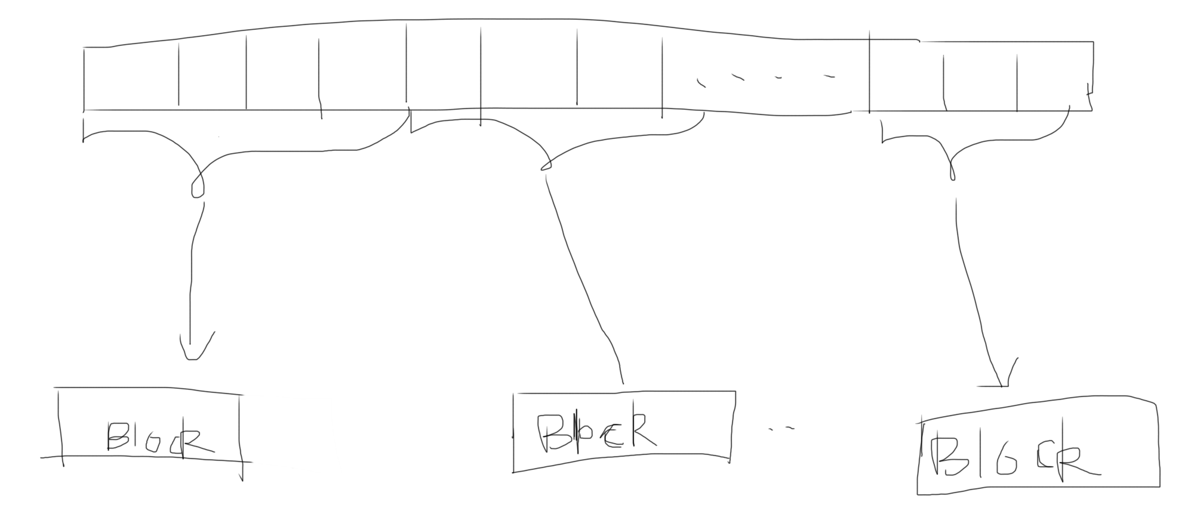

ssize_t write(struct file* f, const char __user * buff, size_t from, loff_t * );

实际上，在一般情况下，read/write是只跟缓存打交道的。（当然，存在特殊情况。下面会说到）。read就直接从缓存读数据。如果要读的数据还不在缓存中，则触发一次读盘操作，然后等待磁盘上的数据被更新到磁盘高速缓存中；write也是直接写到缓存里去，然后就不用管了。后续内核会负责将数据写回磁盘。为了实现这样的缓存，每个文件的inode内嵌了一个address_space结构，通过inode->i_mapping来访问。address_space结构中维护了一棵radix树，用于磁盘高速缓存的内存页面就挂在这棵树上。而既然磁盘高速缓存是跟文件的inode关联上的，则打开这个文件的每个进程都共用同一份缓存。

### Cache and Buffer

read cache: LRU cache

**write buffer (**Durability/performance trade-off)**:**

First, by delaying writes, the file system can **batch** some updates into a smaller set of I/Os; Second, by buffering a number of writes in memory, the system can then **schedule** the subsequent I/Os and thus increase per- formance; Finally, some writes are avoided altogether by delaying them; for example, if an application creates a file and then deletes it, delaying the writes to reflect the file creation to disk **avoids** them entirely.

<https://yq.aliyun.com/articles/8905>

Liang的思考过程：内存读写速度 >> 磁盘读写速度，必须引入磁盘缓存，读写文件都是内存与缓存之间的读写。（一个例外是当进程打开文件时，使用了O_DIRECT标志，在这种情况下，页面Cache被跳过，且使用了进程用户态地址空间的缓冲区。有些数据库应用程序使用O_DIRECT标志，这样他们可以使用自己的磁盘缓冲算法。）

读的时候如果cache miss, 那么就需要读磁盘，然后将数据写入缓存。写数据的时候，先将数据写入缓存。然后又OS同一调度，将缓存数据写入磁盘。

画外音： 考虑磁盘的物理结构，采用类似“电梯调度”之类的算法可以加快写入，这也是采用缓存的另一个优点。

问题1：在读取的时候首先查cache, 那么cache的该怎么存呢？

必须要建立inode中block到page cache的映射关系, 能够支持根据block信息快速查找对应的page cache.

方案1： LRU cache

Liang： HashMap<磁盘block地址， block数据>。因为OS读文件是按照Block地址去读取的。（LRU cache）

HashMap<block地址，ListNode>

class ListNode{

block_addr;

String Block_data;

ListNode prev;

ListNode next;

}

方案2： Address_space? (还未理解)

考虑inode之中需要存哪些东西？

1. 文件基本信息（略）
2. inode 到 page cache的映射
3. block的地址信息

### Crash Consistency

写入策略：如果程序写入缓存之后，需要立即写入磁盘还是延迟写入？

两种策略，重要的需要立即写入（inode）,不重要的可以延迟写入（无法完全保证数据一致性）。

那么如何保证数据的一致性呢？（延迟写入之前机器挂了怎么办？）

Write file involves write bitmap, data block, inode etc. These operations must be atomic, either commit all or nothing.

借鉴DBMS的思想： Journaling/WAL(Write-Ahead-Log)

### 磁盘IO模型

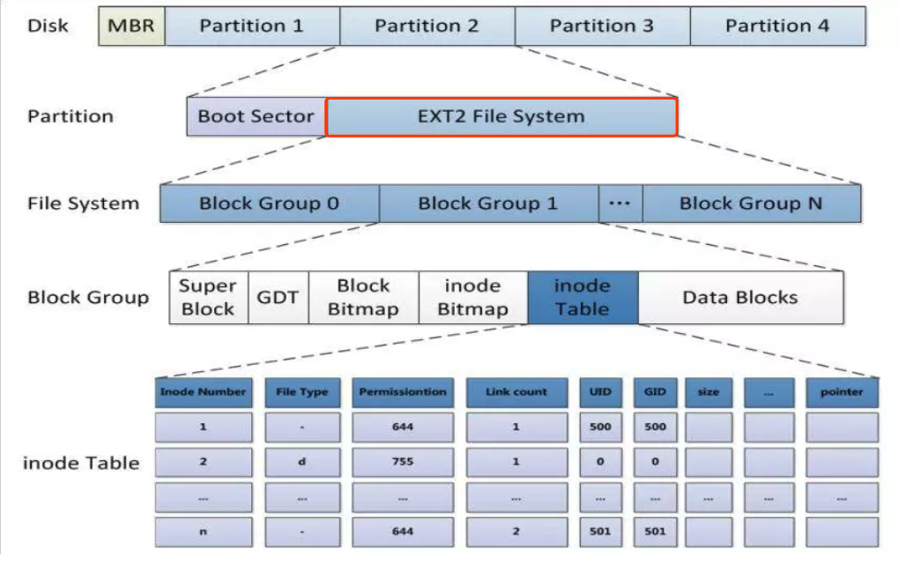

文件的存储模型：文件包含了若干个磁盘块(block)。有如下几种方式：

1. 连续分配

优点：读取快。

缺点：随着文件的删除容易产生零碎空间，如果想在文件后面append,需要移动后面的文件。

1. Linkedist

优点：没有碎片

缺点：读取慢(只能顺序读取); 指针也要花费额外空间；指针数据损坏后，后续数据丢 失

1. FAT

在内存中用一张表记录（2）中的指针。

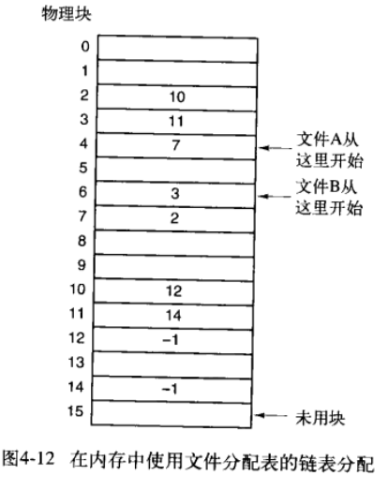

缺点：表占用空间太大，并且要一直保存那些没打开的文件。

1. inode索引

每个文件对应一个inode, 它包含了一个array of block address. 每个元素记录了块的位置。

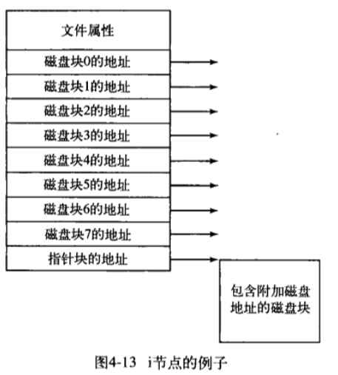

Use cases:

* Create a new file：给定一个文件名（或者叫路径），在Tree中插入一个dentry
* Write a file：给定一个文件名(路径)和一些数据，把这些数据写入文件名对应的块。
* Read a file:按照文件名找到inode, 从root dentry 进行DFS。
* Delete a file:按照文件名找到对应的dentry, 然后释放文件对应的block, 并删除dentry 节点

空闲块管理与分配算法

1. Bit vector:

在内存中保存bit vector, each bit coorepsonds to a block, 1 represent the block is used, 0 represents the block is free

1. Linked List

将空闲块按照linkedlist 链接起来

写Block的调度：buffer中保存一个队列，里面有许多待写入的文件块，如何按照硬盘的物理结构安排他们的写入顺序？

<https://zhuanlan.zhihu.com/p/22604682>

1. 先到先写
2. SSTF Scheduling
3. C-SCAN Scheduling
4. Selection of a Disk-Scheduling Algorithm

文件系统Buffer Cache:

用来缓存Block。 某个文件需要写Block的时候，有两种策略：

1. 先写入Buffer, 再写入磁盘；
2. 异步写：写入buffer后，并不是立即把block写入磁盘。稍后由OS 统一批量写入。

好处：批量写入效率更高，考虑电梯调度算法，将block在磁盘上的顺序排序，然后写入。

问题：容易产生某些block永远无法写入； 如果电脑挂了，怎么保证数据不丢失?

Page Cache:

用来缓存Map<文件名， 文件数据(a list of blocks)>

读写文件的过程：

第1种方式：

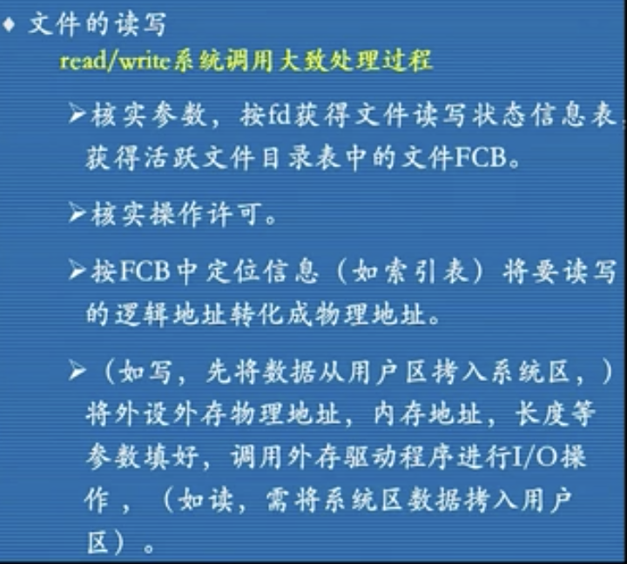 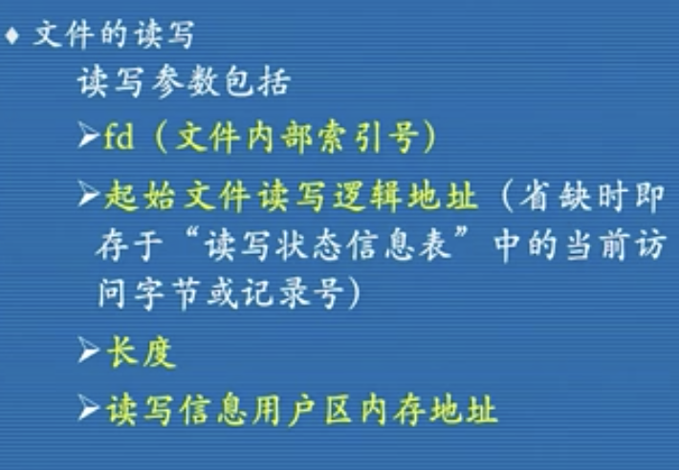

第2种方式：

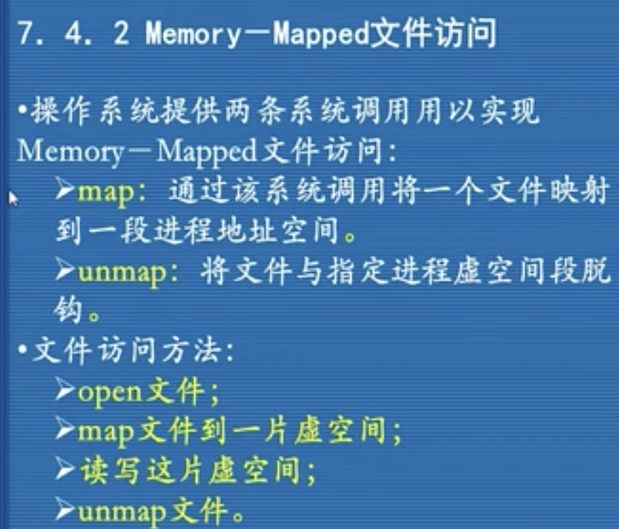

打开的文件---->字节流----->逻辑块------>page cache ------>物理块------>buffer cache---------->磁盘

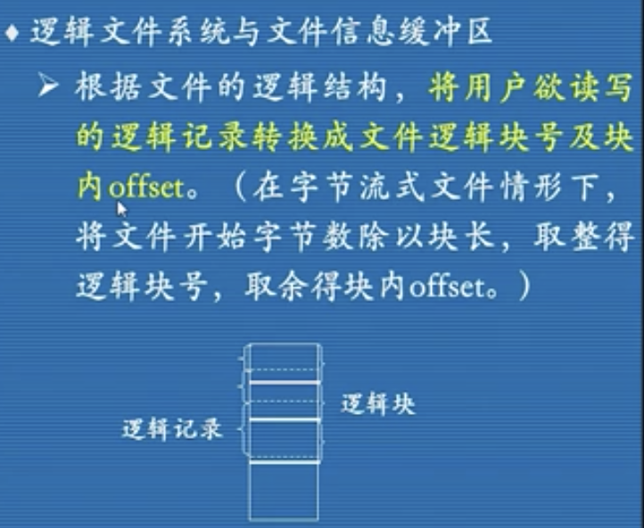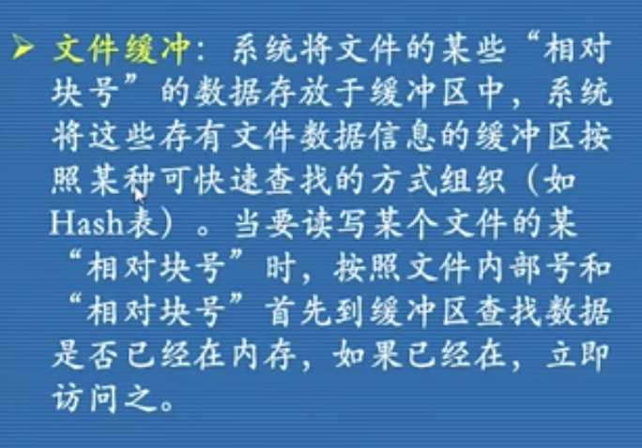

相对块号就是逻辑块号

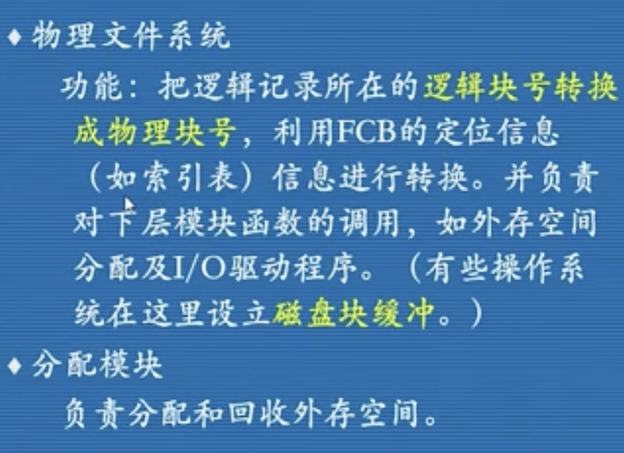

## File/ Block /Object based storage

### Object storage

Objects are discrete units of data that are stored in a structurally flat data environment. There are no folders, directories, or complex hierarchies as in a file-based system

Each object is a simple, self-contained repository that includes the data, metadata, and an ID.

Object storage removes the complexity and scalability challenges of a hierarchical file system with folders and directories.

Liang: 确实，如果使用类似hierarchical file system的结构的话，就会有个single node来保存这个hierarchical structure, 这个单点就构成了系统的瓶颈，一个是不好扩展，另一个是会产生系统瓶颈，还有单点失败的风险。

### File storage

A hierarchical storage system like this works well with relatively small, easily organized amounts of data. However, as the number of files grows, the search and retrieval process can become cumbersome and time-consuming.

### Block storage

## IO Management

### Blocking/Nonblocking

1. 调用open()函数打开一个文件的时候，指定flag | O_NONBLOCK
2. 在driver的部分也需要检测flag是否是非阻塞的，然后实现对应的操作.

epoll

/*

* This structure is stored inside the "private_data" member of the file

* structure and represents the main data structure for the eventpoll

* interface.

*/

struct eventpoll {

/* Protect the access to this structure */

spinlock_t lock;

/*

* This mutex is used to ensure that files are not removed

* while epoll is using them. This is held during the event

* collection loop, the file cleanup path, the epoll file exit

* code and the ctl operations.

*/

struct mutex mtx;

/* Wait queue used by sys_epoll_wait() */

wait_queue_head_t wq;

/* Wait queue used by file->poll() */

wait_queue_head_t poll_wait;

/* List of ready file descriptors */

struct list_head rdllist;

/* RB tree root used to store monitored fd structs */

struct rb_root_cached rbr;

/*

* This is a single linked list that chains all the "struct epitem" that

* happened while transferring ready events to userspace w/out

* holding ->lock.

*/

struct epitem *ovflist;

/* wakeup_source used when ep_scan_ready_list is running */

struct wakeup_source *ws;

/* The user that created the eventpoll descriptor */

struct user_struct *user;

struct file *file;

/* used to optimize loop detection check */

int visited;

struct list_head visited_list_link;

#ifdef CONFIG_NET_RX_BUSY_POLL

/* used to track busy poll napi_id */

unsigned int napi_id;

#endif

};

## 网络

网卡也是一种IO设备，可以参考Chapter 10 IO Device.

// 网卡驱动程序入口和退出函数

drvstus_t device_entry(driver_t* drvp, uint_t val, void* p);

drvstus_t device_exit(driver_t* drvp, uint_t val,void* p);

// 网卡中断处理函数

drvstus_t device_handle(uint_t ift_nr, void* devp, void* sframe);

发送过程总览

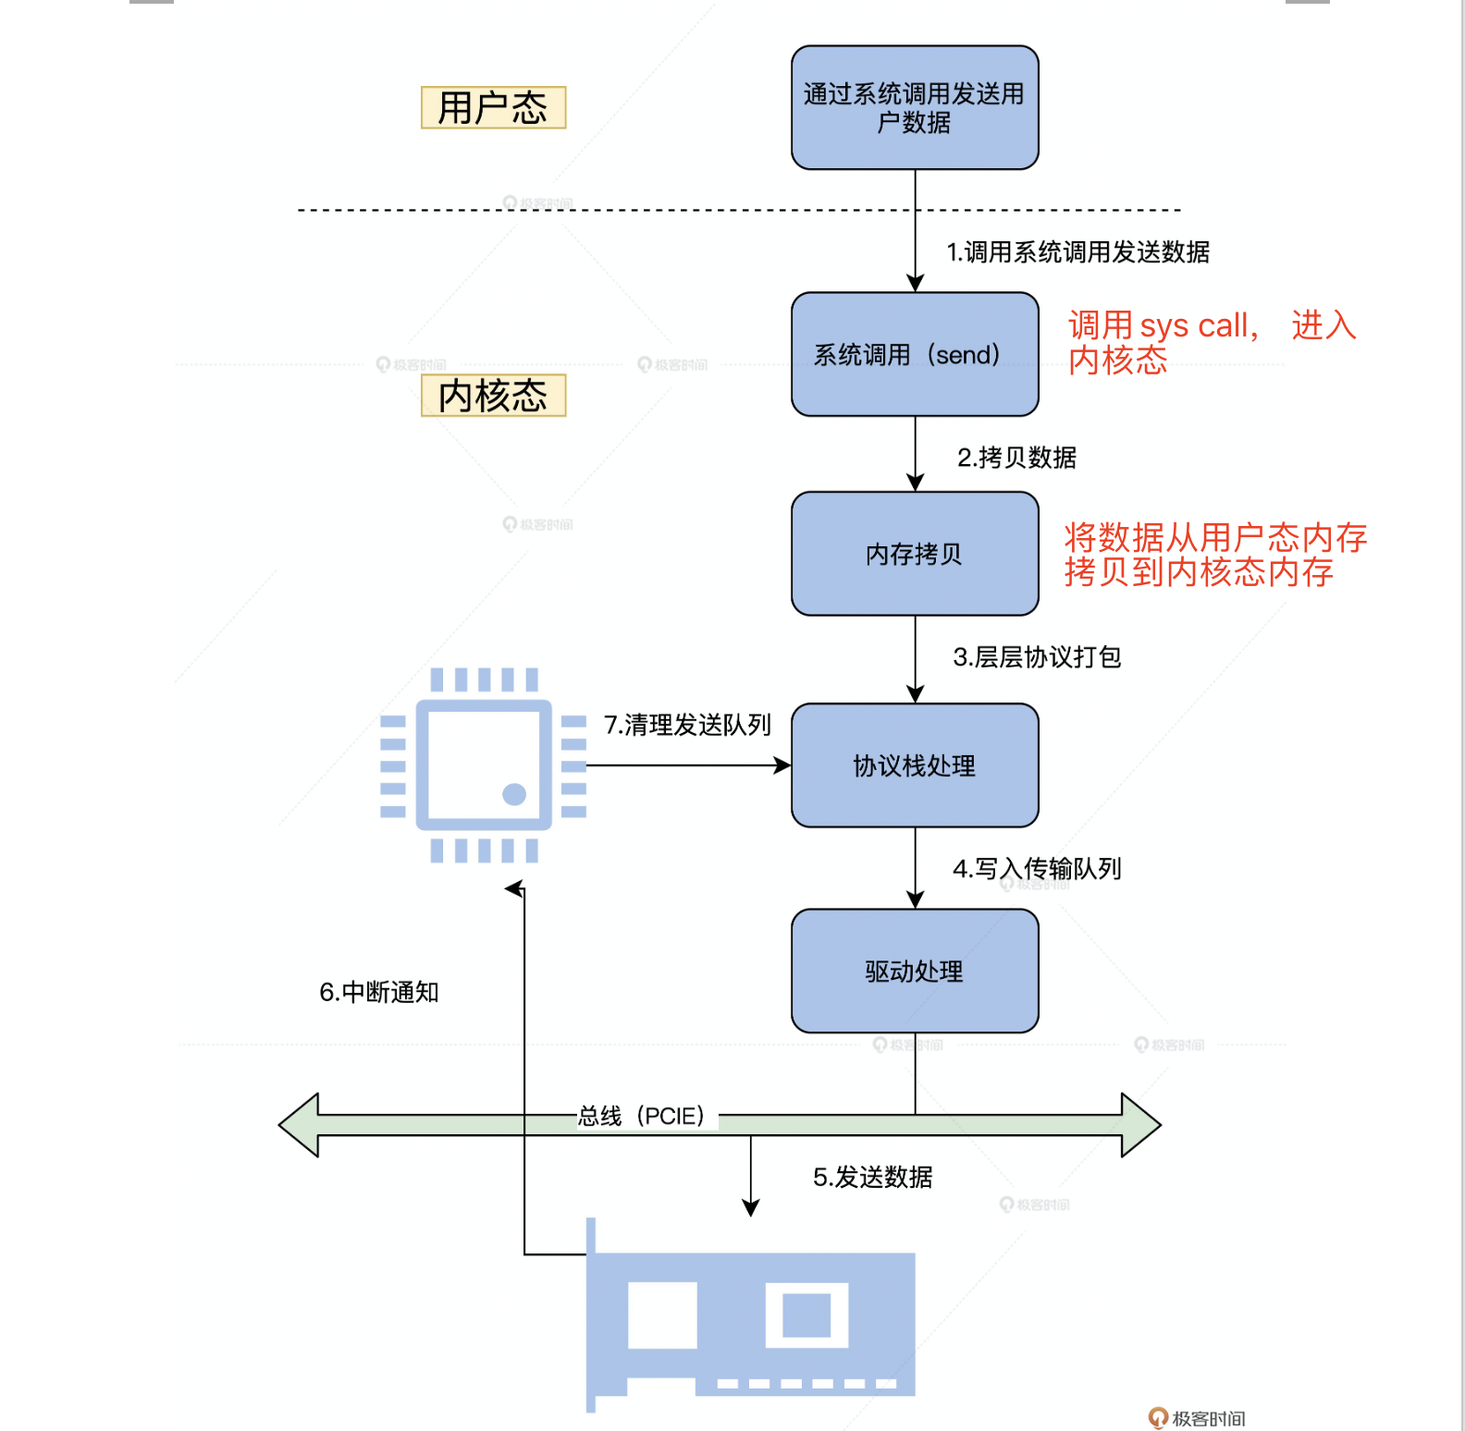

接收过程总览

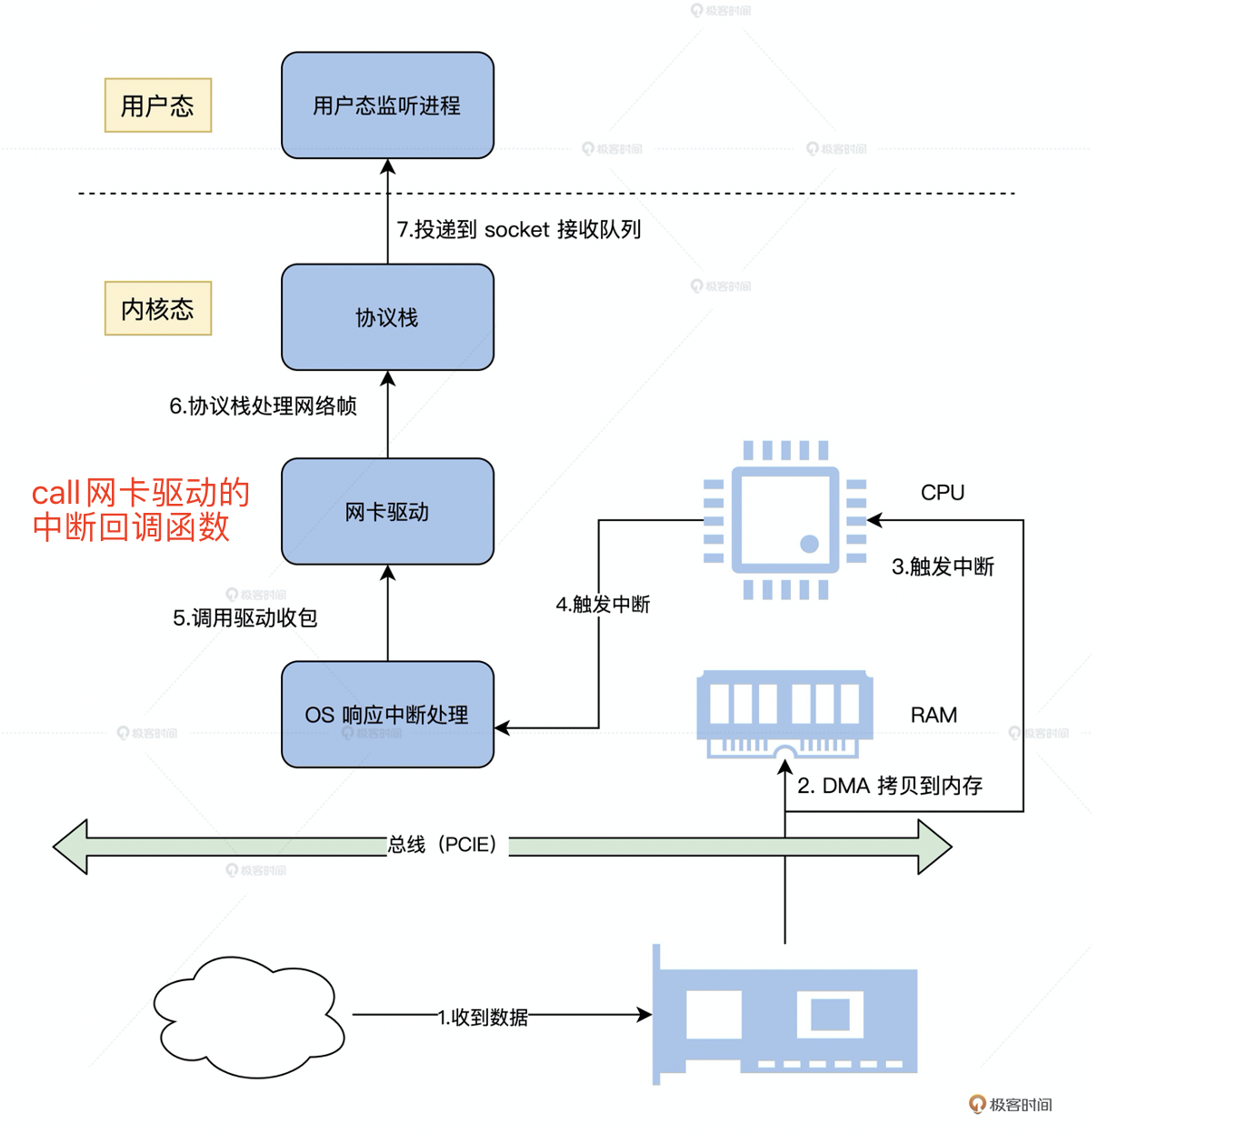

# 附录

## 前置硬件知识

### CPU指令执行

Liang: 在冯诺依曼体系提出之前，计算机像一个黑盒，有一个或多个输入(假设有8个开关表示八个bit)，然后有一个输出。

首先，程序员需要：

1. 调整输入开关来表示输入的二进制数(每个开关表示一个bit);

2. 调整控制加法器到底是加法还是减法的开关;

3. 控制电源通电，得到一个输出.

4. 重复上述步骤执行下一条指令

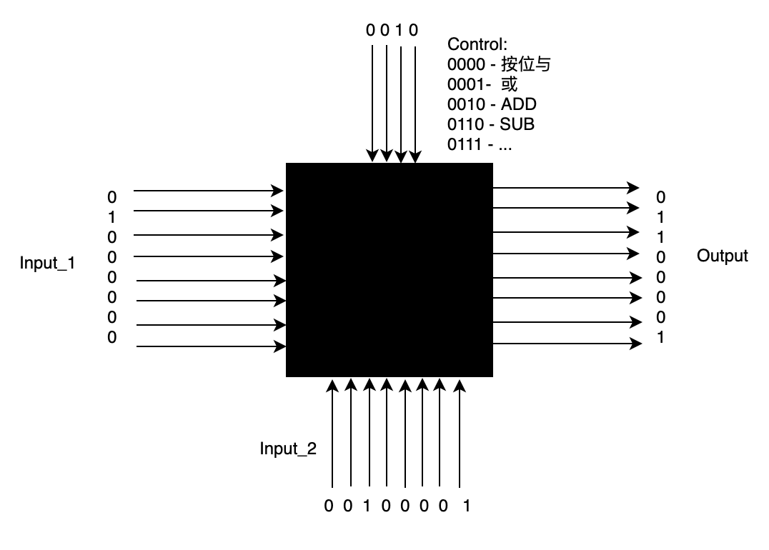

* CPU的Core相当于黑盒，输入/输出/控制位(二进制数: 也就是开关的开闭状态) 保存在寄存器中。

*注：CPU一直处于通电状态，此处省略接电脚针*

* Clock：由于电路中电流传输需要一定的时间，所以需要等待一段时间让整个电路达到一个稳定的状态。一条指令需要用到多个总线上的设备, 所以需要一个clock来协调各个设备的协同；

*注: CPU内部集成了时钟电路，每次在时钟信号上沿执行指令并输出。*

* 内存数据<==(读写)==>寄存区的本质是什么？内存和寄存器不过相当于一堆开关(比如内存数据是01010000，它本质上就是8个开关的开闭状态)，它们通过导线连接。那么数据加载到寄存器，使得寄存器的开关状态也变成了01010000, 那么是怎么实现的呢？

寄存器和内存的基本单元是锁存器(更高级的是触发器)，可以让输入的数据保持住，只需一次输入，即使后面输入全部撤销或发生改变， 输出也不会改变，只要保持通电状态(通常元器件需要专门的引脚接电源)。

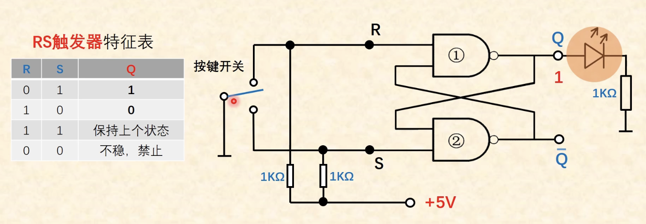

那么寄存器其实也是多组锁存器的组合(每个bit一个锁存器)， 只要一次输入（比如01001000），就会被保存，以后的输出总是和输入相同（01001000）， 从而实现保存数据。

那么可以再加一个时钟引脚，当时钟信号为1时，允许重新输入，当时钟信号为0时，锁存器不响应输入的变化，保持之前状态。

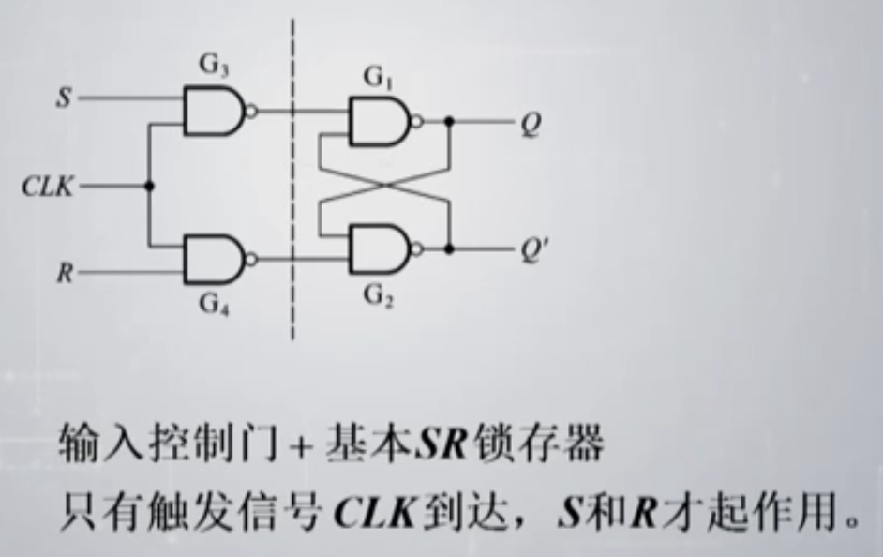

汇编语言可以简单地理解为二进制机器语言的一种符号表示，跟机器语言是一对一的关系。使用汇编语言执行一条指令的过程大致就是：

* LOAD立即数/内存地址/其他寄存器 into register.
* 执行指令: ADD reg_1, reg_2
* STORE register into memory

### Interrupt&IO Device

#### 中断初始化

//中断描述符

typedef struct s_descriptor /* 共 8 个字节 */

{

u16_t limit_low; /* Limit */

u16_t base_low; /* Base */

u8_t base_mid; /* Base */

u8_t attr1; /* P(1) DPL(2) DT(1) TYPE(4) */

u8_t limit_high_attr2; /* G(1) D(1) 0(1) AVL(1) LimitHigh(4) */

u8_t base_high; /* Base */

}__attribute__((packed)) descriptor_t;

Requirements：外部设备可以是无穷多个，但是所有设备必须共享一个CPU中断引脚。这也就是为什么我们引入中断控制器的原因。

**IO device** --(中断信号) --> **中断控制器**--(vector)-->**CPU**

#### 中断控制器

中断控制器的功能是：把外设的中断信号，转换成CPU能够明白的vector，并完成中断执行控制，确保在合适的时机把中断提交给CPU执行。对这部分内容，《interrupt in linux》有详细的描述。

Liang: 由于开发人员预先不知道IO device 会被插入哪个主板接口(但是知道哪一类接口，比如usb, pci-e2.0等)，并且开发人员不知道当前主板上已经插入了哪些IO devices. 所以我猜想，添加中断的过程是这样的：

* 由驱动开发人员调用OS中断框架的接口，在IDT里面注册一个gate descripter, 从而得到一个vector;
* 然后在中断控制器的维护一个中断信号和vector的映射表，但是中断信号如何identify???通过设备的id和IO port？？？

问题1： 硬件的中断号是怎么分配的？

Liang: 所有IO设备都是跟中断控制器连接的，当计算器启动的时候，中断控制器检测所有跟它相连的IO设备，并为其分配一个硬件中断号。中断控制器会维护一个中短线到中断号的映射

#### 中断处理

以Intel X86为例：

Before the IDT can be used, the base address and limit for the IDT must be loaded into the IDTR register using an LIDT instruction. This operation is typically carried out immediately after switching to protected mode.

The IA-32 Architecture defines **18** predefined interrupts and exceptions and **224** user defined interrupts, which are associated with entries in the IDT(interrupt descriptor table). Each interrupt and exception in the IDT is identified with a number, called a **vector**.

**Vector** references one of two kinds of gates in the IDT: an **interrupt gate** or a **trap gate**. They provide the following information:

* Access rights information (权限)
* The segment selector for the code segment that contains the **handler procedure.**(中断处理程序的地址)
* An **offset** into the code segment to the first instruction of the handler procedure. (中断处理程序当前执行到那条指令了，基于第一条指令的偏移量)

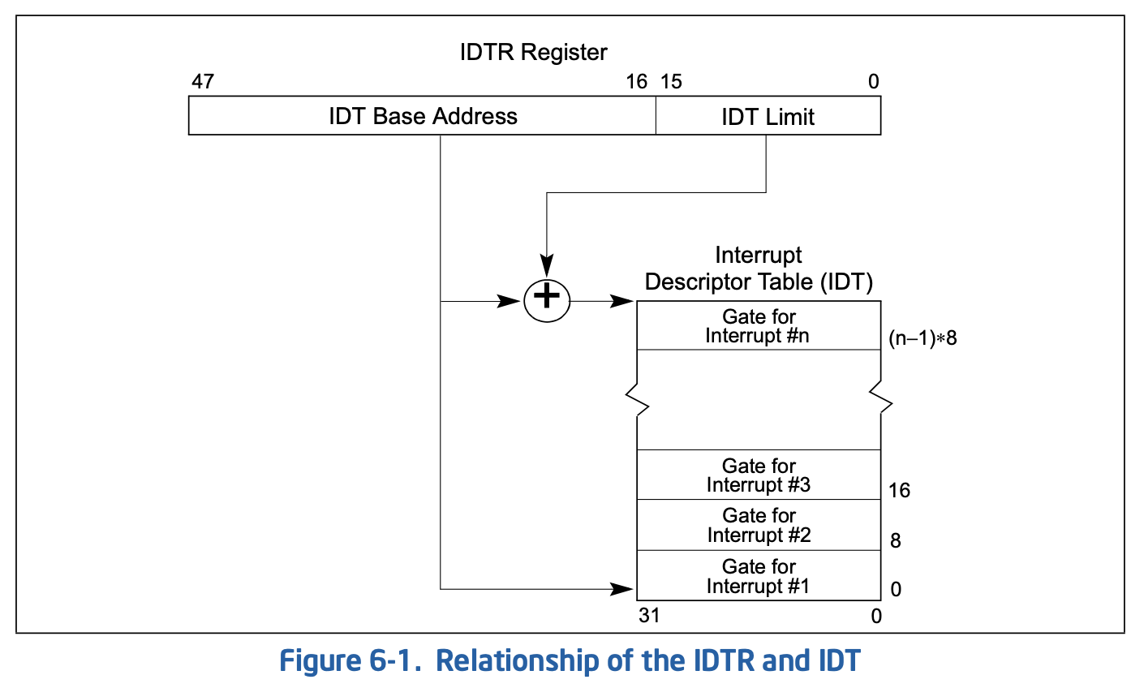 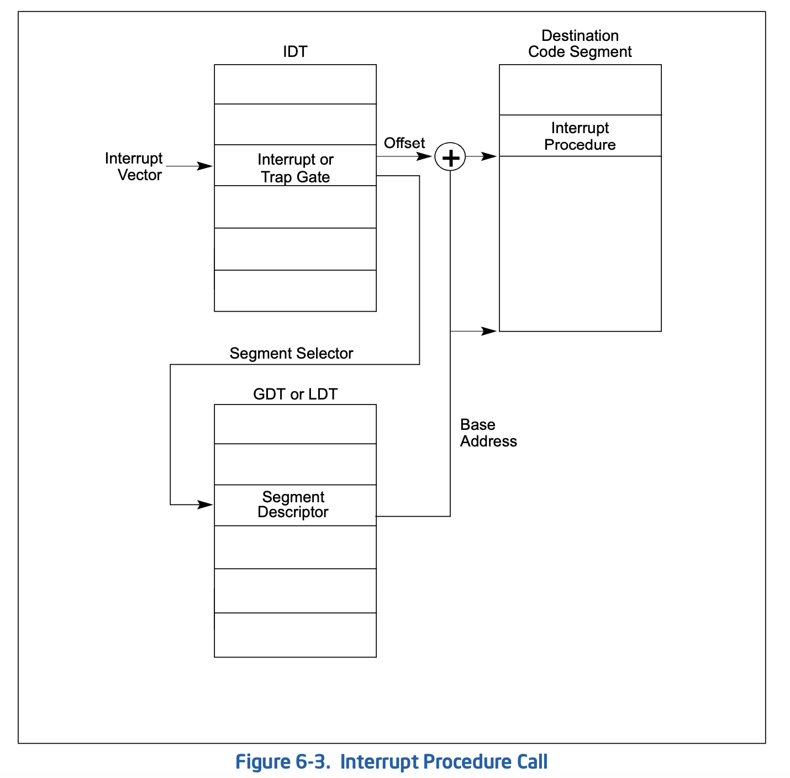

#### Linux的中断框架

需求：

* 一个系统中可能有多个中断控制器，每个中断控制器有自己的一套硬件中断号(hw_irq);
* 多个device可以共享一个中断号.

LINUX中断框架

|  |  |  |
| --- | --- | --- |
| 硬件概念 | linux数据结构 | 说明 |
| 中断向量(vector) | irq | linux中断系统的中断号 |
| 中断处理函数 | irq_action | 中断处理函数(ISR - Interrupt Service Routine)，按理应该就是一个函数指针，可这里确是一个指向struct irq_action的指针。  这是因为在早期的一些处理器中，多个设备共享一个中断号。因此一个中断号就会对应多个不同的ISR，它们通过一个单向链表串联在一起的。 |
| IDT | irq_desc[] |  |
| Interrupt gate descriptor | irq_desc |  |
| 中断控制器 | irq_chip, irq_domain | irq是linux中断框架中的中断号，它和硬件中断号存在一个映射关系。每个中断控制器都有一个irq_domain结构体，维护了这个映射关系。  irq_chip是一组函数指针，由中断控制器都实现 |

数据结构

struct irq_chip {

const char *name;

// some api the interrupt controller driver should implment

void (*irq_enable)(struct irq_data *data);

void (*irq_disable)(struct irq_data *data);

void (*irq_mask)(struct irq_data *data);

void (*irq_unmask)(struct irq_data *data);

void (*ipi_send_single)(struct irq_data *data, unsigned int cpu);

void (*ipi_send_mask)(struct irq_data *data, const struct cpumask *dest);

...

};

struct irqaction {

irq_handler_t handler;

void *dev_id;

struct irqaction *next;

...

}

struct irq_desc {

struct irqaction *action; /* IRQ action list */

…

}

struct irq_domain {

const char *name;

/* reverse map data. The linear map gets appended to the irq_domain */

unsigned int revmap_size;

struct radix_tree_root revmap_tree;

struct irq_data __rcu *revmap[];

};

struct irq_data {

unsigned int irq;

unsigned long hwirq;

struct irq_chip *chip;

struct irq_domain *domain;

…

};

Linux中断实验：

步骤：

1. 先知道使用的中断对应的中断号
2. 申请中断号：request _irq()，它会自动急活该中断号；如果不用了就调用 free _irq()
3. 注册中断处理函数

enable_irq(irq#)/disable_irq(irq#) : 关闭特定中断号中断

local_enable_irq/local_disable_irq: 关闭一颗cpu所有中断

### 并发保护

#### 原子操作

多个操作要么一起成功，要么一起失败，不可分割

#### spin lock

未抢到锁的线程忙等(不断try, 消耗cpu时间)， 适用于短暂的等待

#### Semaphore

#### mutex

自旋时间 > 线程switch out and in 时间 => 互斥锁 is better

### 内核时间

#### 系统时钟

每个厂商都有自己的时钟系统，为了通用性，大家都符合同一个标准：systik. 系统时钟会产生一个周期性的中断。

#### 定时器

软件定时器利用时钟中断来实现不同时间的定时器。

## Segmentation/Paging

段页机制是为了实现各个进程之间的isolation: 进程之间无法读写其他进程的内存。

Liang: 这对实现多租户系统有着参考意义.

### V1: 一个进程占用全部物理内存空间

要实现多道程序轮流分时执行，最简单的方法是：让一个进程使用全部物理内存，然后切换到其他进程的时候，将物理内存中的数据全部swap out into disk，并从disk上swap in another process.

ISSUE:

* Disk IO is too slow;
* 一个进程可能不需要用到所有的物理内存。

### V2: 切换进程的时候, 将数据留在物理内存中

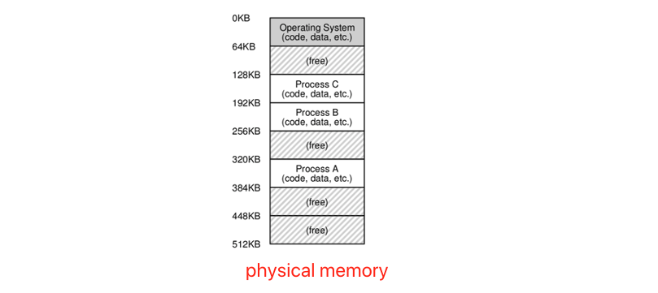

ISSUE: 当某个进程运行的时候, 如何阻止它访问其他进程的物理内存?

Liang: OS需要记录每个进程运行的物理内存地址，禁止进程访问不属于它的地址。那就要求进程的物理内存是连续的，否则要记录进程占用的全部物理内存地址，这就非常耗费空间且低效。

### V3: Address Space

一种virtualization技术，在物理内存上添加一个virtual address space层。

Each progress拥有相同的、连续的address space(比如0~4G)，它只能通过虚拟地址访问物理内存，实现了进程间的隔离。

ISSUE: 如何把地址空间映射到物理内存空间?

#### Dynamic Relocation

Each progress 的整个地址空间=>连续的物理内存空间, 并且进程的地址空间不能大于物理内存空间.

Implementation：

使用两个CPU寄存器base和bound分别保存base 和 bound in physical space.当程序开始运行时, OS 给它分配一个physical base address. 进程使用的地址是 virtual address, 由硬件负责把virtual address translate into physical address.按照下面的公式： physical address = virtual address + base. bound register负责判断进程访问是否越界?

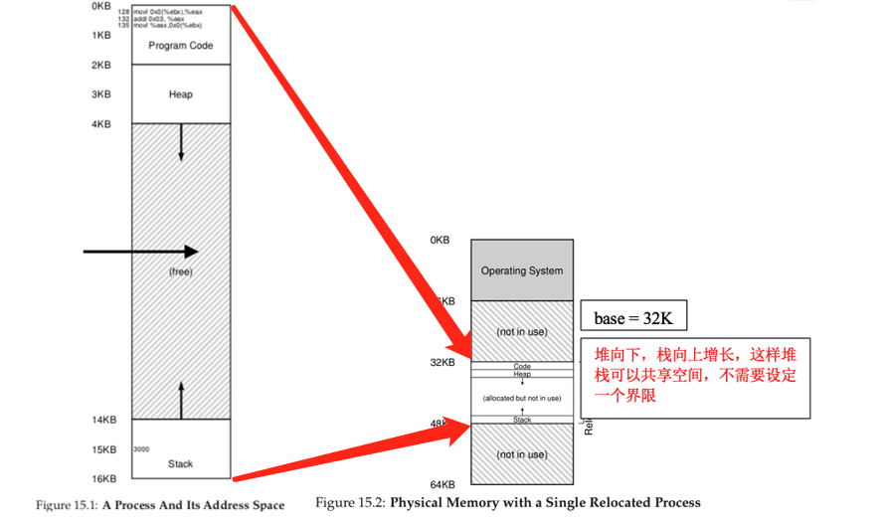

ISSUE:

进程内部未使用的部分也必须映射到物理内存(图中34kb~ 48kb is wasted, internal fragmentation);

进程的整个adress space在physical space中必须连续存放, 随着OS不断allocate memory /release memory, 真个内存会包含许多空洞，导致明明总的空闲空间足够大，但是每个空洞的空间却很小。

#### Segamentation

把进程的address space切割为a list of **variable-sized continuous** segaments (e.g. code segment, data segment, stack segment…) that are mapped into **discrete** physical memory.

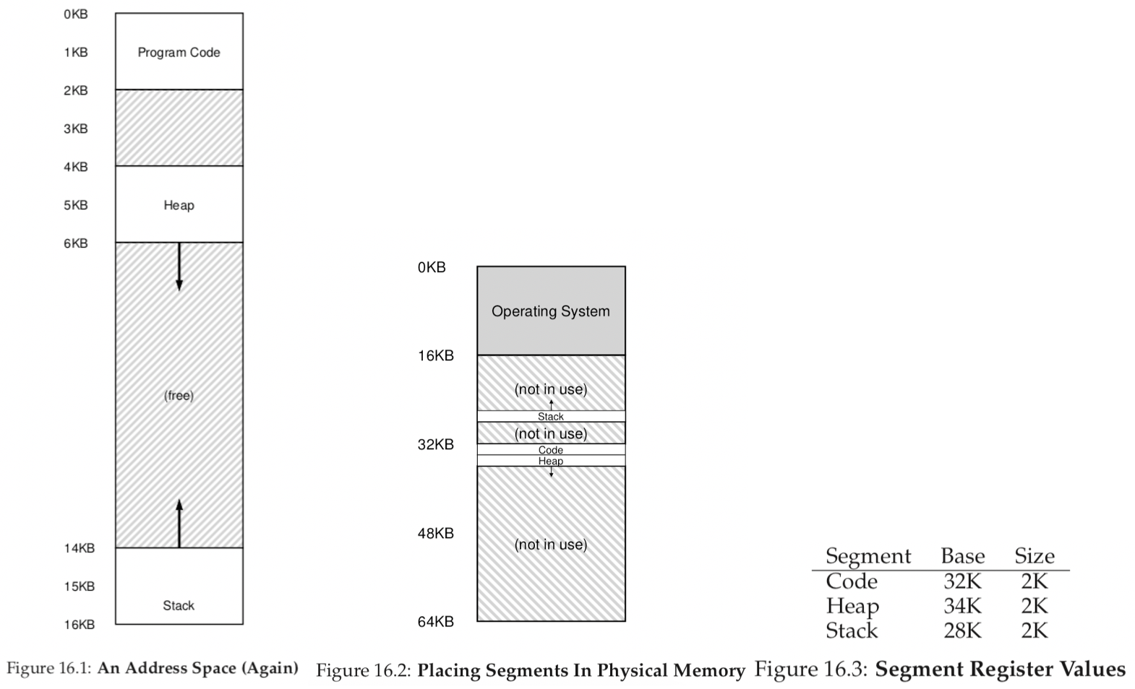

There is a trade-off for the granularity of segament:

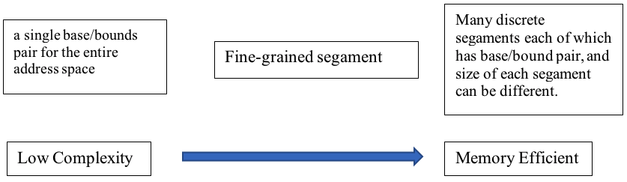

ISSUE:

* 由于每个segment大小不一致，随着segment allocation and deallocation, there will be a lot of holes with different size in memory.(external fragmentation).
* 内存管理对可变大小的segment比较困难, 需要记录每个segments的起始地址，这样才能定位一个segment.

#### Paging

把进程的 address space 切割为a list of **fixed-sized** **continuous** pages, each of which are mapped into **discrete** physical memory.

Liang: trade-off between memory usage efficiency and complexity of space management.

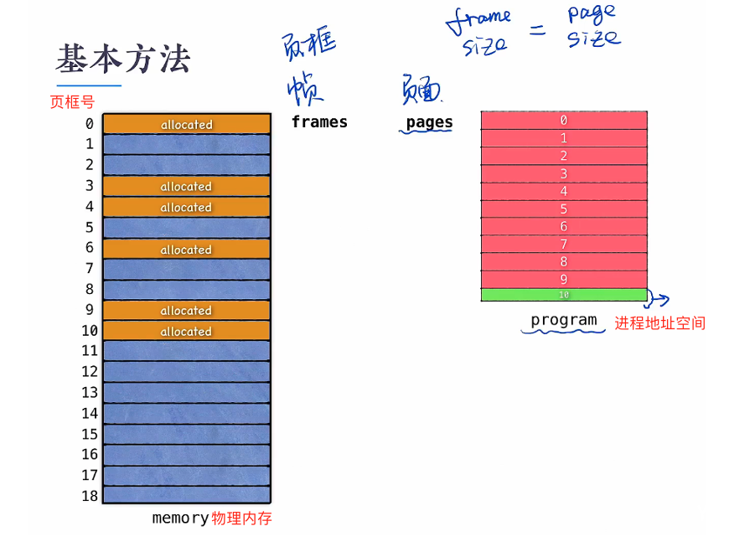 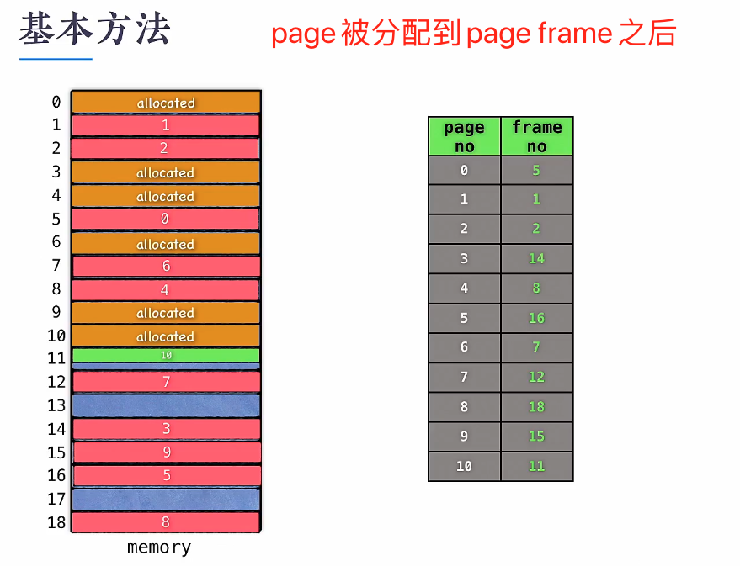

虚拟地址(va)=>物理地址(pa)

va ===>>> PAGE NO(=some bits of va) + OFFSET(=some bits of va) ==>>> PFN + OFFSET

Map VA to PFN 本质就是添加逐级添加页表项.

**ISSUE:** page table is too big.

虚拟地址必须是连续的, 这样page no才是连续==>>页号可作为PTE index of page table in each level, 这样在页表中依据page no查询PTE是O(1)的时间复杂度。这样一来未使用的page也必须有对应的PTE, 这样就造成了page table可能过大。

补充计算：对于32bit machine，每个进程的虚拟地址空间为4G( 4*1024*1024 kb). 如果一个page大小为4Kb，则需要1024*1024个pte(page table entry), 一个pte大小为4byte, 那么一个page table size为**4Mb**. 假设一台主机上跑了100个进程，那么就需要400Mb来保存页表.

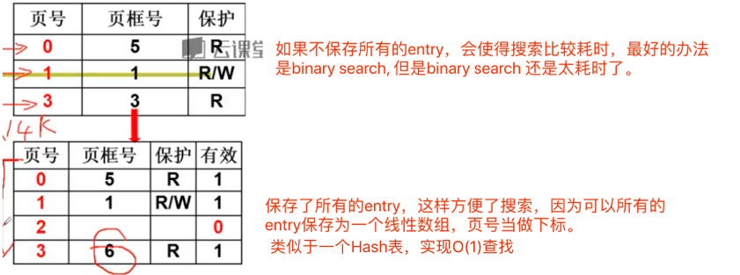

**SOLUTION**: Multi-Level Page Tables

采用多叉树形存储页表，那么复杂度降为O(h)。对于没有使用的pages, 它所在的page table entry不指向任何下级page table.

Liang:利用时间换取空间，设计始终都是trade-off. 没有最好的，只有最合适的

类比书籍的章节结构：章的编号是连续的(0-based)，每一章包含的节也是连续的(0-based).

#### Hybrid

Avoid assign PTE to unused page

可以将对进程先进行分段(code, heap, stack), 这样避免了为还未使用的segment分配内存，然后段内进行分页。

Liang: 那么每段一个页表？



SN: 01- code; 10-heap; 11-stack;

AddressOfPTE = Base[SN] + PTB[VPN]

Base[]: 3 segment base registers

Each bounds register holds the value of the maxi- mum valid page in the segment.

## X86 Memory Management

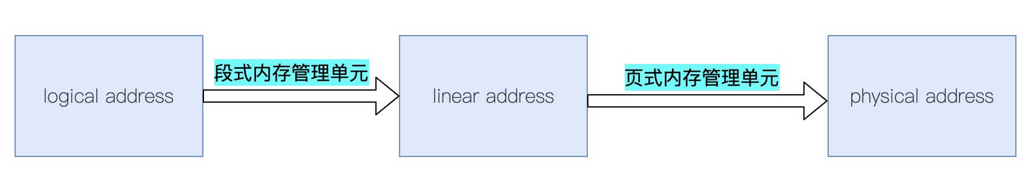

#### Segmentation(Logical Address)

A logical address consists of a 16-bit segment selector(ID of segment) and a 32-bit offset.

|  |  |  |  |  |
| --- | --- | --- | --- | --- |
| segment selector | | | | offset |
| 0 | 1 | 2 | 3 ~ 15 | 16 ~ 31 |
| Requested Privilege Level (RPL) | | GDT / LDT | Index of segment descriptor in the Descriptor Table | OFFSET in the segment |

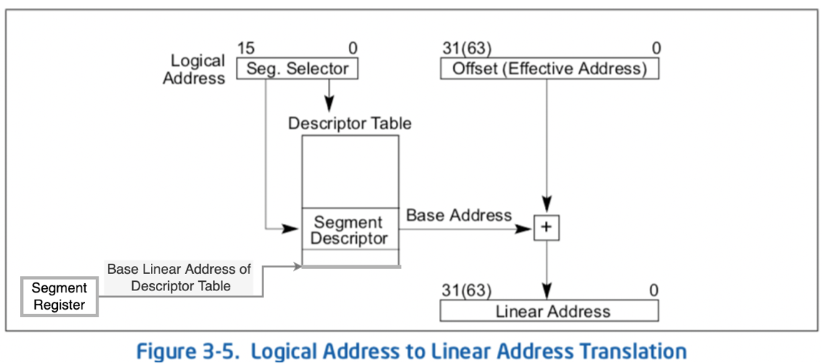

#### Paging(Linear Address)

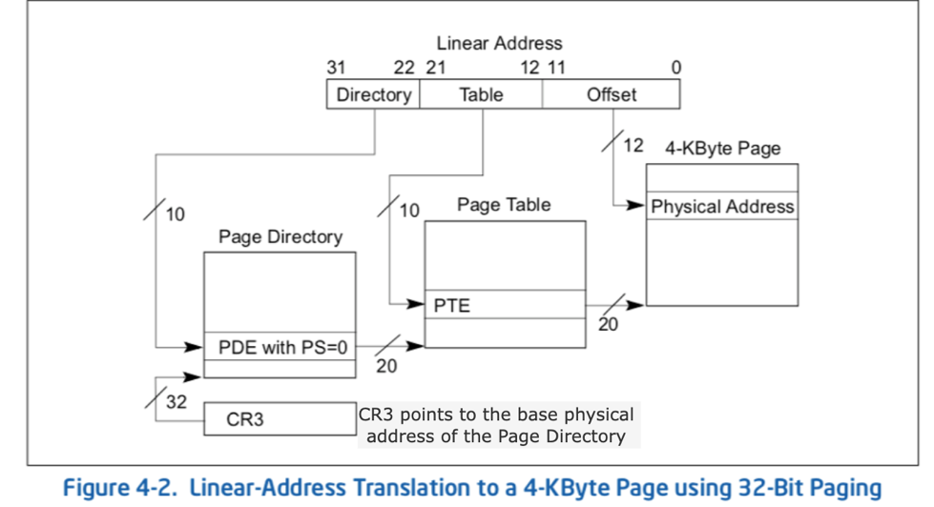

#### Hybrid(Segmentation & Paging)

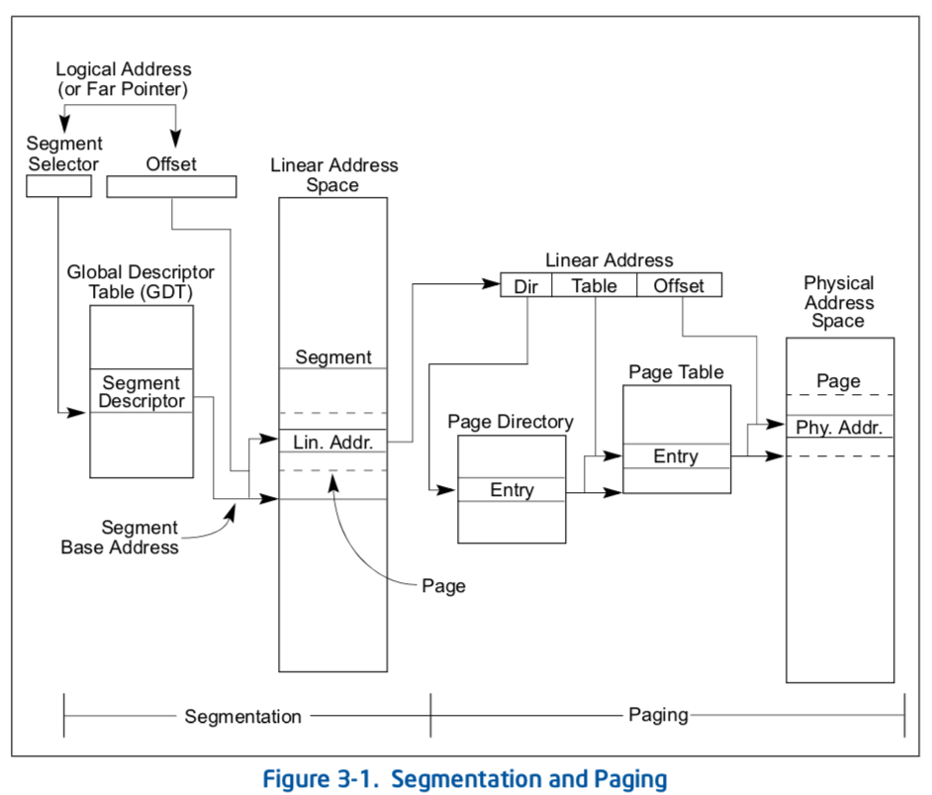

## IO Device

### device model:

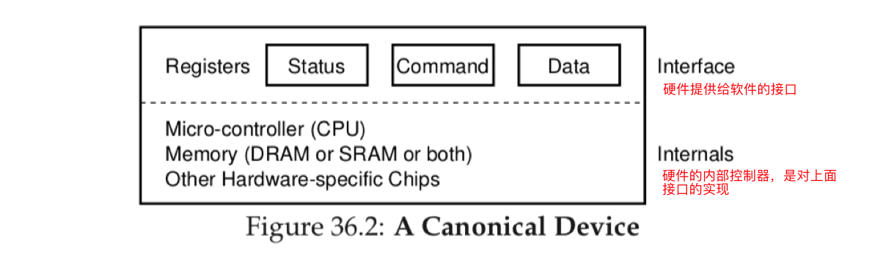

In the picture above, the (simplified) device interface is comprised of three types of registers.

|  |  |
| --- | --- |
| register type | description |
| status | can be read to see the current status of the device |
| command | tell the device to perform a certain task |
| data | pass data to the device, or get data from the device. By reading and writing these registers, the operating system can control device behavior |

**The Canonical Device Protocol Evolution:**

### V1. CPU keep poll IO controller

**STEP1**. OS waits until the device is ready to receive a command by repeatedly reading the status register (**polling** the device);

**STEP2**. OS sends some data down to the data register;

**STEP3**. OS writes a command to the command register;

**STEP4**. OS waits for the device to finish by again polling it in a loop, waiting to see if it is finished (it may then get an error code to indicate success or failure);

ISSUE: polling is inefficient;

### V2. The interrupt

The **interrupt** (allow for overlap of computation and I/O)

OS can issue a request, put the calling process to sleep, and context switch to another task. When the device is finally finished with the operation, it will raise a hardware interrupt, causing the CPU to jump into the OS at a pre-determined **interrupt handler**.

The **handler** is just a piece of operating system code that will finish the request and wake the process waiting for the I/O, which can then proceed as desired.

If a device is fast, it may be best to poll; if it is slow, interrupts, which allow overlap, are best.

Liang: 如果device可以很快完成任务的话，轮询更好；但是如果device比较慢，中断更好。因为如果设备很快的话，可能只需要轮询很少的次数就可以了，而中断需要挂起进程，然后等device就绪之后在切换回来，那么轮询消耗的时间如果小于进程切换的时间，那么轮询就划算，反之中断更划算。这不就类似于乐观锁和悲观锁吗？如果每个线程访问临界区时间很短，那就让每个线程自旋等待(忙等)，反之，就需要让线程阻塞，让出cpu的使用权。

ISSUE: Not efficient enough, when using Programmed I/O (PIO) to transfer a large chunk of data to a device, the CPU is once again overburdened with a rather trivial task.

Liang: 回顾一下CPU在整个过程中的工作:

(1) 首先cpu需要问device是否就绪，没有就挂起process;

(2) device就绪之后发起中断，cpu收到中断之后，告诉device需要什么数据，然后写 到哪块内存中，然后cpu继续执行其他任务；

(3) device把数据传输完毕之后，再次发送中断，然后cpu接受到中断后，把被挂起的 进程标记为ready, 等待调度。

整个过程，cpu需要参与的事情太多了，如果把这部分工作交给IO controller, cpu只需要告诉IO controller, 需要什么数据，到哪一块内存，然后等全部就绪之后，再发中断就很好了，中间不需要cpu再参与。

### V3. Direct Memory Access

A very specific device within a system that can orchestrate transfers between devices and main memory without much CPU intervention.

How it works:

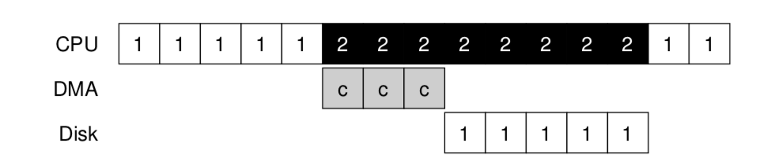

To transfer data to the device, for example, the OS would program the DMA engine by telling it where the data lives in memory, how much data to copy, and which device to send it to. At that point, the OS is done with the transfer and can proceed with other work. When the DMA is complete, the DMA controller raises an interrupt, and the OS thus knows the transfer is complete.

### CPU communicate with a device

The processor permits applications to access I/O ports in either of two ways:

1. Through a separate I/O address space;
2. Through Memory-Mapped I/O.(MMIO)
3. Explicit I/O instructions.

For example, on x86, the **IN** and **OUT** instructions can be used to communicate with devices.

* **IN AL imm8;** //Input byte from imm8 I/O port address into AL.
* **OUT imm8, AL; //** Output byte in AL to I/O port address imm8

1. Memory-mapped I/O. (no new instructions are needed)

The hardware makes device registers available as if they were memory locations. To access a particular register, the OS issues a **LOAD** (to read) or **STORE** (to write) the address; the hardware then routes the load/store to the device instead of main memory.

There is not some great advantage to one approach or the other. Both approaches are still in use today.

## Process

### IA-32架构的Task Management

#### Task structure

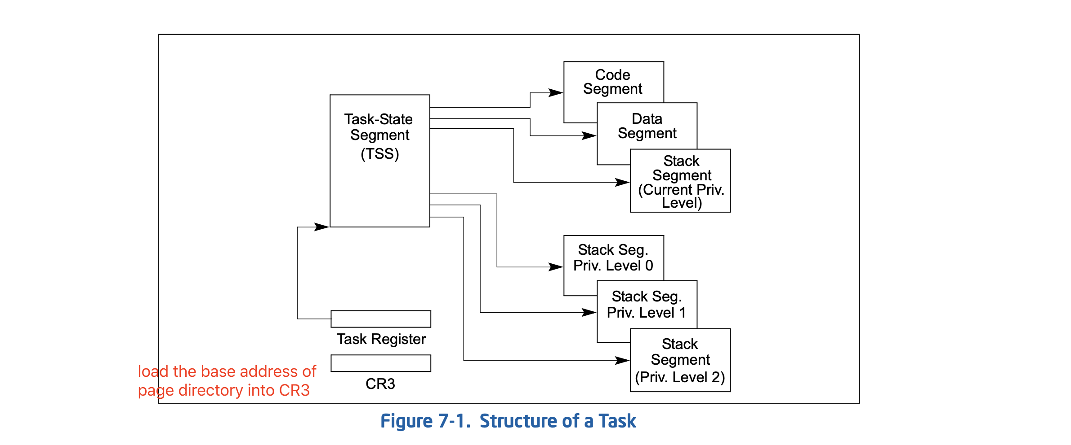

### 数据结构

将程序的一次运行抽象为一个进程，方便多道程序并发执行, 从而充分利用计算机资源。进程的切换是通过 CPU中断实现的。

进程切换涉及到context switch(保存现场和还原现场)，是需要消耗cpu的。比如服务器有大量IO请求的时候, 就会存在大量的上下文切换，导致cpu消耗。如果不切换的话，当前进程会阻塞导致 cpu空闲。也就是说如果一个进程 *IO的时间 > 进程上下文切换时间*，那切换就是赚的。

因为目前的IO控制器都足够智能，如果cpu发出一个IO指令，IO控制器能够在不需要 cpu干预的情况下，把数据加载到内存中(DMA)，并且在完成之后向cpu发送硬件中断，通知cpu. 这种情况下，cpu发出指令后，进程不会阻塞，所以进程不会被挂起(suspended)，也就不会有进程的上下文切换。

描述进程的数据结构

typedef struct s_THREAD

{

spinlock_t td_lock; //进程的自旋锁

list_h_t td_list; //进程链表

uint_t td_flgs; //进程的标志

uint_t td_stus; //进程的状态

uint_t td_cpuid; //进程所在的CPU的id

uint_t td_id; //进程的id

uint_t td_tick; //进程运行了多少tick

uint_t td_privilege; //进程的权限

uint_t td_priority; //进程的优先级

uint_t td_runmode; //进程的运行模式

adr_t td_krlstktop; //应用程序内核栈顶地址

adr_t td_krlstkstart; //应用程序内核栈开始地址

adr_t td_usrstktop; //应用程序栈顶地址

adr_t td_usrstkstart; //应用程序栈开始地址

mmadrsdsc_t* td_mmdsc; //进程地址空间

context_t td_context; //机器上下文

objnode_t* td_handtbl[TD_HAND_MAX];//进程打开资源的文件描述符

}thread_t;

机器上下文件

typedef struct s_CONTEXT

{

uint_t ctx_nextrip;

uint_t ctx_nextrsp;

x64tss_t* ctx_nexttss;

}context_t;

### 进程调度

进程链表

typedef struct s_THRDLST

{

list_h_t tdl_lsth; //挂载进程的链表头

thread_t* tdl_curruntd; //该链表上正在运行的进程

uint_t tdl_nr; //该链表上进程个数

}thrdlst_t;

对应一个cpu core

typedef struct s_SCHDATA

{

spinlock_t sda_lock; //自旋锁

uint_t sda_cpuid; //当前CPU id

uint_t sda_schdflgs; //标志

uint_t sda_premptidx; //进程抢占计数

uint_t sda_threadnr; //进程数

uint_t sda_prityidx; //当前优先级

thread_t* sda_cpuidle; //当前CPU的空转进程

thread_t* sda_currtd; //当前正在运行的进程,每个cpu core都有

一个当前正在运行的进程

thrdlst_t sda_thdlst[PRITY_MAX]; //进程链表数组

}schdata_t;

全局进程数据结构：给调度器使用(是个全局数据结构)

typedef struct s_SCHEDCALSS

{

spinlock_t scls_lock; //自旋锁

uint_t scls_cpunr; //CPU个数

uint_t scls_threadnr; //系统中所有的进程数

uint_t scls_threadid_inc; //用于分配进程id

schdata_t scls_schda[CPUCORE_MAX]; //每个CPU调度数据结构

}schedclass_t;

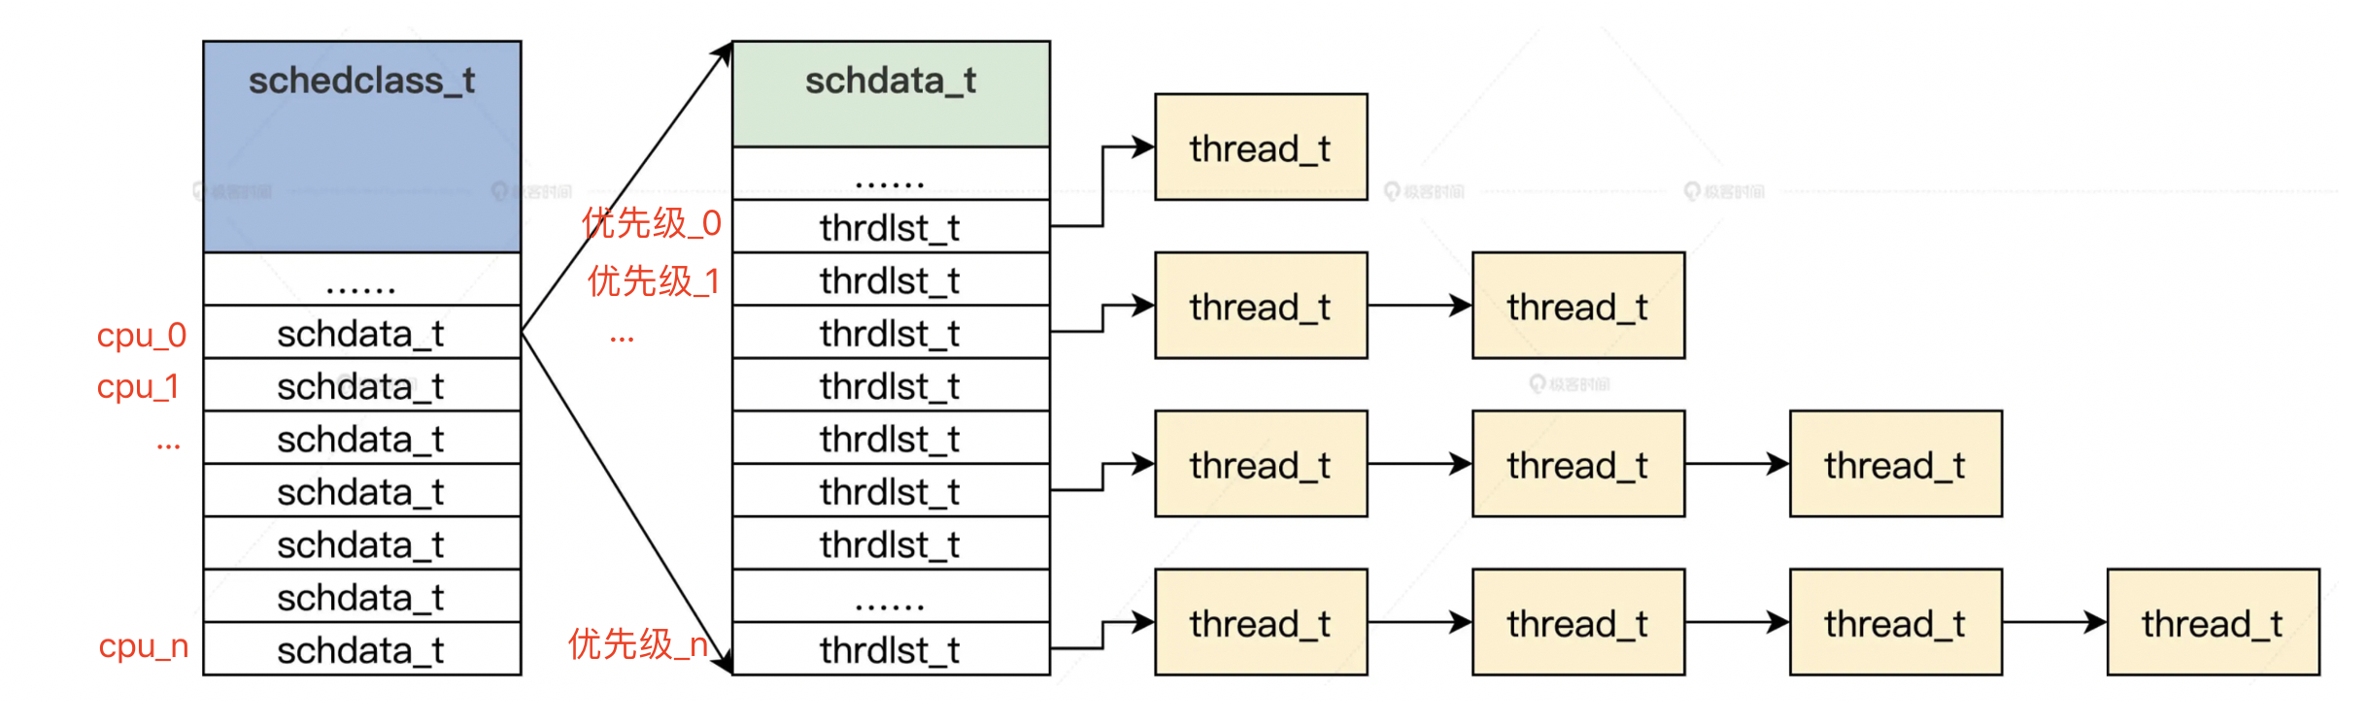

进程切换：

* Save当前进程的通用寄存器 into 当前进程的内核栈；Save CPU 的 RSP 寄存器into 当前进程的机器上下文结构。
* Load下一个进程机器上下文结构中的 RSP 的值（被保存在内存中的进程描述符中）into CPU 的 RSP 寄存器中；接着，调用一个函数切换 MMU 页表；最后，从下一个进程的内核栈中恢复下一个进程的通用寄存器。

/*必须使用汇编语言来操作寄存器*/

void save_to_new_context(thread_t *next, thread_t *prev)

{

__asm__ __volatile__(

"pushfq \n\t" //保存当前进程的标志寄存器

"cli \n\t" //关中断,因为这个过程不能被打断

//保存当前进程的通用寄存器。push: 把源操作数复制到堆栈

"pushq %%rax\n\t"

"pushq %%rbx\n\t"

"pushq %%rcx\n\t"

"pushq %%rdx\n\t"

"pushq %%rbp\n\t"

"pushq %%rsi\n\t"

"pushq %%rdi\n\t"

"pushq %%r8\n\t"

"pushq %%r9\n\t"

"pushq %%r10\n\t"

"pushq %%r11\n\t"

"pushq %%r12\n\t"

"pushq %%r13\n\t"

"pushq %%r14\n\t"

"pushq %%r15\n\t"

//保存CPU的RSP寄存器到当前进程的机器上下文结构中

"movq %%rsp,%[PREV_RSP] \n\t"

//把下一个进程的机器上下文结构中的RSP的值，写入CPU的RSP寄存器中

"movq %[NEXT_RSP],%%rsp \n\t" //事实上这里已经切换到下一个进程了，因为切换进程的内核栈

//调用__to_new_context函数切换MMU页表

"callq __to_new_context\n\t"

//恢复下一个进程的通用寄存器

"popq %%r15\n\t"

"popq %%r14\n\t"

"popq %%r13\n\t"

"popq %%r12\n\t"

"popq %%r11\n\t"

"popq %%r10\n\t"

"popq %%r9\n\t"

"popq %%r8\n\t"

"popq %%rdi\n\t"

"popq %%rsi\n\t"

"popq %%rbp\n\t"

"popq %%rdx\n\t"

"popq %%rcx\n\t"

"popq %%rbx\n\t"

"popq %%rax\n\t"

"popfq \n\t" //恢复下一个进程的标志寄存器

// 输出当前进程的内核栈地址

: [ PREV_RSP ] "=m"(prev->td_context.ctx_nextrsp)

// 读取下一个进程的内核栈地址

: [ NEXT_RSP ] "m"(next->td_context.ctx_nextrsp), "D"(next), "S"(prev) //为__to_new_context函数传递参数

: "memory"

);

return;

}

void __to_new_context(thread_t *next, thread_t *prev)

{

uint_t cpuid = hal_retn_cpuid();

//对应当前cpu core

schdata_t *schdap = &osschedcls.scls_schda[cpuid];

//设置当前cpu的当前运行进程为next

schdap->sda_currtd = next;

//设置下一个运行进程的tss为当前CPU的tss

next->td_context.ctx_nexttss = &x64tss[cpuid];

//设置当前CPU的tss中的R0栈为下一个运行进程的内核栈

next->td_context.ctx_nexttss->rsp0 = next->td_krlstktop;

//装载下一个运行进程的MMU页表,即将下个进程的MMU页表的首地址load到对应的寄存器(CR3)

hal_mmu_load(&next->td_mmdsc->msd_mmu);

if (next->td_stus == TDSTUS_NEW)

{

//如果是新建进程第一次运行就要进行处理

next->td_stus = TDSTUS_RUN;

retnfrom_first_sched(next);

}

return;

}

### 进程等待与唤醒

维护一个数据结构来保存所有的需要等待的进程。

只要当前正在运行的进程：

* 把自己加入等待队列
* 更新进程状态

注意：这里进程进入等待状态时，进程仍然在运行还未让出cpu，只是状态被更新，之后在调用调度函数的时候会被切换，此时等待进程才暂定运行。

## Disk工作原理

硬盘在逻辑上被划分为磁道(Track)、柱面(Cylinder)以及扇区(Sector)。

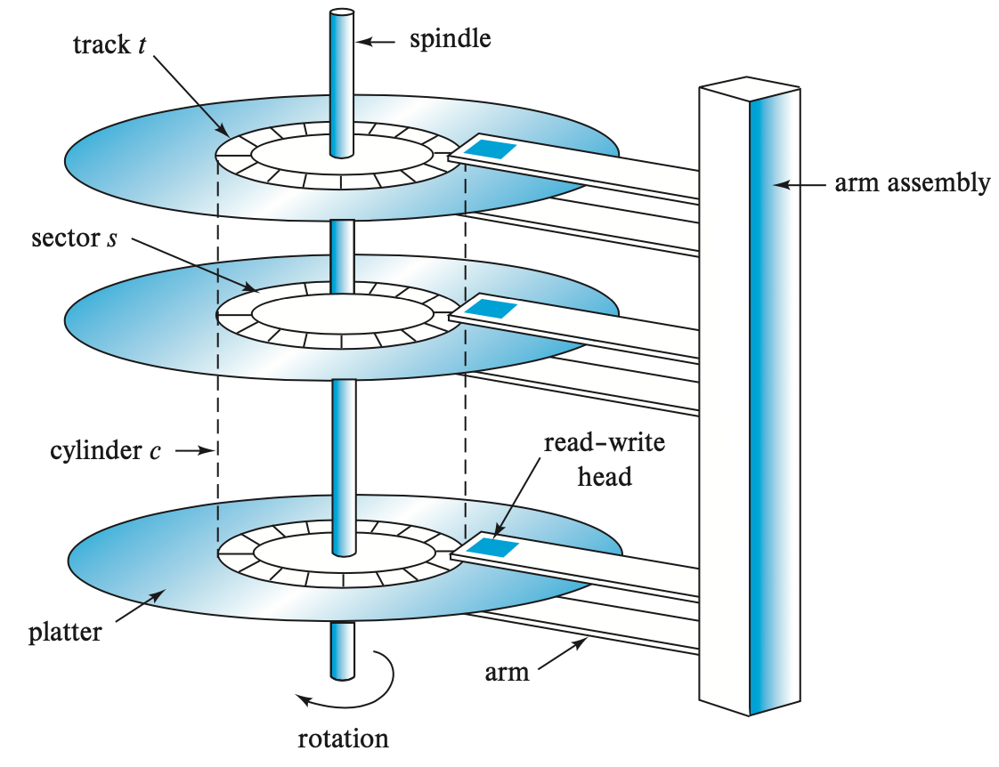

Access time

seek time： time for arm to reposition to right track. 2~20 ms

rotational latency time: time for disk to spin to the right sector. 4~11ms

* sector是硬盘的最小存储单位。每个扇区大小为512 Byte，包含数据和一些其他信息。一个扇区有两个主要部分：存储数据地点的标识符和存储数据的数据段。扇区的第一个主要部分是标识符。标识符，就是扇区头标，包括该扇区的三维柱坐标。
* block(逻辑块) 是OS文件系统的最小单位, 一般由连续的8个sector 组成 = 4kB.

Note： block size选取的trade-off

如果磁头读取最小单位是4kb的block(8 consecutive sector), 那么对一个 10M 的文件， 它占用2560 blocks，或者20480 sectors 。假设该文件对应的这些blocks或者sectors是分散在disk上，那么这样一来采用block方式读取文件就会大幅减少磁盘寻道时间，从而提高了读取效率。

但是逻辑块也并不是越大越好。因为一个block仅能包含一个文件的数据(这样能减少系统的复杂度)，如果小文件过多则会浪费存储空间。所以好的方式是根据实际的使用场景来设置block size。

主引导记录（Master Boot Record，MBR），又叫做主引导扇区，是计算机开机后访问硬盘时所必须要读取的首个扇区，它存储在0号盘面的0号磁道的1号扇区上。系统在启动时主动去读取这个区块的内容，这样系统才会知道你的程序放在哪里且该如何进行启动。在总共512byte的sector中，MBR只占用了其中的446个字节，另外的64个字节记录了硬盘分区表（Disk Partition Table，DPT），最后两个字节“55”和“AA”，是分区的结束标志。它们共同组成了硬盘的主引导扇区。

<https://www.cnblogs.com/jmzz/archive/2012/03/02/2377794.html>

Cylinder是OS文件系统分区的最小单位， 若干个cylinder组成一个文件系统。一般而言，一个分区只能够被格式化成为一个文件系统。

磁盘自带缓存：

**Cache** is just some small amount of memory (usually around 8 or 16 MB) which the drive can use to hold data read from or written to the disk. For example, when reading a sector from the disk, the drive might decide to read in all of the sectors on that track and cache them in its memory; doing so allows the drive to quickly respond to any subsequent requests to the same track.

On writes, the drive has a choice:

Should it **acknowledge(ACK)** the write has completed, (1) when it has put the data in its memory? (2) after the write has actually been written to disk?

The (1) is called **write back** caching (or sometimes **immediate reporting**), and (2) is called **write through**. Write back caching sometimes makes the drive appear “faster”, but can be dan- gerous; if the file system or applications require that data be written to disk in a certain order for correctness, write-back caching can lead to problems (read the chapter on file-system journaling for details).

Disk Scheduling :

保存在cache中的准备写入的blocks, 可以按照一定order写入，从而降低磁盘寻道时间。

1. Elevator (a.k.a. SCAN or C-SCAN)
2. SPTF: Shortest Positioning Time First.

磁盘与内存的类比

|  |  |
| --- | --- |
| memory | disk |
| page | block |
| process(程序一次运行的资源的集合) | File/inode(包含文件的所有metadata) |
| 将一个进程的(连续的)地址空间分割成多个page, 映射到memory不同的page frame。进程数据在逻辑上是连续的，但是在物理上是不连续的(page 之间不连续，但是page内部是连续的)。  通过页表可以查询到逻辑页对应的物理page frame。 | 一个文件被分割成多个block存放在磁盘上。在逻辑上是连续的(file object中的offset是连续的)，但是在物理磁盘上是不连续的(block之间不连续，但是block内部是连续的)。  通过inode可以查询到物理block。 |

Liang：如果文件的blocks在磁盘上连续存储的话，会使得metadata很容易描述(inode中只需要用起始和终止地址，或者起始和总偏移描述就行)，但是会产生较多的磁盘碎片，降低了空间利用率。

硬盘分区？

硬盘格式化？

就是把表示文件系统的数据结构(超级快)写入到硬盘的第一个逻辑扇区中。